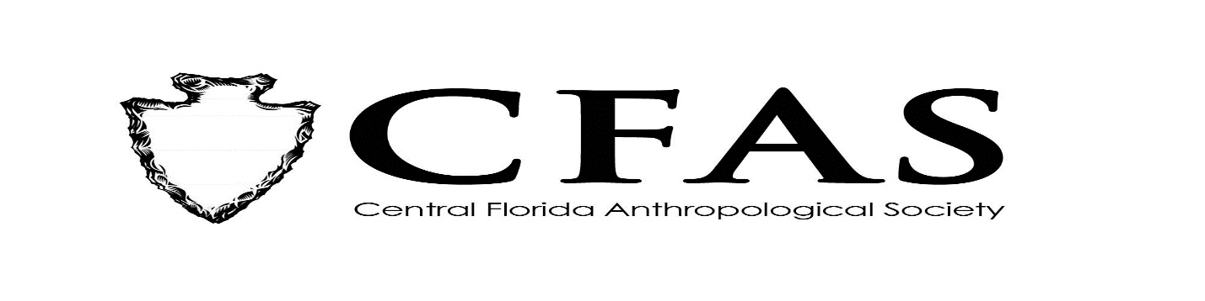
Agenda
General Meeting
October 21, 2019

- Welcome
- Meeting Convene
- Officer Reports:
- President (Deborah L. Bauer) : Details on FAS 3rd Quarterly Meeting that was held in Gainesville on 10/19/2019; announcement that Susan Harrington as new CFAS Secretary; One board vacancy for Treasurer is still in need of filling
- Vice President (Edward González-Tennant)
- Secretary (Susan Harrington): Introduction & work on Membership Renewals/Database
- Media Relations Liasion (Richard J. Ott)
- 2019-2020 Guest Lecture Series Speaker:
Dr. Shana Harris of the University of Central Florida –
Presentation: "A Therapeutic Trip: Treating Drug Addiction with Psychedelics in Mexico."
- General Announcements:
-November 2019 Speaker: Dr. Stefan Krause – “ The 2014 Mitmit: Practicing Private Heritage in Yap State, FSM.”
- Adjournment

