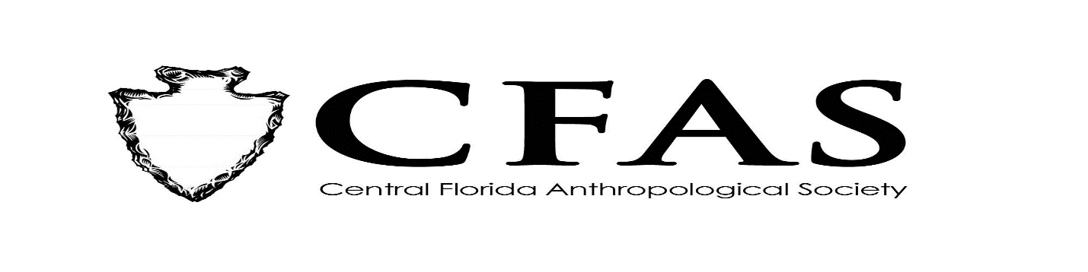
Agenda
General Meeting
November 18, 2019

- Welcome
- Meeting Convene
- Officer Reports:
- President (Deborah L. Bauer): Publication of CFAS Newsletter in November – Solicit Member News; Working on a Membership Renewal Form for Website to Submit Membership Applications Online; Solicit Membership about Social Dinner Before December Meeting
- Vice President (Edward González-Tennant)
- Secretary (Susan Harrington)
- Media Relations Liaison (Richard J. Ott)
- 2019-2020 Guest Lecture Series Speaker:
Dr. Stefan Krause – “ The 2014 Mitmit: Practicing Private Heritage in Yap State, FSM.”
- General Announcements:
-December 2019 Speaker: TBA
6. Adjournment

