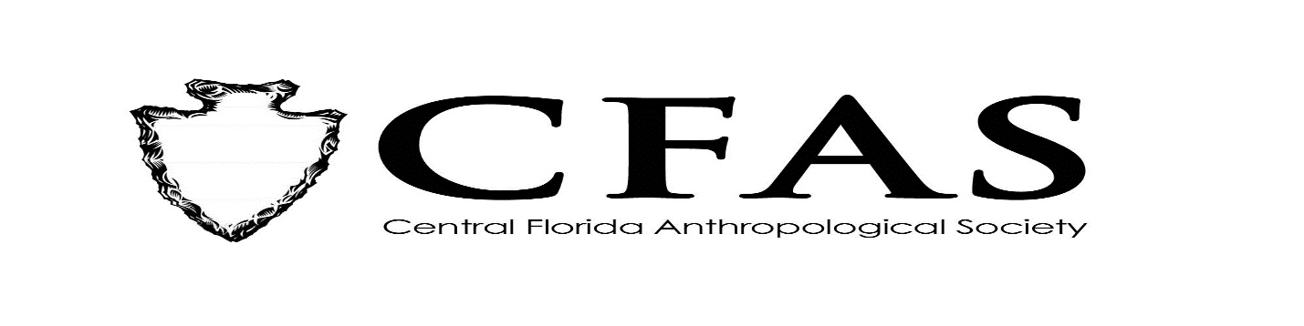
Agenda
General Meeting
December 16, 2019

- Welcome
- Meeting Convene
- Old Business: Vote on 2020 Officer Slate
- New Business
- Officer Reports:
- President (Deborah L. Bauer):
-Reminder: No meeting in January 2020 due to Dr. King Holiday
- Vice President (Edward González-Tennant)
- Secretary (Susan Harrington)
- Media Relations Liaison (Richard J. Ott)
- 2019-2020 Guest Lecture Series Speaker:
- Dr. Zack Gilmore - "The Baker Museum at Rollins: Relics and Tales from a Forgotten Collection"
- General Announcements:
-February 2020 Speaker: TBA
9. Adjournment

