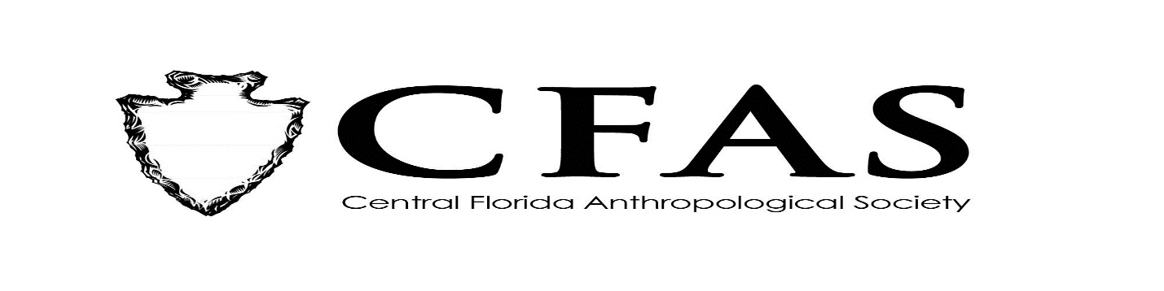
Agenda
General Meeting
June 21, 2021

- Welcome
- Meeting Convene
- Officer Reports:
- President (Deborah L. Bauer)
- Vice President (Vacant)
- Secretary (Susan Harrington)
- Treasurer (Vacant)
- 2020-2021 Guest Lecture Series Speaker:
Ms. Shana Boyer of the University of South Florida –
Presentation: "Privies as Portals: An Analysis of Ceramics at a Late 19th Century Household Privy in Ellenton, Florida”
- General Announcements:
-CFAS will be taking its normal summer break as scheduled in July and August 2021. We plan to resume in September 2021 with (tentatively) in person meetings at the Winter Park Public Library. Details of the September speaker should be forthcoming soon. We hope everyone has a great summer break!
- Adjournment

