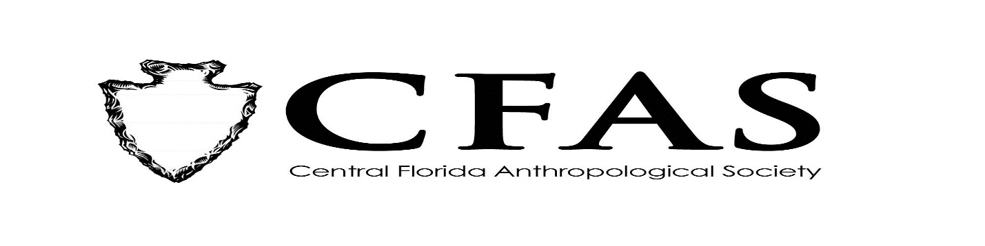
Agenda
General Meeting
September 16, 2019

- Welcome
- Meeting Convene
- Officer Reports:
- Katherine Navarro Resignation
- Promotion of Deborah Bauer as President and FAS Chapter Representative
- Joining of Edward González-Tennant as Vice President and Richard Ott as Media Relations Liaison
- Vacancies of Secretary and Treasurer Still Need to Be Filled
- Launch of New CFAS Website
- 2019-2020 Guest Lecture Series Speaker:
Ms. Sandra Parks of the Stetson Kennedy Foundation –
Presentation: “Stetson Kennedy’s Florida.”
- Announcements
- Adjournment

