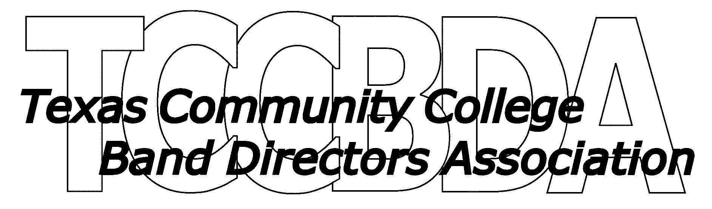

BUSINESS MEETING MINUTES – Monday July 28, 2008

Room CC 213, Henry B. Gonzales Convention Center, San Antonio

The meeting was called to order at 12:03 by President Will Fairbanks.

13 TCCBDA members were present.

Minutes from the February 2008 TMEA meeting as posted on the TCCBDA website were approved.

The Treasurer’s Report was handed out and a report was given by Will Fairbanks in the absence of Treasurer Lynda Reid. It was reported that the organization has a balance on hand of $6493.60 at the printing of the report.

Old Business included the following:

The 2009 Symphonic Band Clinician will be Fred Allen from Stephen F. Austin and the Jazz Ensemble
Clinician will be Mike Steinel from the University of North Texas.

President Fairbanks discussed the fee structure for the clinicians. He stated that we should probably look at raising the clinician fees to bring us in line with the TMEA clinician fee structure. He reported that some clinicians were reluctant to participate because of our lower fees. It was agreed that this should be looked into but that the issue be tabled until our February TMEA meeting so that more members would be present.

The Fall 2008 Audition Tape Judges were reviewed as follows

a. Flutes – Joe Waldrop (Wharton)
b. Double Reeds - (?)
c. Clarinets – Lamont Goodman (Navarro)
d. Low Clarinets – Jill Stewart (Blinn)
e. Saxes – Roy Allen (Brookhaven)
f. Trumpets – Jose Campeon (Laredo)
g. Horns – Brian Harris (McLennan)
h. Trombones – Bruce Keeling (South Plains)
i. Euphoniums – Gary Smith (Temple)
j. Tuba – Gary Smith (Temple)
k. Percussion – (?)
l. String Bass – John Reid (South Plains)
m. Jazz Ensemble Brass – Sparky Koerner (COM)
n. Jazz ensemble WW/Rhythm – Richard Birk (Brazosport)

It was reported that Joe Perea has accepted another job outside of TCCBDA and will not be available to judge percussion tapes or be the symphonic band percussion organizer. It was discussed who might take his place. It was suggested that Dr. Sarah Burke from Blinn might be able to do it. Jill Stewart said she would ask Dr. Burke. As of the meeting the percussion positions have not been filled.

TMEA Registration System:

Vice President David Griffith reported on the TMEA registration system, He felt that at this time the system was not easily compatible to our current system and suggested that the our current all state registration system be kept in place this year. It was suggested that the TMEA system continue to be pursued and a sample system be set up and looked at by the membership. Moving to the TMEA system might help with better housing and other services from TMEA.

Calendar Dates were discussed as listed on the website; all deadlines and information for the All State audition process are posted on the website.

Symphonic Entry Deadline: October 31, 2008
Jazz Band Deadline: November 7, 2008

President Fairbanks reminded the membership of the new CD Recording Policy:

CD’s should be in audio (not data) format, that directors should confirm that they function in
regular CD players (not computers), and that unless visibly damaged from shipment, an audition
CD that does not function for the panel be disqualified

All information regarding audition procedures are listed on the website.

NEW BUSINESS

President Fairbanks welcomed new directors. Jill Stewart reported that Harry Blake is the new Band Director at Blinn. She also reported that Larry Campbell is still serving as the Chairman of the Fine Arts Department and Low Brass Professor at Blinn, but will not longer do the Bands.

President Fairbanks encouraged the membership to keep all contact information current.
There was no other business.

The meeting was adjourned at 12:46pm and members were dismissed to make selections of Symphonic Band audition etudes.

