BAY AREA & STATE

How PG&E missed chance to avert San Bruno blast

By [Jaxon Van Derbeken](http://www.sfchronicle.com/author/jaxon-van-derbeken/)

May 23, 2015 Updated: May 23, 2015 6:44pm

* 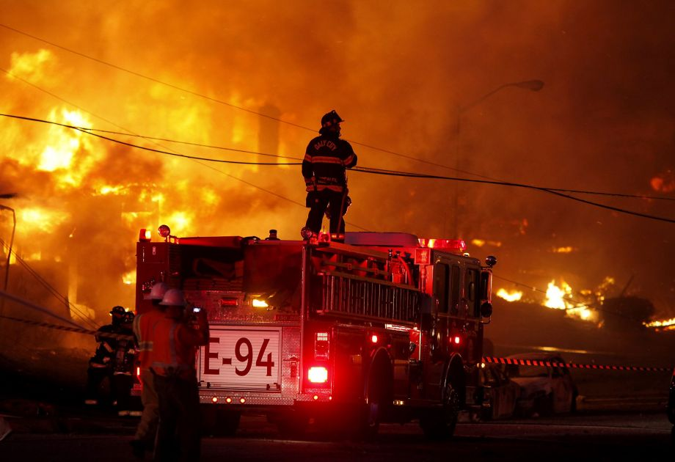

Photo: Brant Ward, The Chronicle

Firefighters battle a fire that destroyed an entire neighborhood in San Bruno in September 2010. The blaze was caused by a natural gas explosion at an underground PG&E pipeline.

Seven years before a natural-gas pipeline explosion in San Bruno killed eight people, Pacific Gas and Electric Co. engineers were alerted that a crucial piece of information about the pipe’s troubled history was missing, a newly uncovered document shows.

That information could have been tracked down at a PG&E district office in San Carlos — and if it had, the disaster might have been averted. But there is no indication PG&E sought out the information or did anything with it.

The missing information concerned what caused the 50-mile-long pipeline to spring a leak in October 1988 near Crystal Springs Reservoir, south of where the line later exploded. The cause became an issue when PG&E was drawing up plans 15 years later to comply with a new federal requirement that all gas transmission pipelines be inspected.

If a line has a history of failed seams — the eventual cause of the San Bruno explosion — federal law requires that it be checked with a method that can detect such a problem, such as pumping it full of water at high pressure.

**[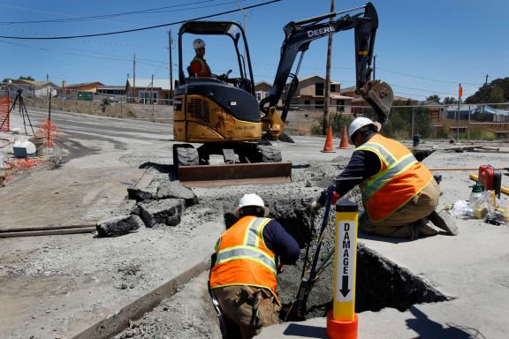](http://www.sfchronicle.com/news/article/Regulator-s-gas-safety-efforts-lag-since-PG-E-6195293.php)**

That’s expensive, however, and PG&E preferred a cheaper method — one that could detect problems such as corrosion, but not a bad seam.

In 2003, as they reviewed records to determine how to inspect the San Bruno pipeline under the new law, PG&E engineers created a map that highlighted the site of the October 1988 leak.

At the top of the map someone wrote, “ERW concerns.” ERW stands for electric resistance welds, which have been linked to hundreds of seam failures on pipelines and which existed on stretches of the San Bruno line.

The map was never turned over to the National Transportation Safety Board when it investigated the cause of the San Bruno disaster. The Chronicle recently obtained it from a source who requested anonymity because of the sensitivity of the case.

The document not only has an arrow pointing to the 1988 leak, it has an engineer’s handwritten note saying information about the incident was not in the company’s pipeline data spreadsheet. That spreadsheet was PG&E’s main source of information for supporting its inspection method.

The database listed the leak as being of “unknown” origin.

But the engineer’s note provided clear guidance to anyone who might have wanted to track down the cause of the leak. The engineer wrote that the leak dated to the same period when 12 feet of the pipeline had been replaced.

A check of PG&E’s district office in San Carlos would have produced the records for that pipeline-replacement job. They showed that the section had failed because of a “longitudinal weld defect” along its seam — the same problem that caused the September 2010 blast that leveled much of San Bruno’s Crestmoor neighborhood.

That defect alone, experts say, should have compelled PG&E to do a thorough evaluation of the line using high-pressure water. The company has tested hundreds of miles of pipeline using that method since the San Bruno disaster, but before 2010 it almost never did so — preferring a method called direct assessment that can catch corrosion on a pipeline, but not a seam weld that is about to fail.

**‘Incomplete’ checks**

Direct assessment was how PG&E tested the San Bruno line in 2003 and 2009.

“Common sense tells you that this process was incomplete and they did not follow through,” said Richard Kuprewicz, a pipeline safety consultant in Washington state who helped draw up the federal inspection regulations. “They should have continued to ask questions until they realized they had some critical data missing and looked at it.

“It’s just not that complicated,” Kuprewicz said. “The fact they failed to do it raises serious questions as to whether they embraced the concept.”

**Tracing pipelines’ history**

PG&E’s head of asset management, Sumeet Singh, said he had been aware of the 1988 leak. “My understanding is that the (pipeline tracking spreadsheet) did show the leak as of unknown cause,” he said.

“I can’t speak to what should have been done back then,” Singh said. He said PG&E has changed how it traces the history of its lines and is now “very robust” in accounting for pipe problems.

“We have a night-and-day different approach to integrity management,” said Greg Snapper, a PG&E spokesman. He said the company has satisfied all the measures federal investigators called for as a result of the San Bruno blast.

Kuprewicz and another expert agreed that the map — with the engineer’s notes written on it — could amount to a “smoking gun” for federal prosecutors who have charged PG&E with violating pipeline safety laws and obstructing the federal safety board investigation into the San Bruno blast. No PG&E executives are charged, but the company itself could be fined more than $1 billion if convicted.

Prosecutors have asserted that PG&E failed to properly assess the risks to the San Bruno pipeline. The company has already agreed to pay a record $1.6 billion state regulatory penalty for the blast.

“They have an obligation to keep historical records — when a record is missing, they have the obligation to do their damnedest to find out what it was,” said Royce Don Deaver, a pipeline safety consultant in Texas. “There is no excuse for it, to allow and tolerate that kind of casual attitude for it. This is dangerous stuff — these pipelines fail.”

Investigators with the National Transportation Safety Board learned of the 1988 leak by happenstance, near the end of their probe into the San Bruno disaster. When the leak came to light, PG&E officials sought to downplay its importance, saying there was no proof it was a seam weld that had failed.

The pipeline repair records were found in May 2011 by a contract accountant in a PG&E office in Walnut Creek, where they had been moved from San Carlos within days after the blast. After they turned up, PG&E interviewed current and former workers without the safety board investigators being present.

**Potential for disaster**

One worker recalled the leak being caused by a faulty seam weld, while another said an unrelated problem had been to blame.

Deaver said a pipeline operator should err on the side of caution when it comes to a potential seam weld failure, given the potential for a disaster such as the San Bruno explosion.

“They have the obligation to look at their entire system to look for the risk,” he said, “not just a particular pipeline segment.”

*Jaxon Van Derbeken is a San Francisco Chronicle staff writer. E-mail:*[*jvanderbeken@sfchronicle.com*](mailto:jvanderbeken@sfchronicle.com)*Twitter: @jvanderbeken*