

**Future Events**

**Mt Dalrymple Backpack Camp….…………..……………….………..3rd – 5th May**

**Redcliff Island evening walk ..………….………………...…..…………...11th May**

**Fresh Water Point ….…….…….….…...……..….…………………………18th May**

**General Meeting….……..….….…...…..…….…………………...…………21st May**

**Abseiling Cape Hillsborough…...…….….…..……………………………25th May**

**The Message Stick**

**May 2025**

Mackay Bushwalkers’ Club Inc. PO Box 1313, Mackay, 4740

Web: <https://mackaybwcq.org.au/>

Email: [mackaybushwalkingclub@gmail.com](mailto:mackaybushwalkingclub@gmail.com)

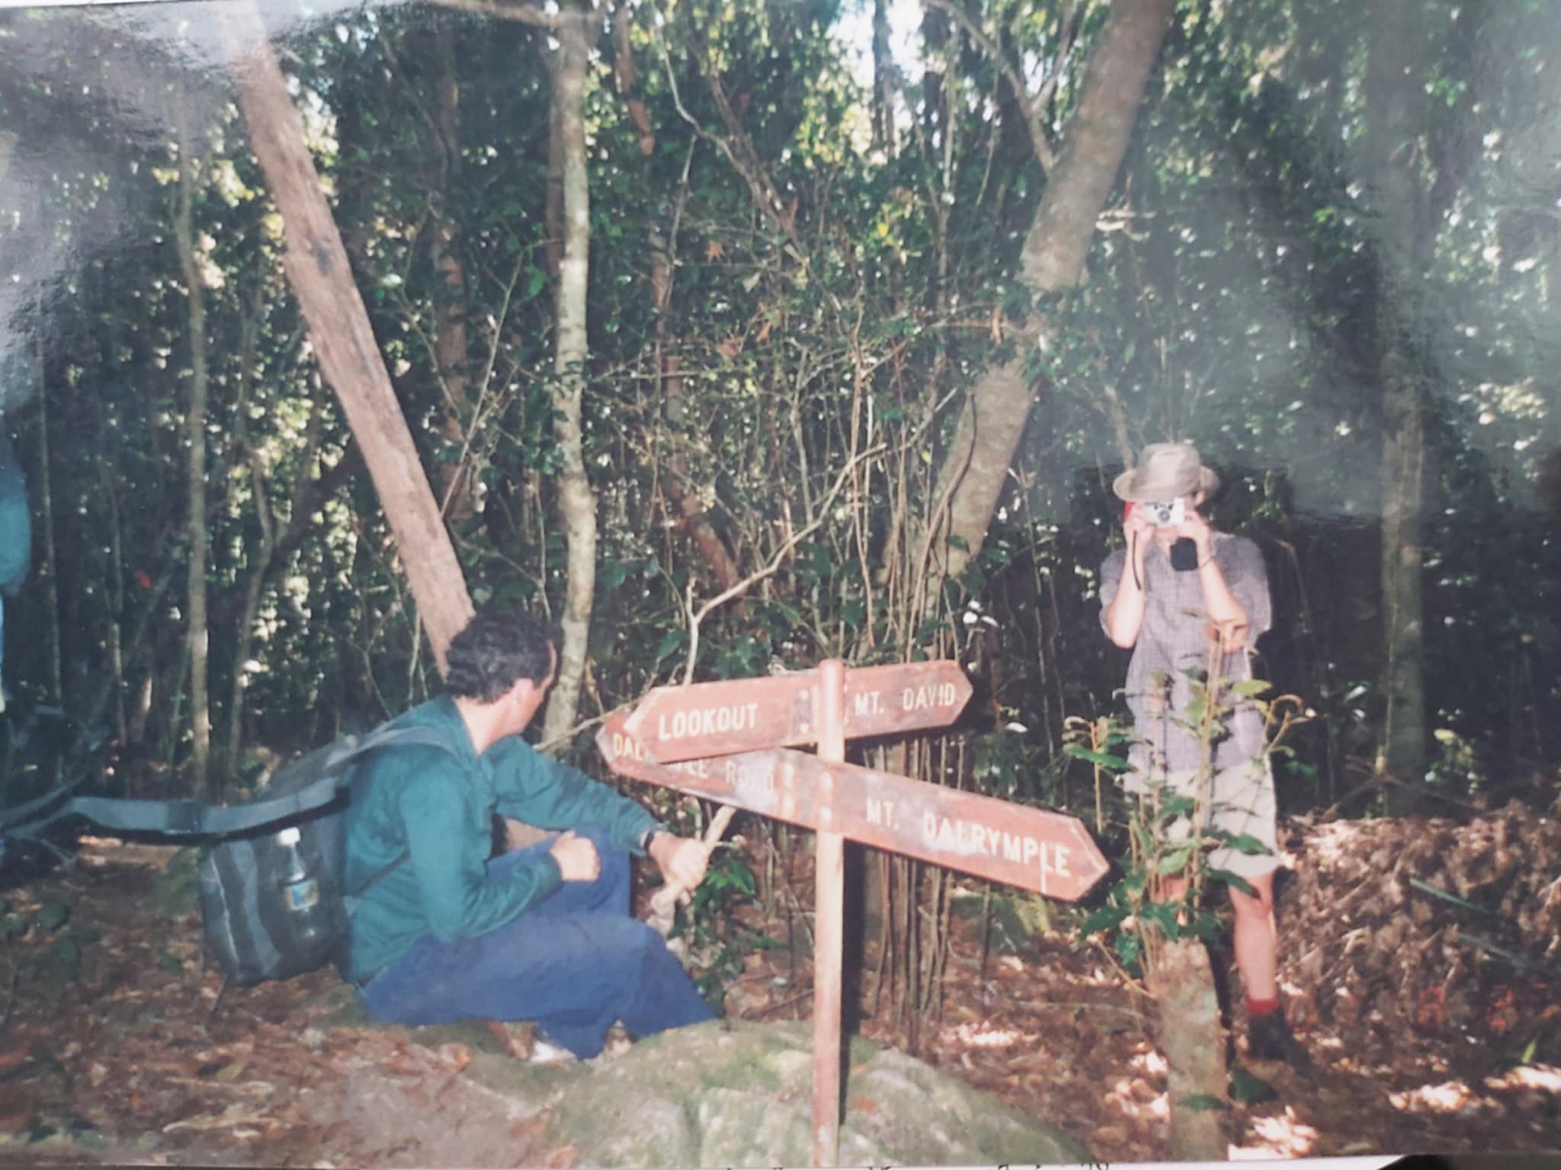

|  |  |  |  |  |  |
| --- | --- | --- | --- | --- | --- |
| **Club Officers** | | | | | |
| **President** | **Peter Bennett** | **0427 383 732** | **Digital Officer** | **Bethany Morgan** | **0415 761 058** |
| **Vice President** | **Carole Weekes** | **0455 872 207** | **Newsletter Editor** | **Telina Lambert** | **0434 392 558** |
| **Secretary** | **Philip Morgan** | **0431 130 074** | **Walks Coordinator** | **Coral Morgan** | **0407 164 856** |
| **Treasurer** | **Mari Simmonds** | **0429 190 168** | **Equipment Officers** | **Frances Eiteneuer** | **0447 866 188** |
| **Membership Secretary** | **Mari Simmonds** | **0429 190 168** |  | **Penny McMahon** | **0421 071 294** |
| **Social Media Manager** | **Wendy Bennett** |  |  |  |  |

**Mt Dalrymple**

|  |  |  |
| --- | --- | --- |
| **Key to Walks Grading System**  **From the Editor**  Weather is unpredictable so please be aware that walks may need to be cancelled at short notice if the leader deems it unsafe to go ahead. Any cancellations will be advertised on the Club’s Facebook Group.  Also remember that the terrain can be treacherous and have a possibility of poisonous animals and plants so be prepared with a small personal **First Aid kit**. It doesn’t have to be huge but should include a snake bandage.  **Trip Leader Bag**  **All walk’s leaders need to arrange for the trip leader bag to be returned to Frances or Penny ASAP after every walk please. Our equipment officers need to check the bag each week to ensure it contains all the necessary equipment and forms needed for the following Sunday’s Walk.**  Assembly point for walks (unless otherwise advised): CAR PARK - CORNER of ALFRED AND NELSON STREETS Car Park address is 295 Alfred Street Please arrive 15 minutes before walk start time.  Please make sure that if you would like to lead a walk in the following month, please inform our walks coordinator Coral Morgan 0407 164 856 before the 21st of May.  All items for the next newsletter including walk information for upcoming walks and previous walk write ups should be sent to mackaybushwalkingclub@gmail.com by 27th of May. | | |
| **Distance**  S = short – under 5km  M = medium – 5-10km  L = long – over 10km | **Terrain**  1-3 = Graded or open terrain, no scrub  4-7 = Bush, minor scrub, rainforest  8-10 = Rocks, creeks, rockhopping, scrambling, thick scrub, major rock scrambling using hands, technical | **Difficulty**  1-3 = Easy, suitable for beginners  4-7 = Medium, reasonable fitness required  8-10 = Hard, strenuous, fit walkers only |

***A Blast From The Past***

***The Ascent of Mount Dalrymple***

***(Port of Mackay by John Kerr, Queensland)***

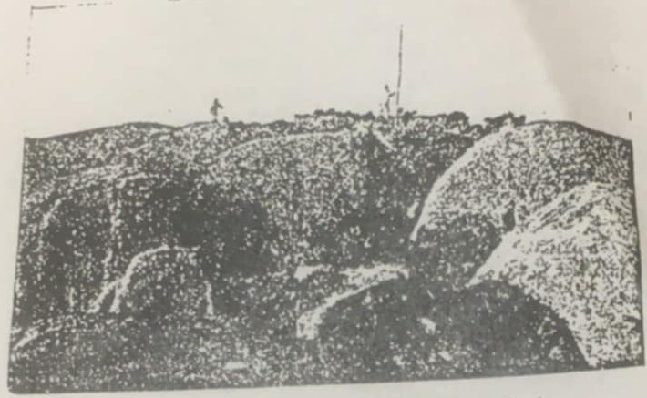The first attempt to ascend Mount Dalrymple was made 23rd July, 1877, by the Hon. Henry. Finch-Hatton (the present Earl of Winchelsea and Nottingham), R.Pole-Carew (now General Sir Reginald Pole-Carew), D.H.Dalrymple no M.L.A., C.Martin (younger brother of Jim and Bob Martin, who afterwards wen to South Africa to a Bank), Harry Robinson (Overseer of Foulden), E.J.Welch, R.N., E.S Rawson, and C.C.Rawson. This Expedition was a failure and returned on the fourth day. The Members to a wrong spur, got up to a height of 3,800 feet and the perceived the summit some three miles away. A gorge about 3,000 feet deep intervening. Heavy rain and shortness of provisions made further efforts impossible, especially as three of the party were knocked up.

The second attempt and first successful ascent was made on the 5th May, 1878, by Henry S. Finch-Hatton, Frank Boyle and C.C.Rawson. The following are Verbatim extracts from the diary of the last-named: -“ May 2nd. Henry and I with Frank Boyle [brother-in-law of A.T.Ball] also Hector Cameron [both stockman at Mount Spencer] and a black boy, started to make another attempt to get to the top of Mount Dalrymple. Rode up Cattle Creek to the Pinnacle, where we crossed and ran up a creek about three miles through two scrub and then camped. My 3rd. Left Hector and boy with horses; Henry, Frank and I all humped our drums* and started up the mountain, two miles up the new creek (Finch-Hatton’s) and took what we thought to be the leading spur. Began raining at 10:30 a.m. and kept it up. Could not get any look out from the top of spur so camped under big boulder; very wet. May 4th. Tried all spurs leading from our camp, but to thick to see anything. Clouds lifted at 1:30 p.m., and we saw ‘The Gibber,’ I got our bearings and started straight for the mountain. Camped on a saddle, very wet all day and night. My 5th. Sunday. Rained all night and very thick this morning. Henry and Frank climbed trees for bearings and again spotted ‘The Gibber.’ Started straight for the mountain, the summit of which we reached at noon. Too thick to see anything. Clouds lifted at 5:00 p.m., and we saw about the finest it was ever my lot to witness. Magnificent panorama for about an hour, when clouds settled down and rain came on again. Too wet and thick to send up rockets. Camped in a cave at back. Henry Shot a turkey just as we got to the top which was very welcome, as we had only a small johnny cake left. I killed a seven-foot carpet snake on the very top, which was all we had for breakfast. May 6th. Put up a flag staff with Henry’s blanket on it, and started down the mountain at 8 a.m., got to out horse camp at 4:45 p.m. left at 5 p.m., and got home [The Hollow] at 9 p.m., having been wet through since Friday at 10:30 a.m., and short of grub.”

The Third ascent was made on May 20th 1883, by Henry S.Finch-Hatton, P.Tindal Porter (Gov. Surveyor), and C.C.Rawson. They camped two nights on the summit, took four photos; fifteen feet of the flagstaff erected five years before were found to be still standing, and 35 new ferns were collected.

The fourth and last ascent was made on June 24th, 1884, by Henry S.Finch-Hatton, Dyson Lacy (of St. Helens), E. Lascelles, and C.C.Rawson, who all Camped on the top for three nights.

“The Mountain” writes C.C.Rawson to me, is entirely covered with dense vine, scrub, and there are two kinds of tree ferns right up to the top. It is 4,250 feet high by aneroid, and there were no signs of it having been ascended by man before we went up; there were no traces of Blacks above the 2,000 feet line.”

***Climb Marked a Centenary***

***6th May 1978***

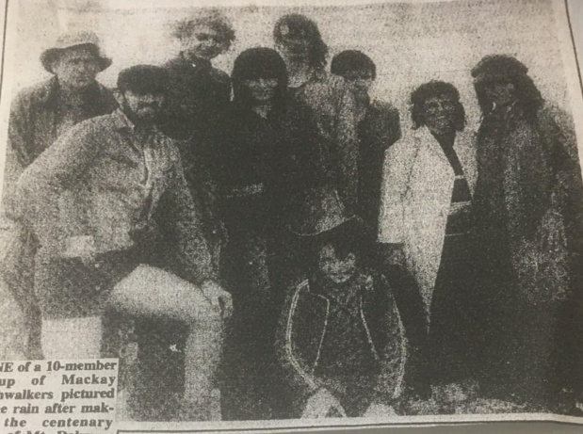 Nine of a 10-member group of Mackay Bushwalkers pictured in the rain after making the centenary climb of mt. Dalrymple in the Eungella area. From left are Mr. Artur Bovey, Mr. Steve Urch, Mr. Stephen Rodgers, Miss Delma Morgan, her brother Steven, Stephen Bailey, Mr. Lesley Howard and Mrs. Coral Morgan with Ralph Morgan sitting Infront. Tenth member of the group Mr. Don Wait, is absent from photograph. Mt. Dalrymple at a height of 1277 metres (4190 feet), is the highest mountain in the Mackay district. The outing marked the centenary of the first climb.

**Future Events**

**All trip leaders please ensure you collect the club gear bag before undertaking your walk and return it as soon as possible afterwards.**

Please contact the leader to nominate for all walks before 12.00pm the day before the walk unless otherwise stated.

**Mt Dalrymple/ Pretty Creek Backpack Camp**

**3rd – 5th May**

**Leader:** Kate Brunner 0467 976 955 or Messager

**Depart:** Contact Leaderfor more information

**Journey:** Contact Leader for more information

**Grade:** n/a

**Estimated walking time:** n/a

**Total of all uphill sections:** n/a

**Pace:** n/a

**Terrain:** Rough

**Vegetation:** Rainforest

**Expect**: Details of this are still to be figured, all is open for input and negotiation. Please people, let me know what you would like!

My current idea: From end of Dalrymple road we follow the western trail as far as Pretty Creek, [3rd creek], set up camp there maybe swim and explore. Some might like to go no further and return same way. Either, same day, next day or day after. Others, would hike on to mount Dalrymple, possibly with side trip to mount David [without camp gear]. We would camp, hopefully under a starry sky on mount Dall. And next morning return, either to the Gorge or same way back to cars at Dalrymple road. The round trip option would require a car shuffle, this was Coral’s idea, who offered to help with the shuffle… I think it might depend on participants if this option was welcome or practical. Walk to Pretty Creek is mostly a [rough] track walk, some ups and downs, but not too hard or too far. For camping it might be a bit cool, so you would need a reasonable sleeping bag. Same for camping on top of D, it might be a cool but there are wind protected spots. Hike to Mount Dalrymple again is on some sort of track, quite steep in parts but not difficultand not super long, this walk normally is a there-and- back in one day, though not with campingload. Fromtop to Gorge, steep, all the way downhill, would not take too long….. 3h? Perhaps? Please let me know your wishes and ideas on this as soon as possible. I will update on fb as we figure out the details. Kate.

**Redcliff Island evening walk**

**Saturday 11th May**

**Leader:** Deb Wilson 0400 319 078

**Depart:** 2pm from Mackay

**Journey:** 90km=$9

**Grade:** S33

**Estimated walking time:** 3 hours

**Total of all uphill sections:** 50m

**Pace:** Leisurely

**Terrain:** Sandy Beach, Stone Causeway, rocks

**Vegetation:** n/a

**Expect:** Terrain sandy beach, stone causeway, there are rocks some of which could be slippery.

We will meet at the Seaforth water park, then travel to Finlaysons Point car park.

We will walk along a short stretch of beach, then begin the walk across the causeway towards the islands.

On the North Island we will walk up a short steep track which is overgrown due to the recent rain. On reaching the top there is a lookout with great coastal views.

Depending on the group, we can also venture to walk around the island.

**Note that this is an evening walk and has a later start time.**

**Freshwater Point**

**Sunday 18th May**

**Leader:** Celestine Lambert 0499 469 444

**Depart:** 7am from Mackay, 8am at Fresh Water Point boat ramp

**Journey:** 100km = $10

**Grade:** M44

**Estimated walking time:** 5 Hours

**Total of all uphill sections:** 40m

**Pace:** Average

**Terrain:** Beach, rough tracks, some rocks

**Vegetation:** Long grass, open sunny sections, coastal scrub

**Expect:** Great coastal views. Possibly

sandflies in places.

This should be a relatively easy day, suitable for beginners. There’ll be some beach walking (sand and rocks), some rough

tracks, and a section along the side of the road.

If there has been rain, the tracks could be muddy. Bring sun protection, enough water for the day, smoko and lunch. There is a very short but steep climb up to a lookout with views south to Mt Funnel and this is well worth the effort.

**Induction 6.30pm &**

**General Meeting 7.30pm**

# Wednesday 21st May

Downstairs room, Mackay Family Care and

Community Support Association Centre 60 Wellington Street, Mackay. Newcomers and visitor’s welcome.

**Abseiling Cape Hillsborough**

**Sunday 25th May**

**Leader:** Philip Morgan 0431 130 074 Depart: 7:30am from Cape Hillsborough Northen Carpark (you’ll see me in a Green Suzuki Swift or a White Nissan Patrol)

**Journey:** N/A

**Grade:** M62

**Estimated walking time:** 2 Hours (to/from Abseiling spot)

**Total of all uphill sections:** Depending on how many times you Abseil

**Pace:** Average

**Terrain:** uneven, bushwalking

**Vegetation:** possible scrub Expect: abseiling at Cape Hillsborough. Abseiling gear is provided, please allow space in your day bag to carry a harness and helmet. The trip duration will largely depends on numbers but I anticipate being back at the cars somewhere around 2-4pm. This trip is dependant on clear weather.

**(note the different meeting place and time)**

**Previous Activities**

**Cape Hillsborough**

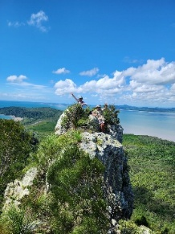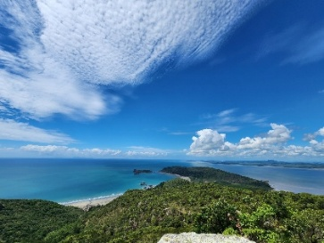**06/04/2025**

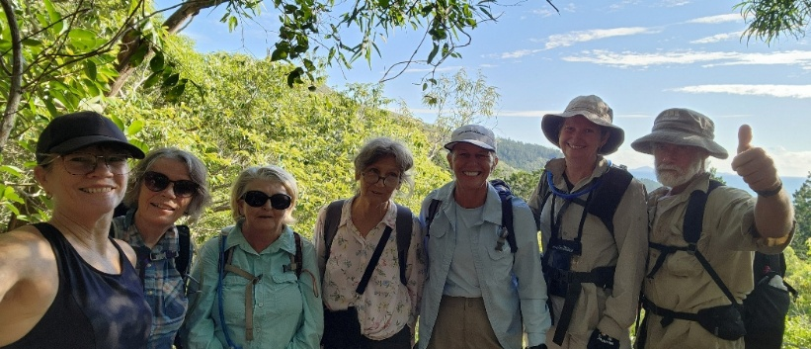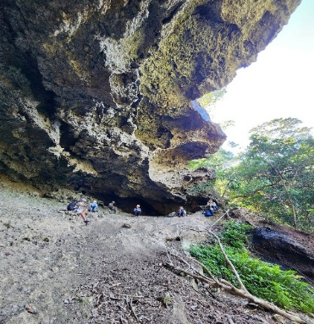The decision was made to not risk life and limb slipping and swimming in Rawsons creek after the weeks rain. Off to Cape Hillsborough instead. Good call. The sun shone down and the breeze keep us cool. What a perfect day. Plenty of time for chatter and taking in the many lovely vistas with the Cascade creek swim at the end a lovely way to cool off. Thanks Kate and Co.

**Julie ward**

**Goose ponds and beyond**

**20/04/2025**

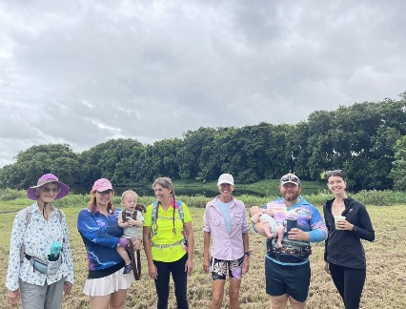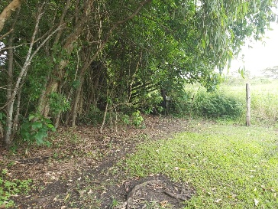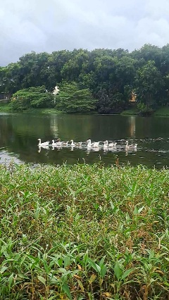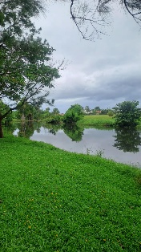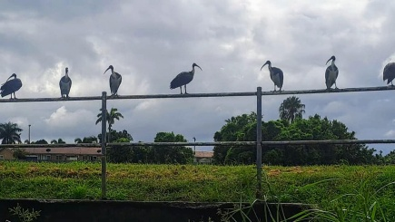Beautiful day. After beautiful blue skies all week Sunday morning greeted us with grey skies and misty rain. This was not going to stop a small group 5 adult club members, 2 visitors and the 2 youngest members from taking on the challenge of the full walking length of the goose ponds trail. We set off all a bit later so we were grateful for the cooler conditions as our little group walked along the edge of the waterway entertained by the vast numbers of ducks, geese and other water fowl and even further along were chooks. We had a few road crossings with 2 members in a pram we decided not to cross the metal bridge to the other side where there is a break in the path and became grass. The grass after a good season was think. We sighted a coffee shop and the advantage of a great toilet so some of us made a bolt before continuing along past the playing fields and a playground which was lunch. We lost our visitor’s earlier in the walk due to them having other commitments. By lunch time it was tired feet but a determined bushwalker completes a challenge so while James stayed back at the playground with the toddler the rest of us, heads up, hiked the last km to the end to a derelict set of cattle yards and a wild paddock before us, and over that grass the hwy. heading back we encounter dog walkers with pooches of all breeds and a few push bikers. It was lovely to just stroll along the creek with its overhanging tree and calm waters which the geese also enjoyed stopping the road traffic to stroll across the to the upper creek. We were in need of refreshment by the time we got back to the more known paths so we side tracked to a sweet treat at Baskins Robins before continuing our venture. We deviated to the southern side of the track for the last bit were more birds gathered and we spotter sail boats on the water, miniature of course but still a sight to see. With weary feet we were relieved to see the cars and people checked their wrist watches and phones to measure the distance, with different readings we went halfway at around 13km. No wonder we had tired feet. There was plenty of chatter and pleasant walking but good things end and we parted ways with smiles. Thank you, Telina, for bringing us together for a lovely day of friends and nature, even suburbia can be wild.

**Celestine Lambert**