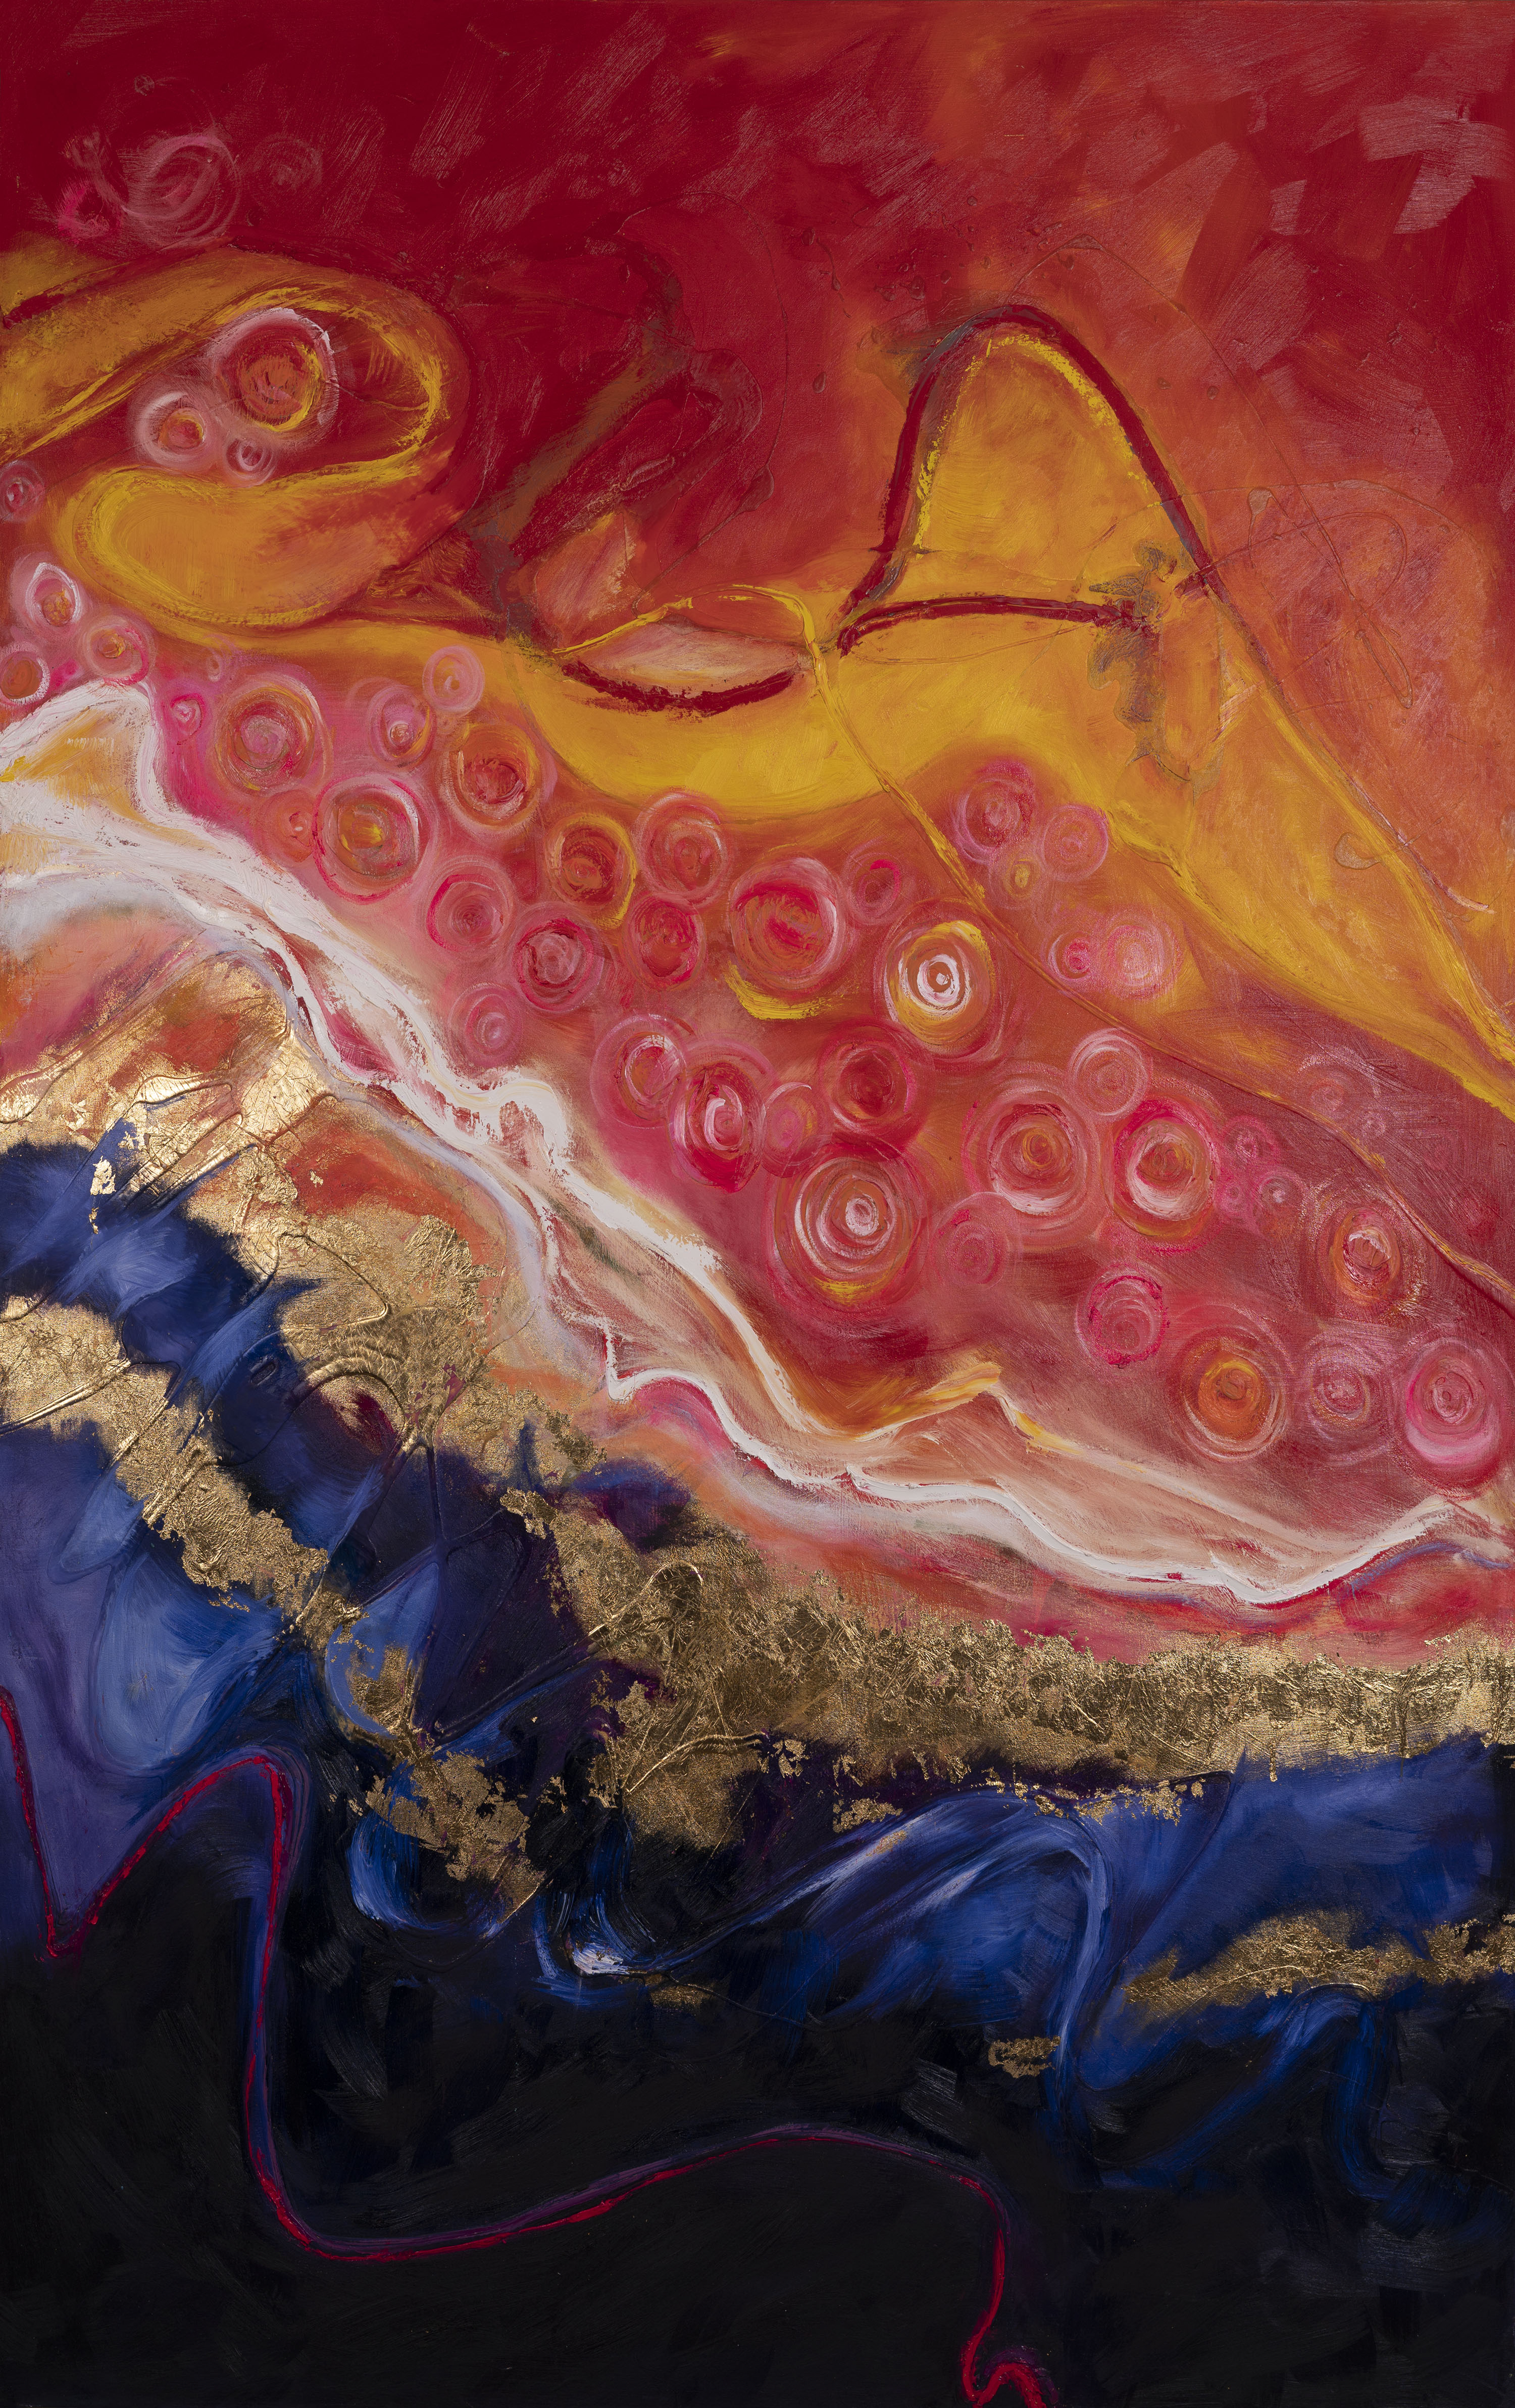
Mary Joan Hinson
Brief Vita
1420 Campbell Ave.
Jacksonville, FL 32207
904.315. 2777
Brushandoil@gmail.com
Brushandoil.com
Facebook: Brush and Oil
Instagram: Brushandoil2109

Education:
PhD in Philosophy, Capella University, 2005

Select Exhibitions and Mural Applications:
Florida State College at Jacksonville South Gallery, Lake Anne Gallery, Complete Choice Gallery, Southlight Gallery, Brest Museum, Cork District Arts, Torpedo Factory Art Center, Savannah Designworks, Beaches Fine Arts Center, Reston Roller Rink, A Child’s Place Clothing Store, Skate Road 13, Durkeeville & Co., Sublime Abstraction, Animals in Art, Nature’s Abstraction, FemArt, St. Nicholas Historical Mural, Jacksonville International Airport, Animal Portraiture, Goodyear Gallery, Naval Air Station Jacksonville, European Creations, Jekyll Island Art Association, St. Augustine Art Association

Selected Employment:
Professor of Visual Arts and Humanities, Florida State College at Jacksonville: 1995 - 2020
*Studio Art courses: Drawing I, Drawing II, Figure Drawing, Painting I, Painting II, Portfolio, Weaving I, Weaving II, Weaving III, Advanced Interdisciplinary Studies
*Art History and Humanities courses: Art History I, Art History II, Art Appreciation, Intro Humanities

Professor of Design, Laureate University: 2015 - 2020
*Online course presentation: Design Thinking

Publications:
The Western Tradition: Part I, Kendall Hunt, 2004
The Western Tradition: Part II, Kendall Hunt, 2004
Art Appreciation Course Workbook, Prentice Hall Publishers, 2007
An Analysis of the Effect of Using Food as an Operant Conditioning Instrument, Capella University, 2005

Community Involvement/Lecturer:
Board of Trusties: Beaches Fine Arts Series (Visual Arts Coordinator), Board of Directors: North Florida Hunter/Jumper Association, Member: Greater Jacksonville Arts Council; Lecturer: Art League of Orange Park, Florida State Colle, Jacksonville University, Jekyll Island Arts Association

Selected Awards and Honors: All listed are winning honors (2020-2021 only):
St. Nicholas Mural Competition for a historical mural.
National Animal Portrait Competition
Jacksonville International Airport Exhibition Competition
Jekyll Island Goodyear Cottage Solo Exhibition Award
Naval Air Station Mural Competition to depict elements of NAS
South Gallery Solo Exhibition Competition
Brest Museum Painting Award
Sublime Abstraction Painting Award
NAS Jacksonville Auditorium Commission Award

2021 Selected Murals with contacts:
St. Nicholas Historical Mural
Dr. Rene Pulido
rpulido@emedmultispecialtygroup.com
904-629-3484
NAS JAX Mural
Ms. Morgan Kehnert
mkehnert@gmail.com
904-616-0845 or 904-542-1548
Davalt Optical Mural
Clinton Ross
Eyepothecaryjax@gmail.com
904-338-8674

