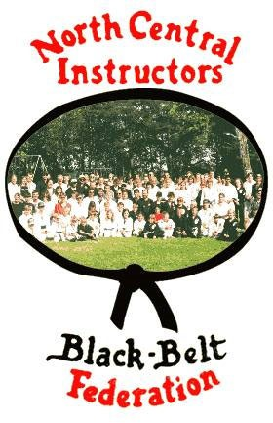
The North Central Instructors Black Belt Federation
And
The Mason Street Center for Martial Studies
36th ANNUAL SPRING SEMINAR and MEETING
April 25th, 2026
Rhinelander High School 665 Coolidge Ave
Rhinelander, WI 54501
8:00 - 10:00 Registration
10:00 - 10:30 NCIBBF Annual Meeting and Black Belt Meeting
10:30 - 4:30 Work-out and Special Guest Speaker

Instructors

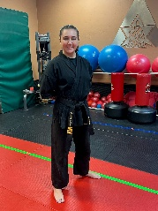
Devan McCready - Sensei

Sensei McCready is a 5th degree black belt in American Freestyle Karate, a first-degree black sash in Shaolin-do Kung Fu and I have trained in Krav Maga and Brazilian Jiu Jitsu. She is currently a law enforcement officer in Wisconsin. She will be instructing in real-world self-defense, Wisconsin self-defense law, practical scenarios, and bullying prevention.

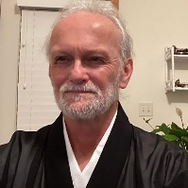
Dr. Dave Nelson – Sensei
Dr. Nelson has been teaching Sanchin and will be teaching combat applications.
From Rhinelander, Wisconsin, David Nelson has been involved in martial arts since 1969. His roots lie in Goshindo Karate under the direction of Mr. Paul Dean. He has studied a variety of Karate styles over the years, along with other traditional arts, such as Iaido, Kendo, and Jujutsu. In 1994 he was lay ordained in Soto Zen and is a member of the Stray Dog Sangha near Madison, Wis. Borrowing from his professional career as a psychotherapist and addictions counselor, he authored, “Black Belt Healing: A Martial Artist’s Guide to Pain Management and Injury Recovery” (Tuttle Publishing). Now retired, he is simply a zen lunatic at large; being nobody, going nowhere.
Dr Nelson will also be our Guest Speaker this year!

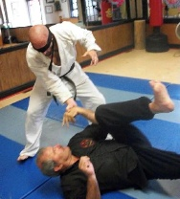
Ernie Paulson – Sensei
Sensei Paulson will be instructing us in applying traditional techniques to combat. He is currently instructing at the Mason Street Center for Martial Studies in Rhinelander and holds the rank of 2nd Dan in Goshindo as well as a Blue Belt in Brazilian Jiu-Jitsu.

North Central Instructors Black Belt Federation
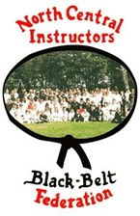
Annual Meeting
April 25, 2026
10:00 am
Rhinelander High School

This serves as official notice of the North Central Instructors Black Belt Federation Annual Meeting

SEMINAR COST WILL BE $40.00 PER PERSON – includes light lunch

Please join us after the seminar for food and drinks at the Mason Street Center for Martial Studies afterwards for food and drinks

Sponsored by
Mason Street Center For Martial Studies
919 Mason Street
Rhinelander, WI 54501
For more information, please contact

Sifu Paul Marquardt
Cell: 715-499-5123
E-Mail: sifupaul@outlook.com
Registration forms available at www.ncibbf.org
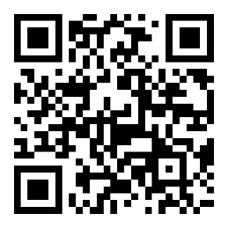
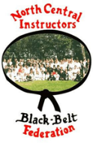

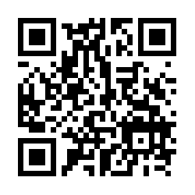
Scan here for registration

RELEASE FORM

NORTH CENTRAL INSTRUCTORS BLACK BELT FEDERATION SEMINAR/MEETING
I understand that this being a physical activity, injuries may and sometimes do occur, and recognize that the nature of Martial Arts training often results in hands on training and partner work. I accept the responsibility for my actions and agree to the following:
I hereby release the Fu-Chen Martial Art Association, its oﬃcers and members; the Mason Street Center for Martial Studies, its Oﬃcers and members; the North Central Instructors Black Belt Federation, its Oﬃcers and members; the Rhinelander School District; all Instructors; and my fellow students from any and all liabilities that may be incurred during this seminar.
I understand that this DOES NOT forfeit any legal rights, which I may be entitled to and I do not give up these rights.
I also give my permission for any photographs that include me or my child may be used on social media
PLEASE PRINT !!!!!

Name: Address: City: State: Zip Code: Phone: ( )
Style: Rank: E-
mail: Sign:
Date:

Legal Guardian (if under 18 years old): Please check if you are a head instructor at a school 
Please check here if you are a member of the NCBBIF 
Please check here if you are a Black Belt or teaching Brown Belt and are interested in membership infor-mation 
This information will be used for future mailings, so please complete as much as possible and print legibly. If you do not wish to be added to the mailing list, please check 

Schools - please make copies so each student has a release form Please make checks payable to the Rhinelander Fu-Chen Kung-Fu School

