Data Profiling Report

* Basic Statistics
  + Raw Counts
  + Percentages
* Data Structure
* Missing Data Profile
* Univariate Distribution
  + Histogram
  + Bar Chart (by frequency)
  + QQ Plot
* Correlation Analysis
* Principal Component Analysis

Basic Statistics

Raw Counts

| **Name** | **Value** |
| --- | --- |
| Rows | 4,114 |
| Columns | 21 |
| Discrete columns | 12 |
| Continuous columns | 9 |
| All missing columns | 0 |
| Missing observations | 0 |
| Complete Rows | 4,114 |
| Total observations | 86,394 |
| Memory allocation | 1.7 Mb |

Percentages

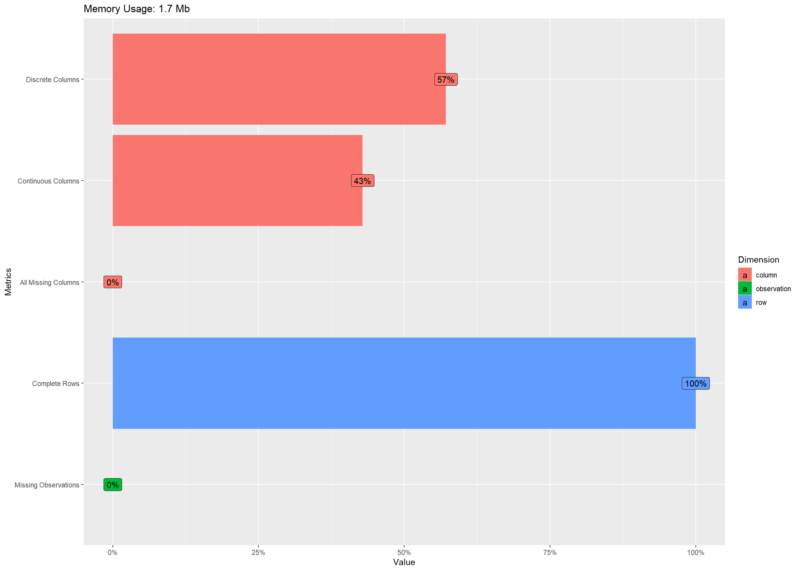

Data Structure

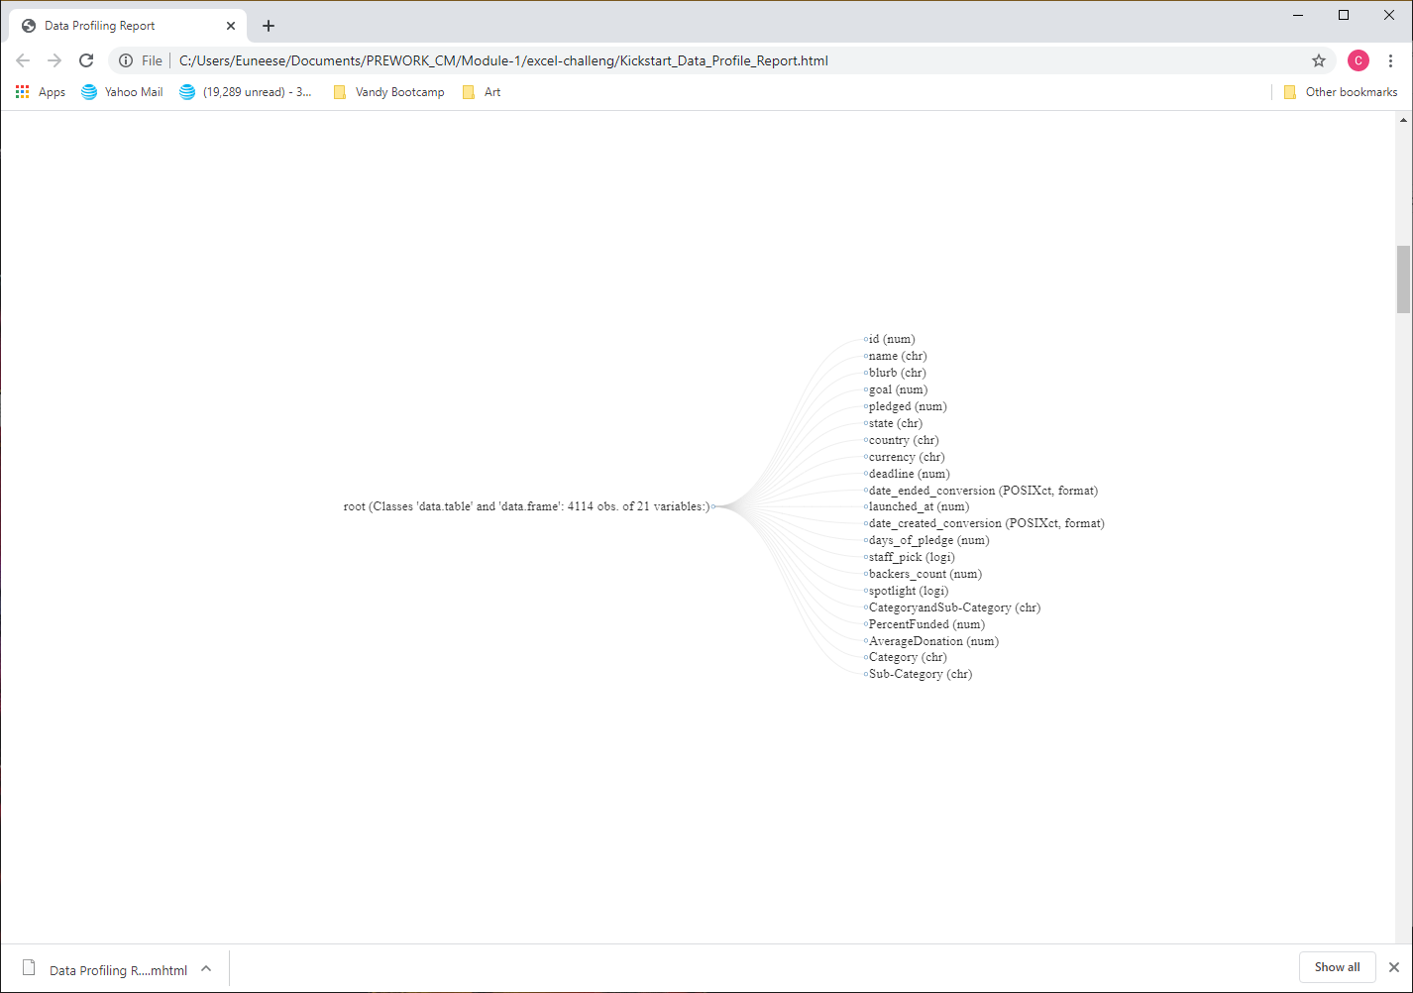

Missing Data Profile

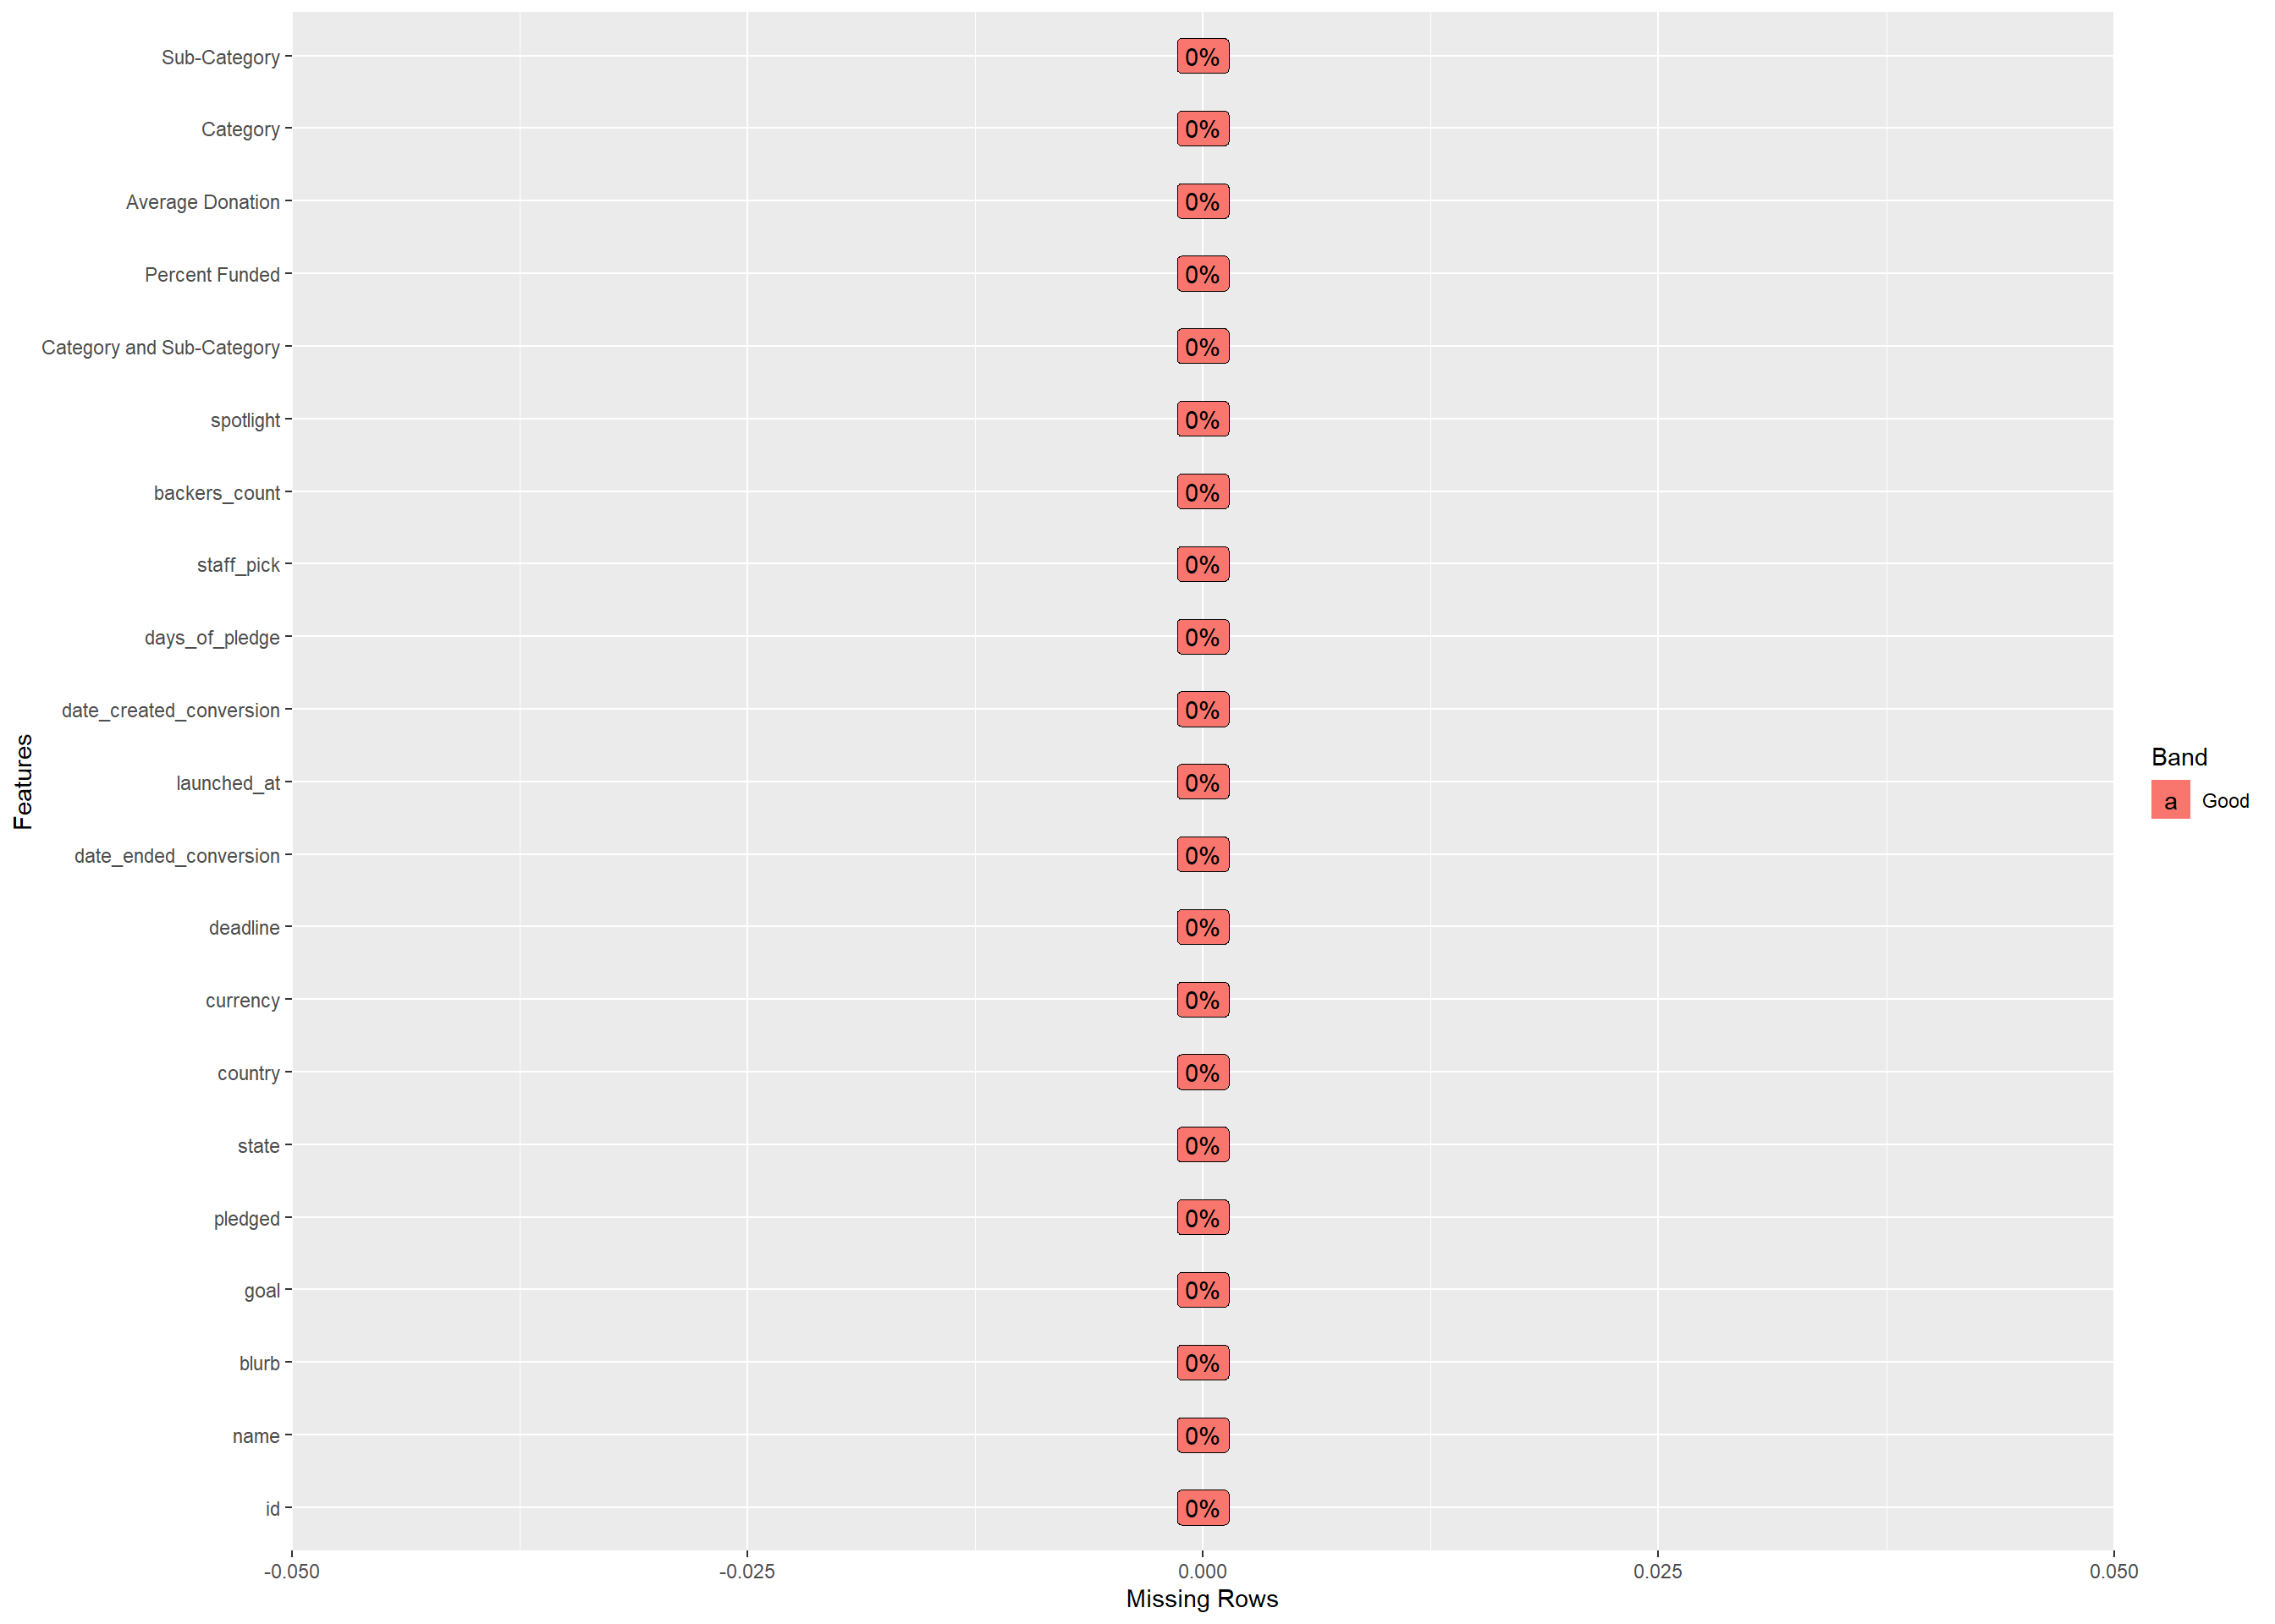

Univariate Distribution

Histogram

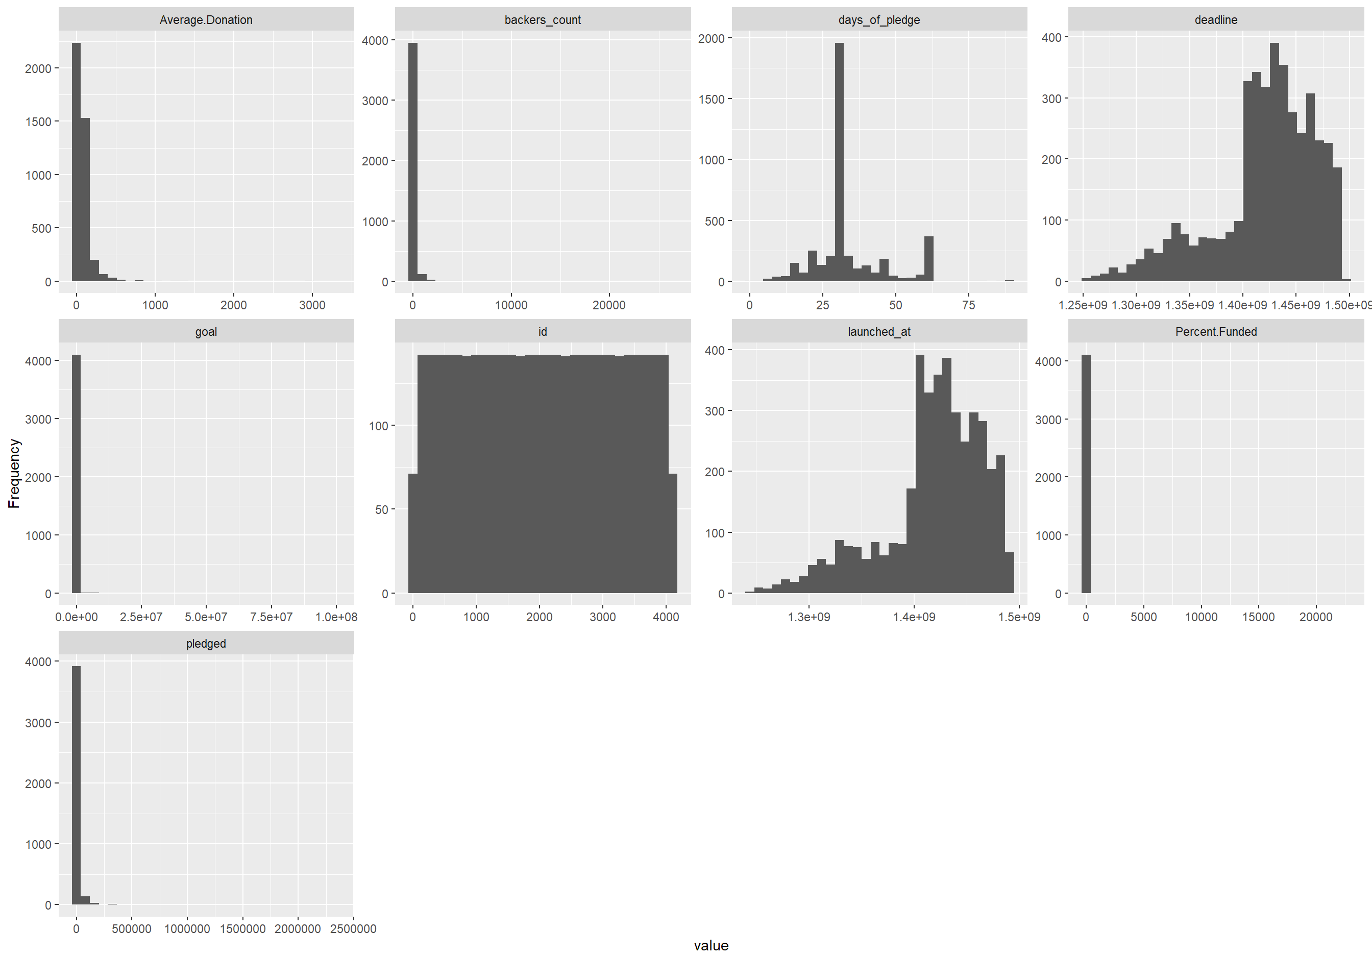

Bar Chart (by frequency)

## 4 columns ignored with more than 50 categories.

## name: 4109 categories

## blurb: 4106 categories

## date_ended_conversion: 4092 categories

## date_created_conversion: 4114 categories

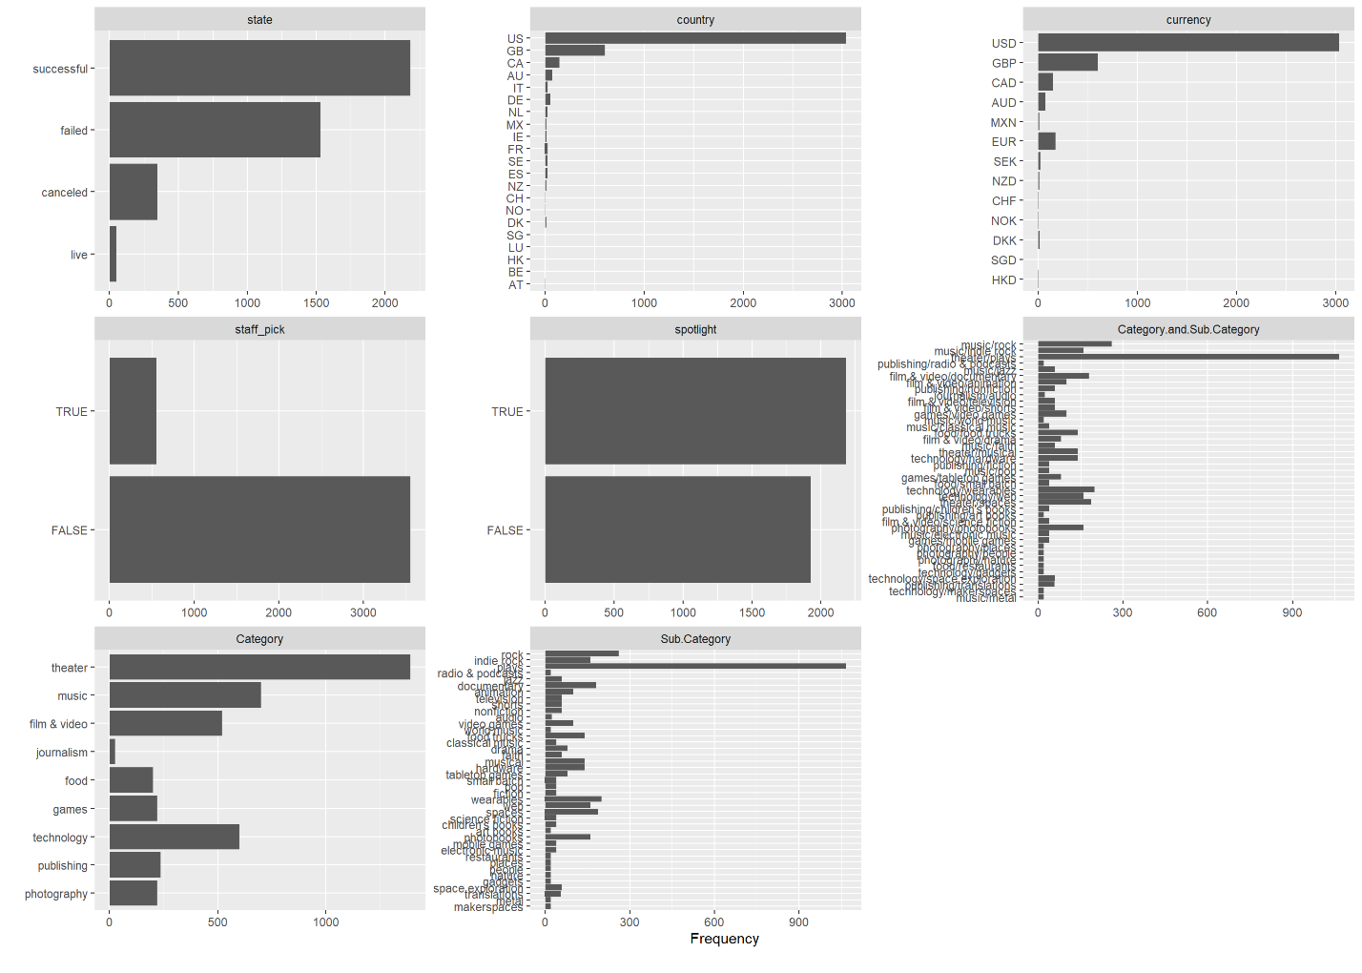

QQ Plot

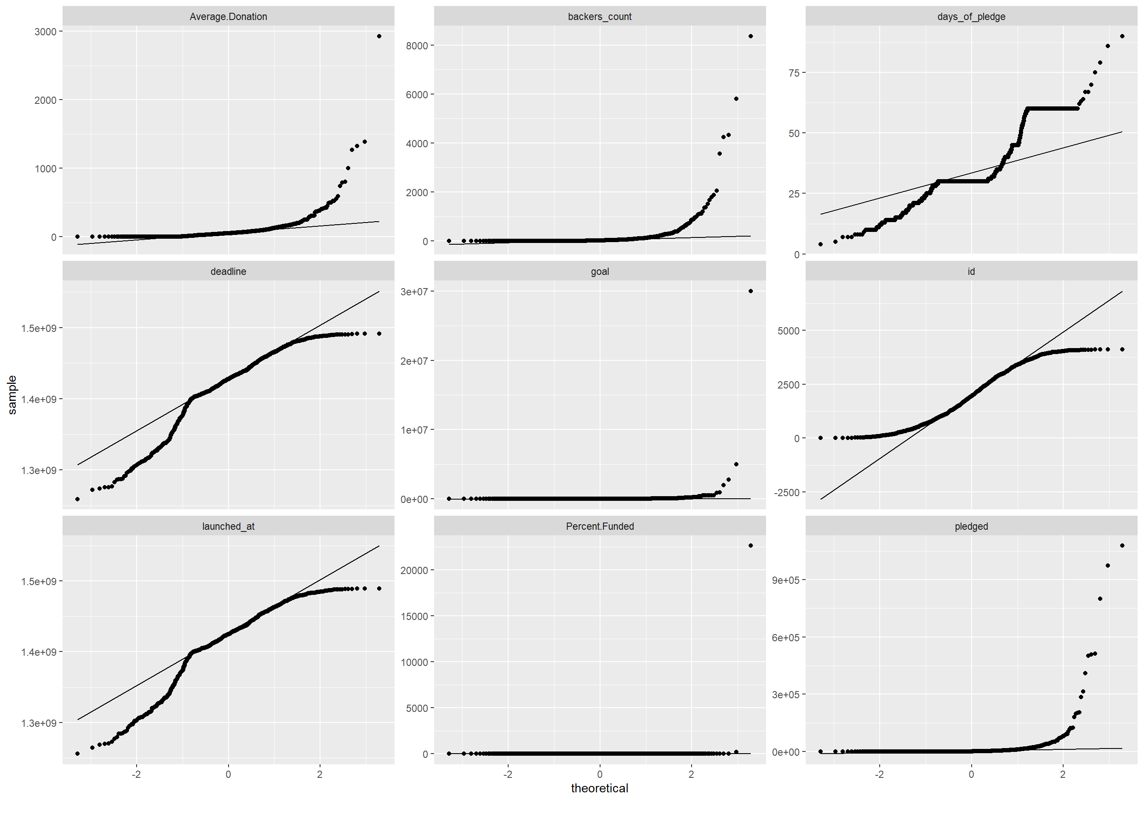

Correlation Analysis

## 7 features with more than 20 categories ignored!

## name: 4109 categories

## blurb: 4106 categories

## country: 21 categories

## date_ended_conversion: 4092 categories

## date_created_conversion: 4114 categories

## Category.and.Sub.Category: 41 categories

## Sub.Category: 41 categories

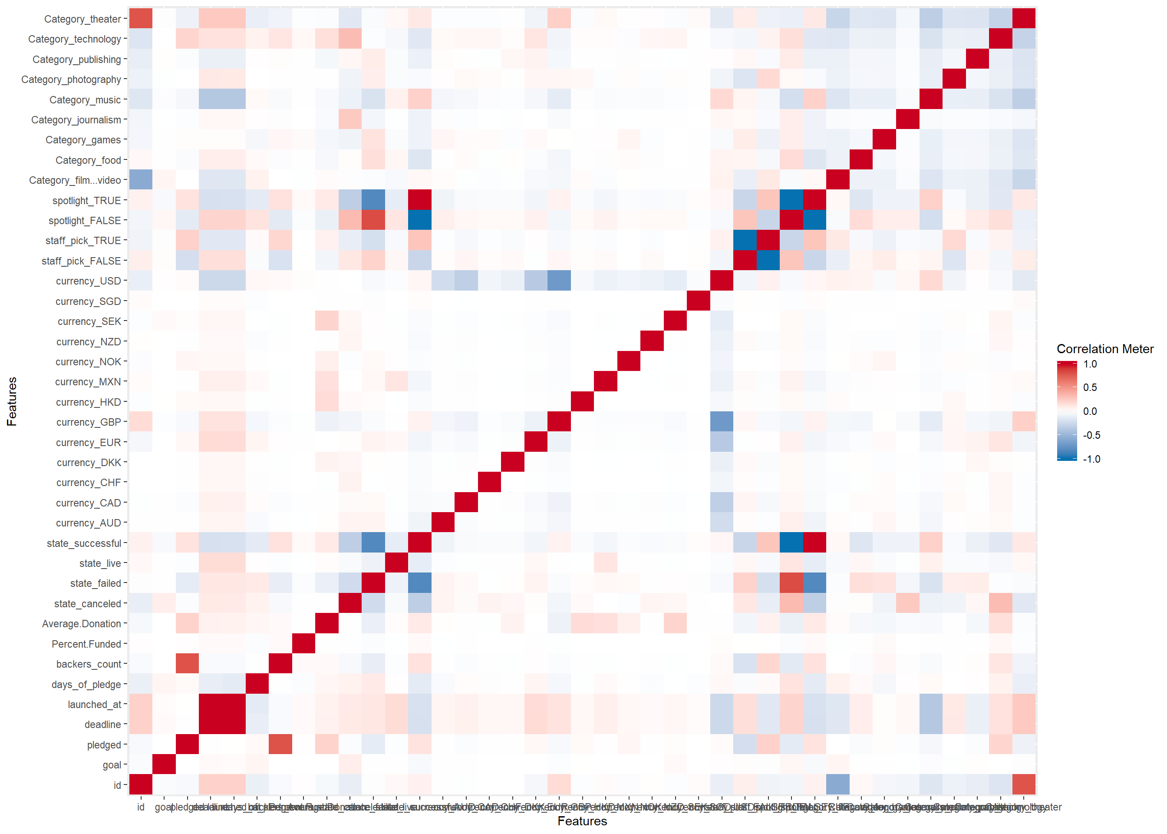

Principal Component Analysis

## 4 features with more than 50 categories ignored!

## name: 4109 categories

## blurb: 4106 categories

## date_ended_conversion: 4092 categories

## date_created_conversion: 4114 categories

