Project Sales

The sales data was taken from a local business. The data came from sales that occurred during 2014 to 2018.

I had to retrieve the data using a query UI built in-house, and then I used Excel to calculate sales and percentages from the data.

This project began with a simple chart to view sales overtime.

What this project managed to identify was a need to classify client types and anticipated sales per classification. This was then used to score each Client Account Manager’s (CAM) portfolio and to re-assign one client type (D) from each field CAM to new in-house CAM’s.

In the beginning “Client” represented all client types. In the end the taxonomy of “Client” became:

|  |  |  |
| --- | --- | --- |
| Client Type | Number of sale events each year | Anticipated Sales per Event |
| A | 48 | $100,000 |
| B | 12 | $30,000 |
| C | 12 | $15,000 |
| D | 2 | $10,000 |

For this project, I used Excel, Pivot Tables, RStudio, Rattle, ggraptR, and Tableau.

Using R Studio, I retrieved the following:

|  |
| --- |
| > library(readxl)  > Sales_Data <- read_excel("Projects/Sales/Sales_Data.xlsx")  > View(Sales_Data)  > glimpse(Sales_Data)  Observations: 60  Variables: 9  $ Year <dbl> 2014, 2014, 2014, 2014, 2014, 2014, 2014, 2014, 2014...  $ Month <chr> "JAN", "FEB", "MAR", "APR", "MAY", "JUN", "JUL", "AU...  $ Sales <dbl> 9683117, 11943025, 13304480, 15379253, 16194897, 123...  $ Num_Items_Sold <dbl> 9320, 10853, 11225, 10927, 12867, 10817, 11663, 1184...  $ Dollar_Per_Item <dbl> 1038.961, 1100.435, 1185.254, 1407.454, 1258.638, 11...  $ Num_Clients_Selling <dbl> 919, 1072, 1122, 1199, 1224, 1062, 1121, 1131, 1145,...  $ Dollar_Per_Client <dbl> 10536.58, 11140.88, 11857.83, 12826.73, 13231.12, 11...  $ Total_Clients <dbl> 4036, 4117, 4188, 4293, 4382, 4462, 4542, 4610, 4712...  $ `Percent_Clients_ Selling` <dbl> 0.2277007, 0.2603838, 0.2679083, 0.2792919, 0.279324...  Using Rattle, I retrieved the following:    Distribution of sales by month:    Distribution of the number of clients selling and the total clients at the time |
|  |
|  |

Looking at the same information, you see looking at this histogram the number of clients selling and number of clients onboarded consistently rise.

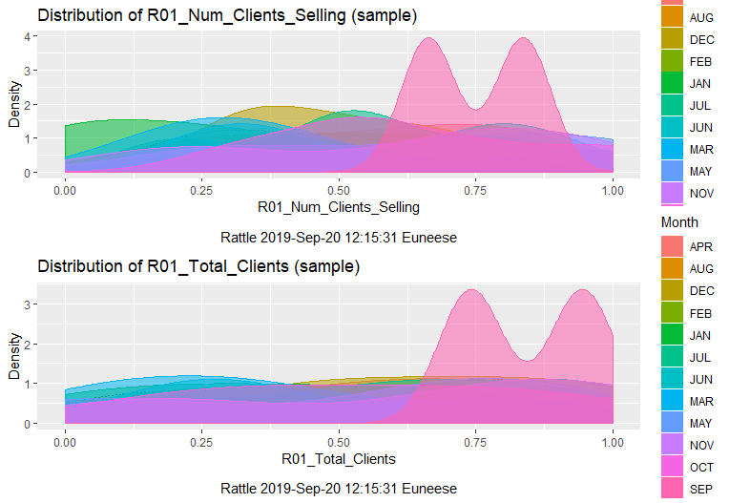



The dollar assigned per client selling drastically changes. We found that there were certain times throughout the year that agencies sold heavy equipment which brought a higher price per item.

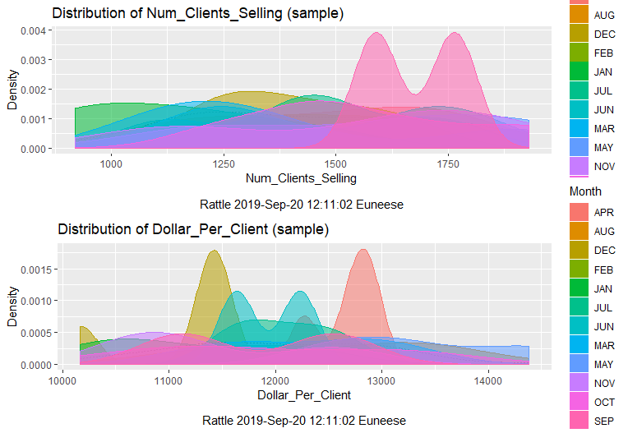

Year-over-year, looking at the percent of clients selling vs total client, it seems that the company peaked in 2016

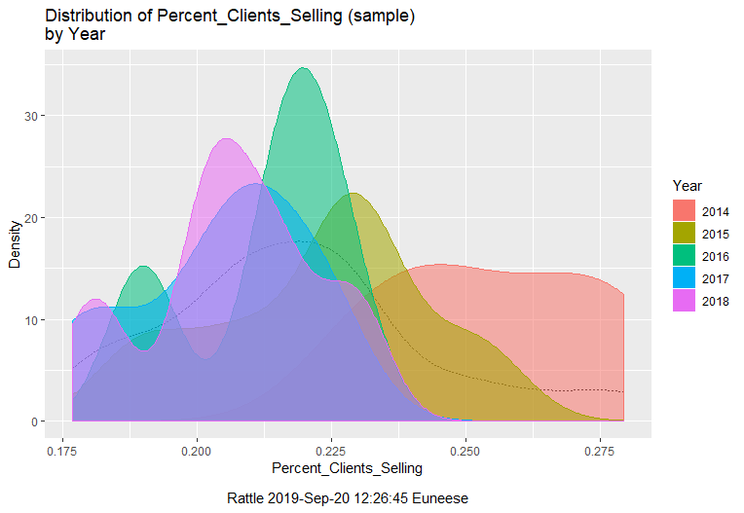

In addition, even though new clients were onboarded, it appears that the company had fewer active clients during 2015, 2016, and 2018.

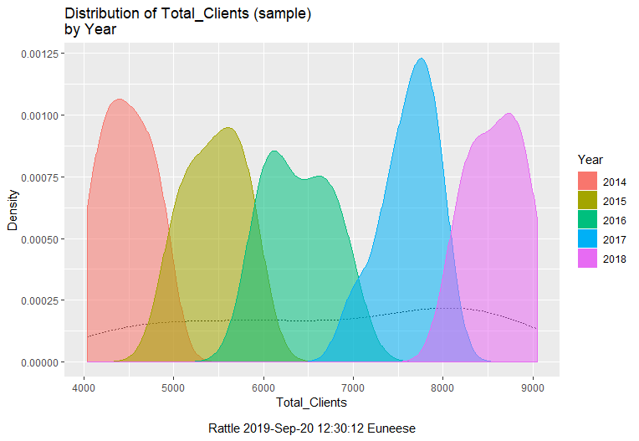

After looking at this chart, it was identified that in 2015 there were fewer clients identified as type A selling.

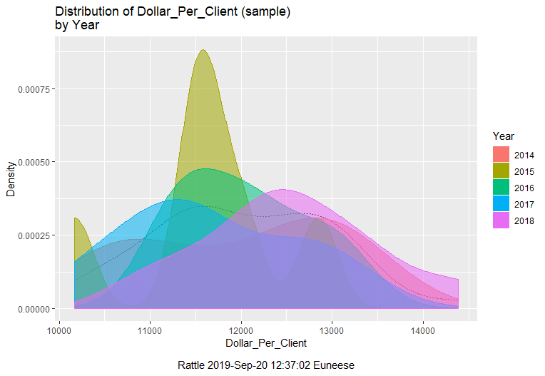

Using ggraptR we see that even though the number of clients onboarded increases, the number actively selling decreases:

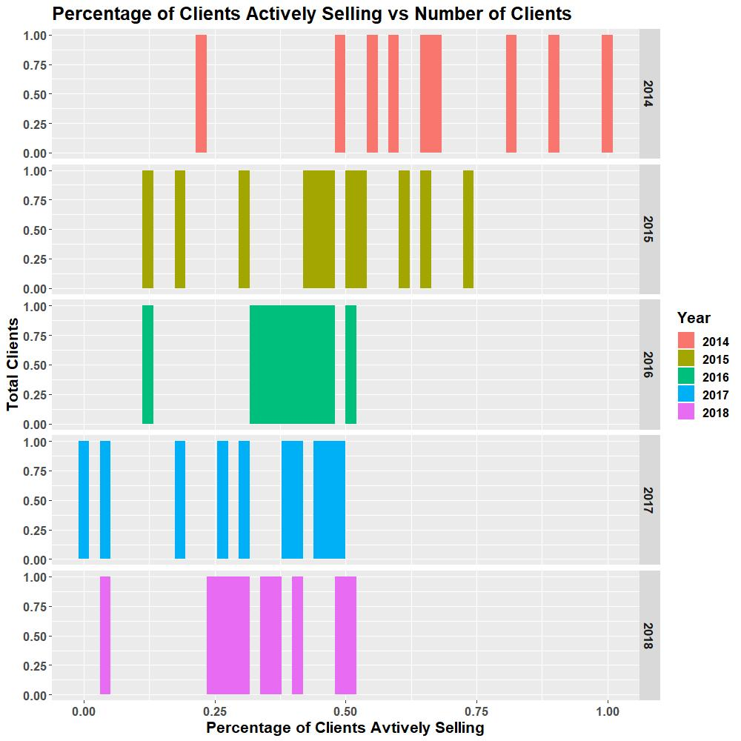

Sales Year over Year, Month over Month using ggraptR

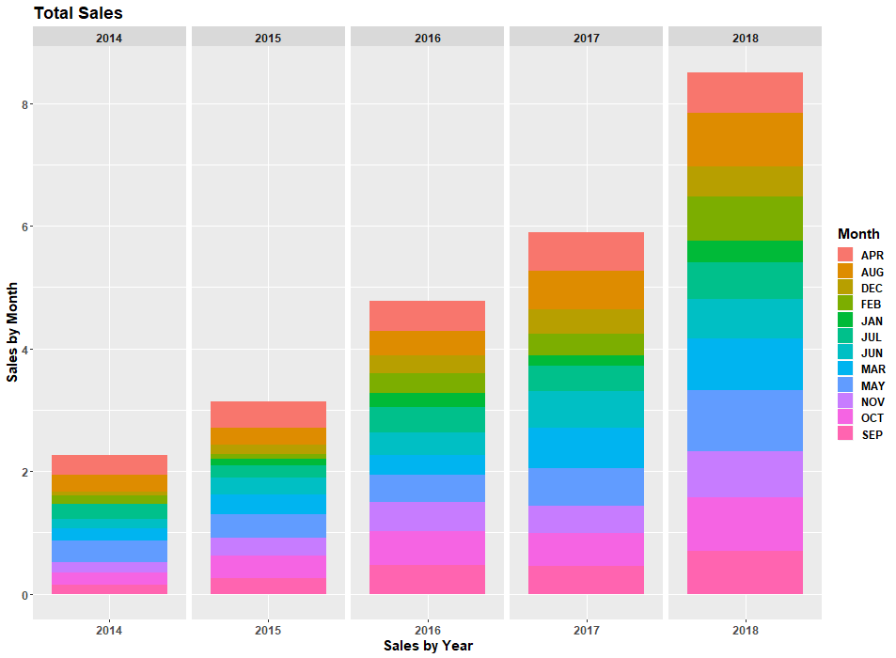

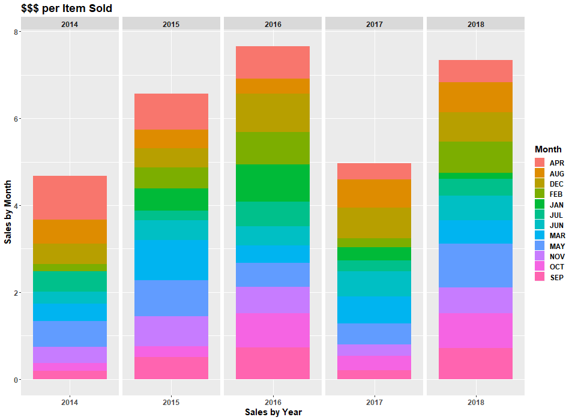

Dashboard built using Excel

