# Data Profiling Report

* Basic Statistics
  + Raw Counts
  + Percentages
* Data Structure
* Missing Data Profile
* Univariate Distribution
  + Histogram
  + Bar Chart (by frequency)
  + QQ Plot
* Correlation Analysis
* Principal Component Analysis

### Basic Statistics

#### Raw Counts

| **Name** | **Value** |
| --- | --- |
| Rows | 439,005 |
| Columns | 14 |
| Discrete columns | 8 |
| Continuous columns | 6 |
| All missing columns | 0 |
| Missing observations | 528,423 |
| Complete Rows | 39,956 |
| Total observations | 6,146,070 |
| Memory allocation | 76 Mb |

#### Percentages

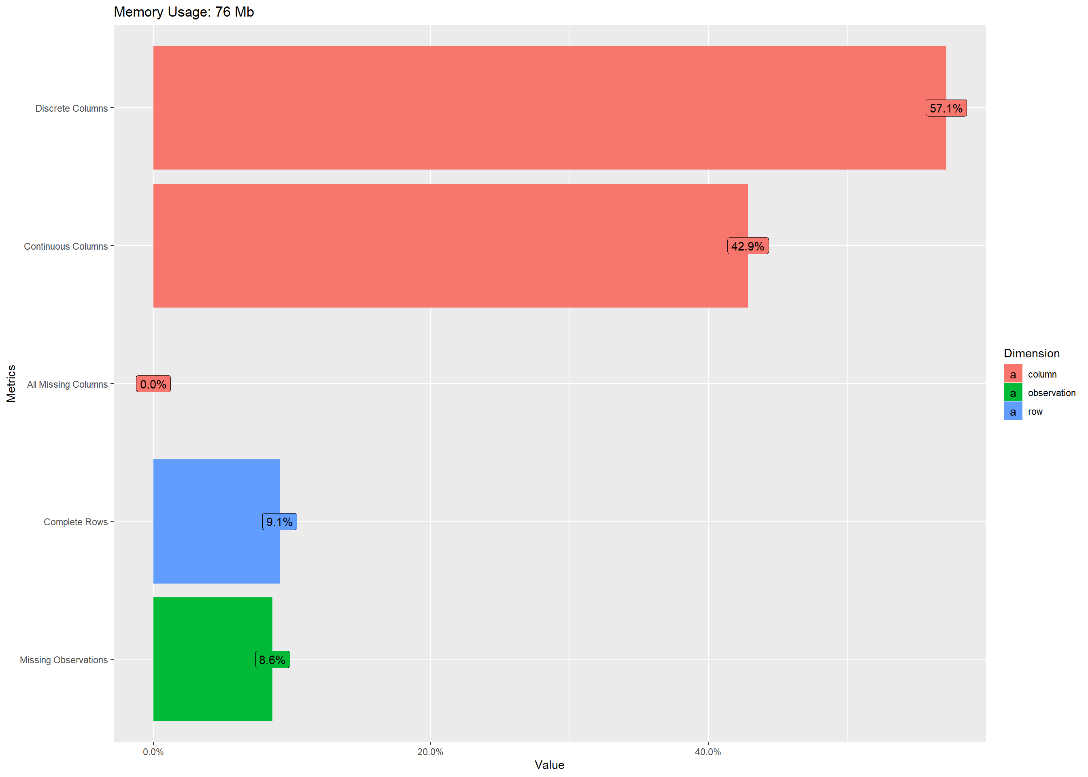

### Data Structure

### 

### Missing Data Profile

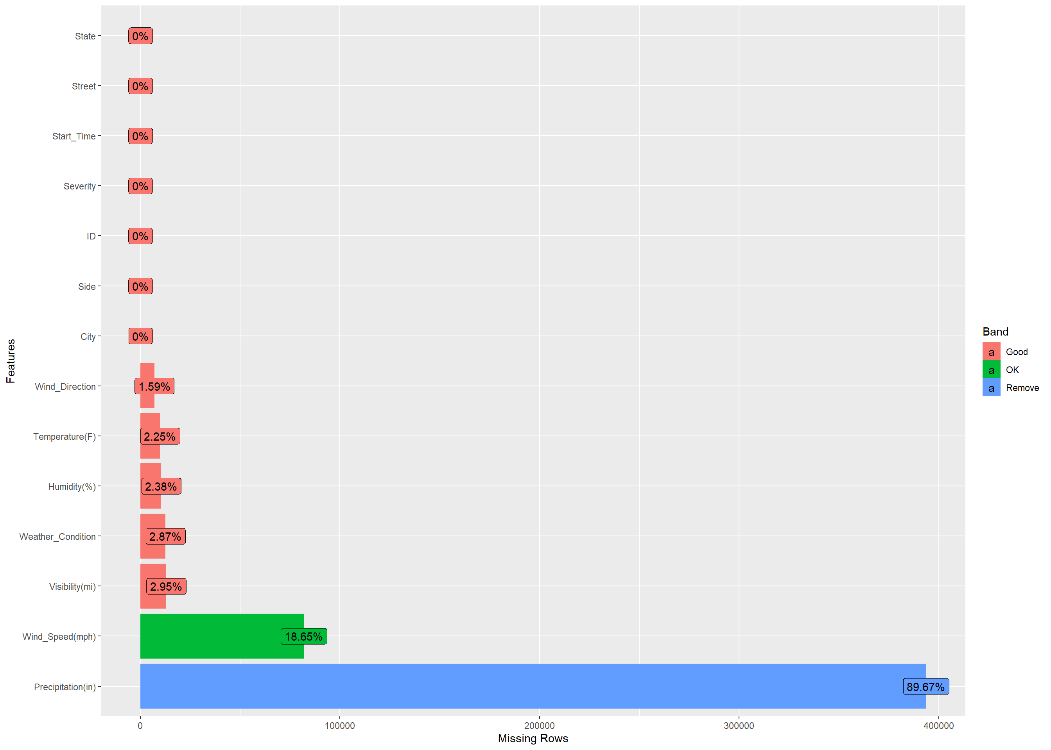

### Univariate Distribution

#### Histogram

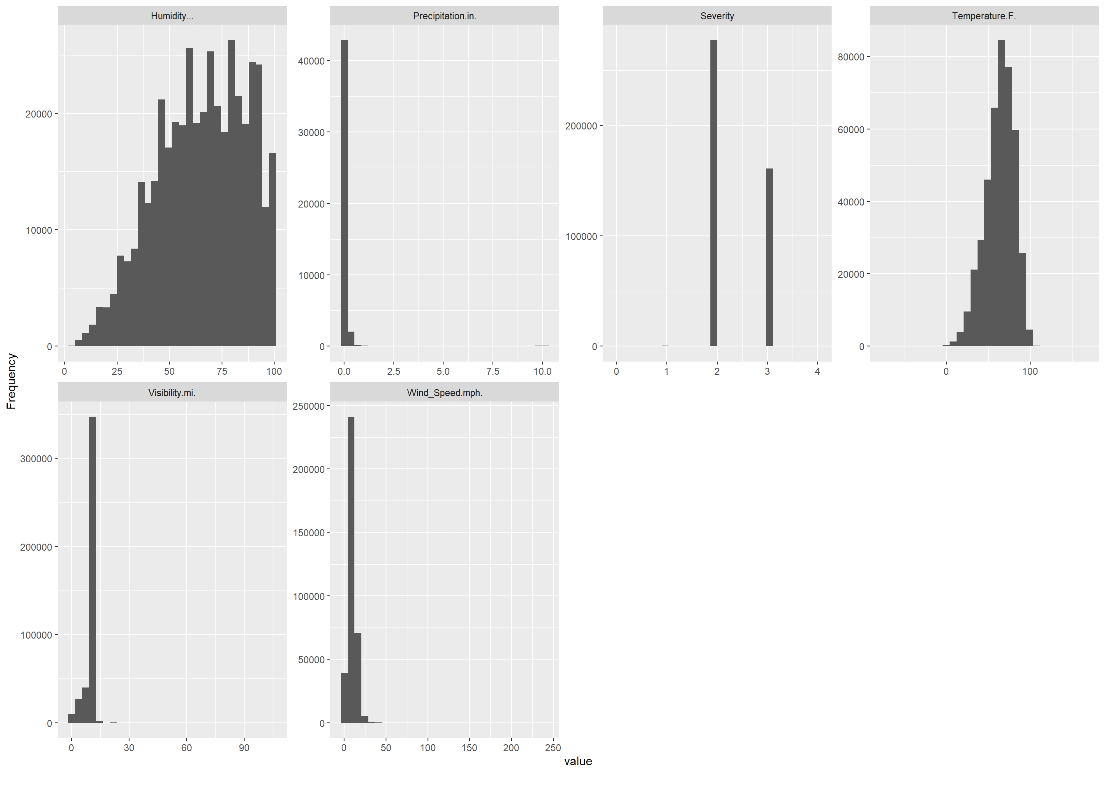

#### Bar Chart (by frequency)

## 5 columns ignored with more than 50 categories.

## ID: 439005 categories

## Start_Time: 244498 categories

## Street: 42824 categories

## City: 4389 categories

## Weather_Condition: 51 categories

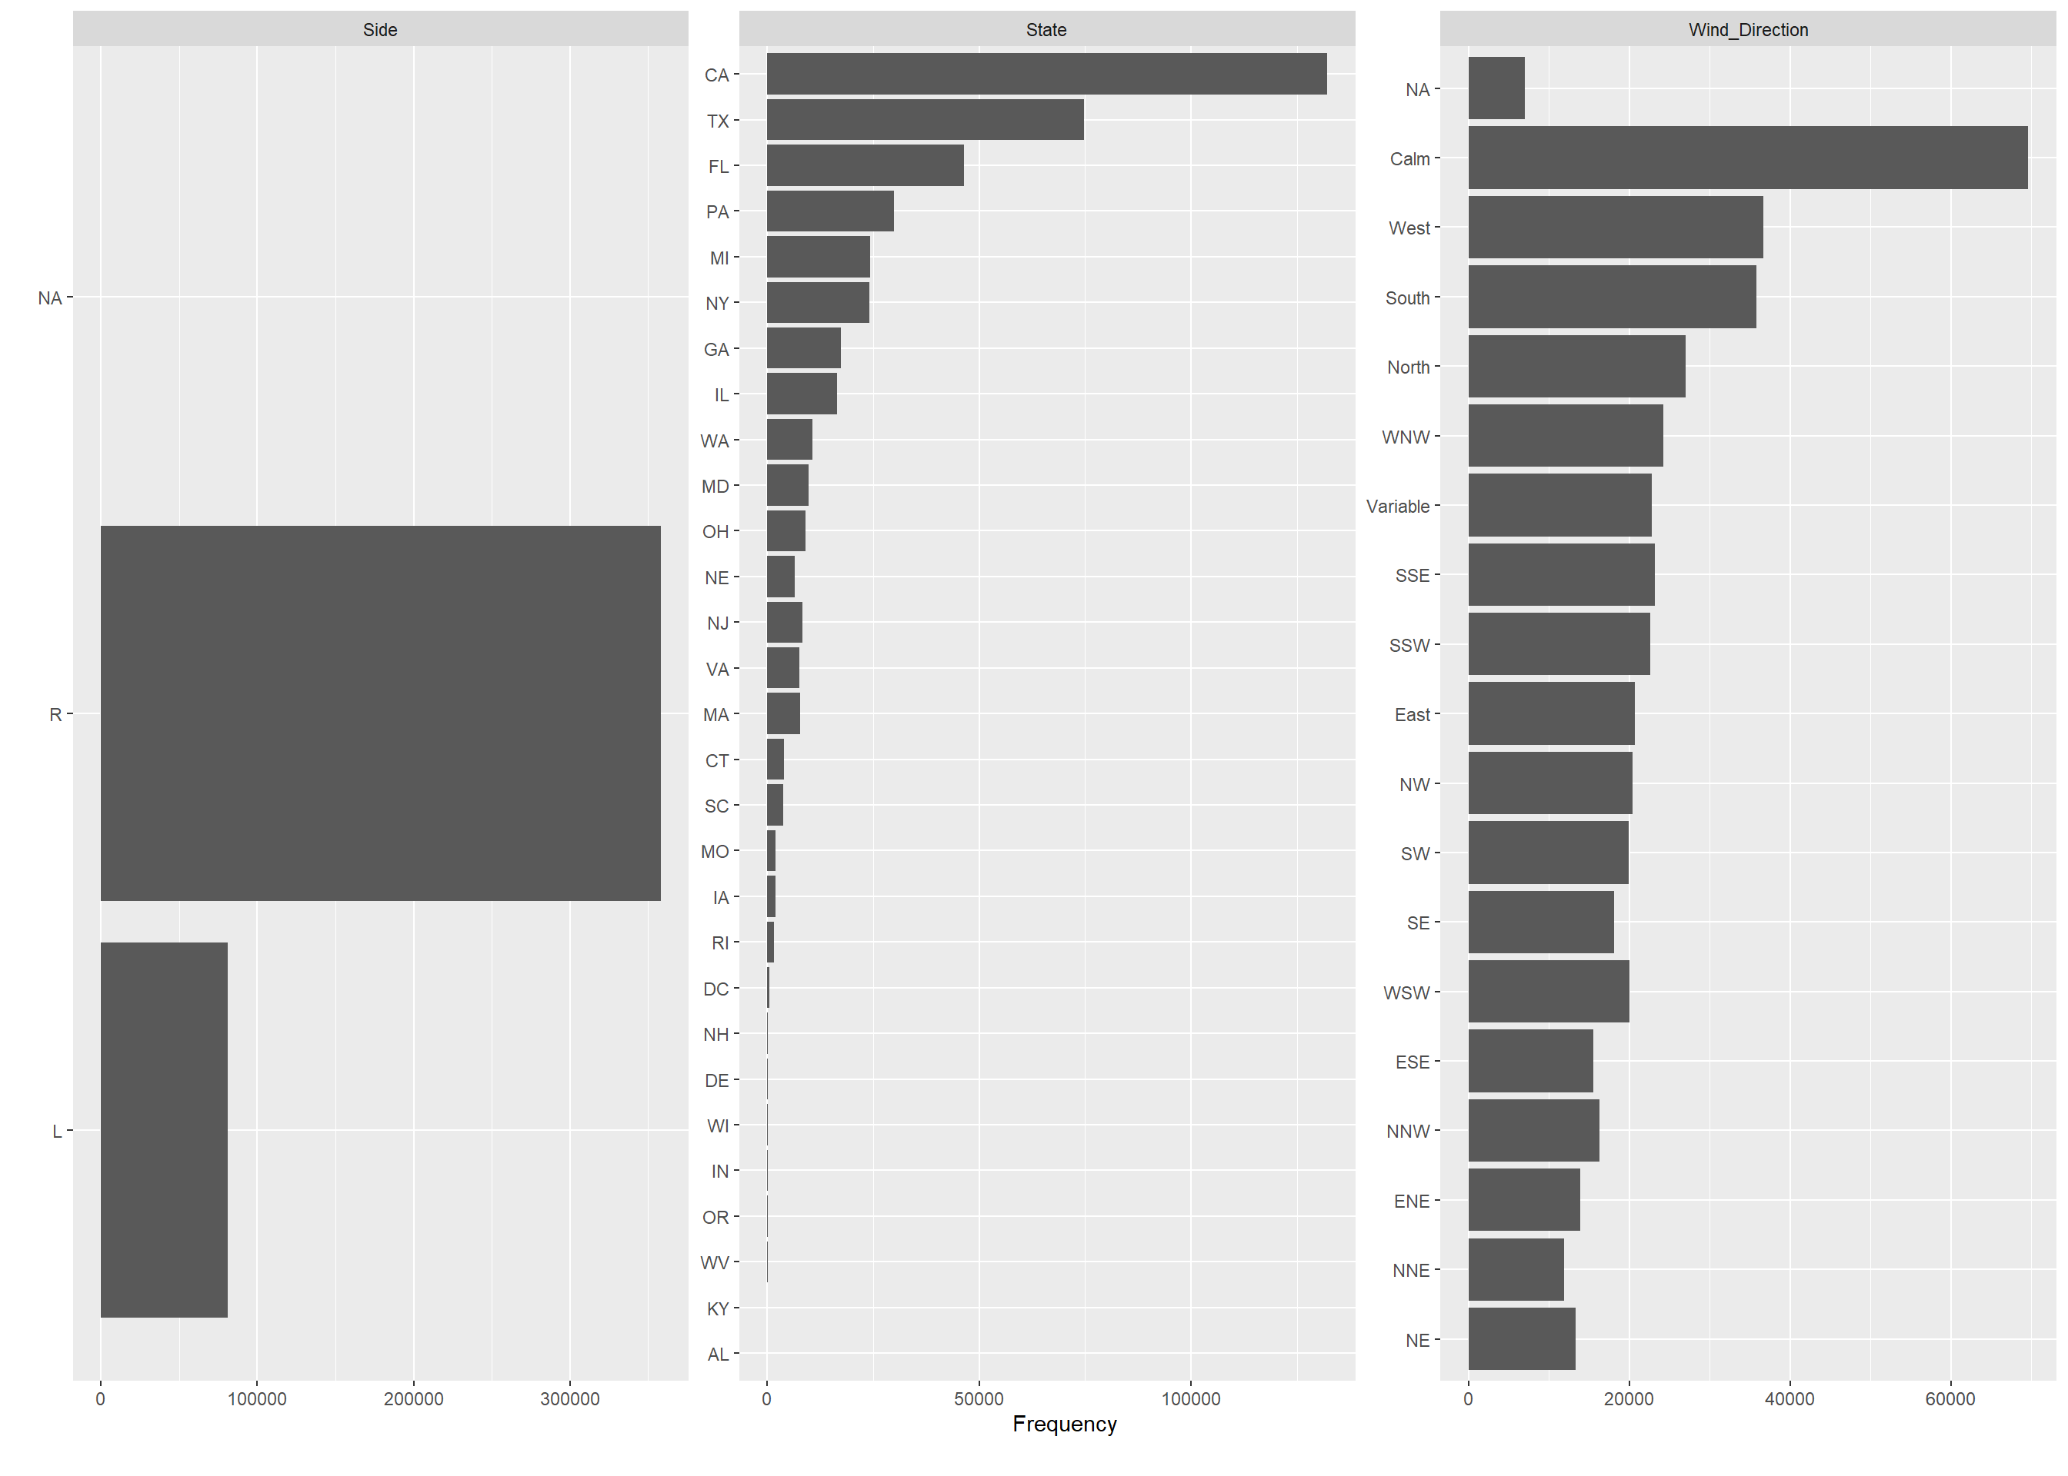

#### QQ Plot

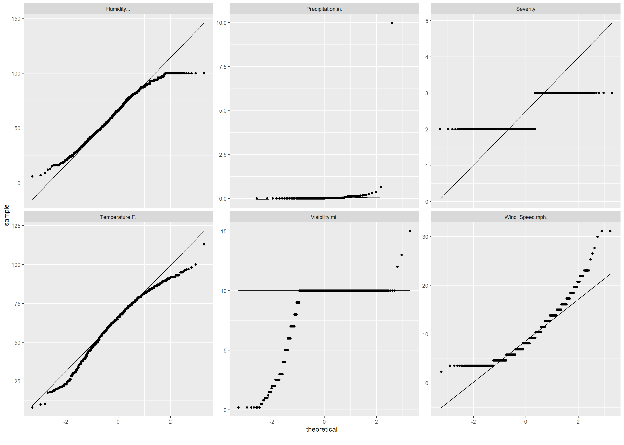

### Correlation Analysis

## 6 features with more than 20 categories ignored!

## ID: 39956 categories

## Start_Time: 35266 categories

## Street: 10572 categories

## City: 2227 categories

## State: 27 categories

## Weather_Condition: 37 categories

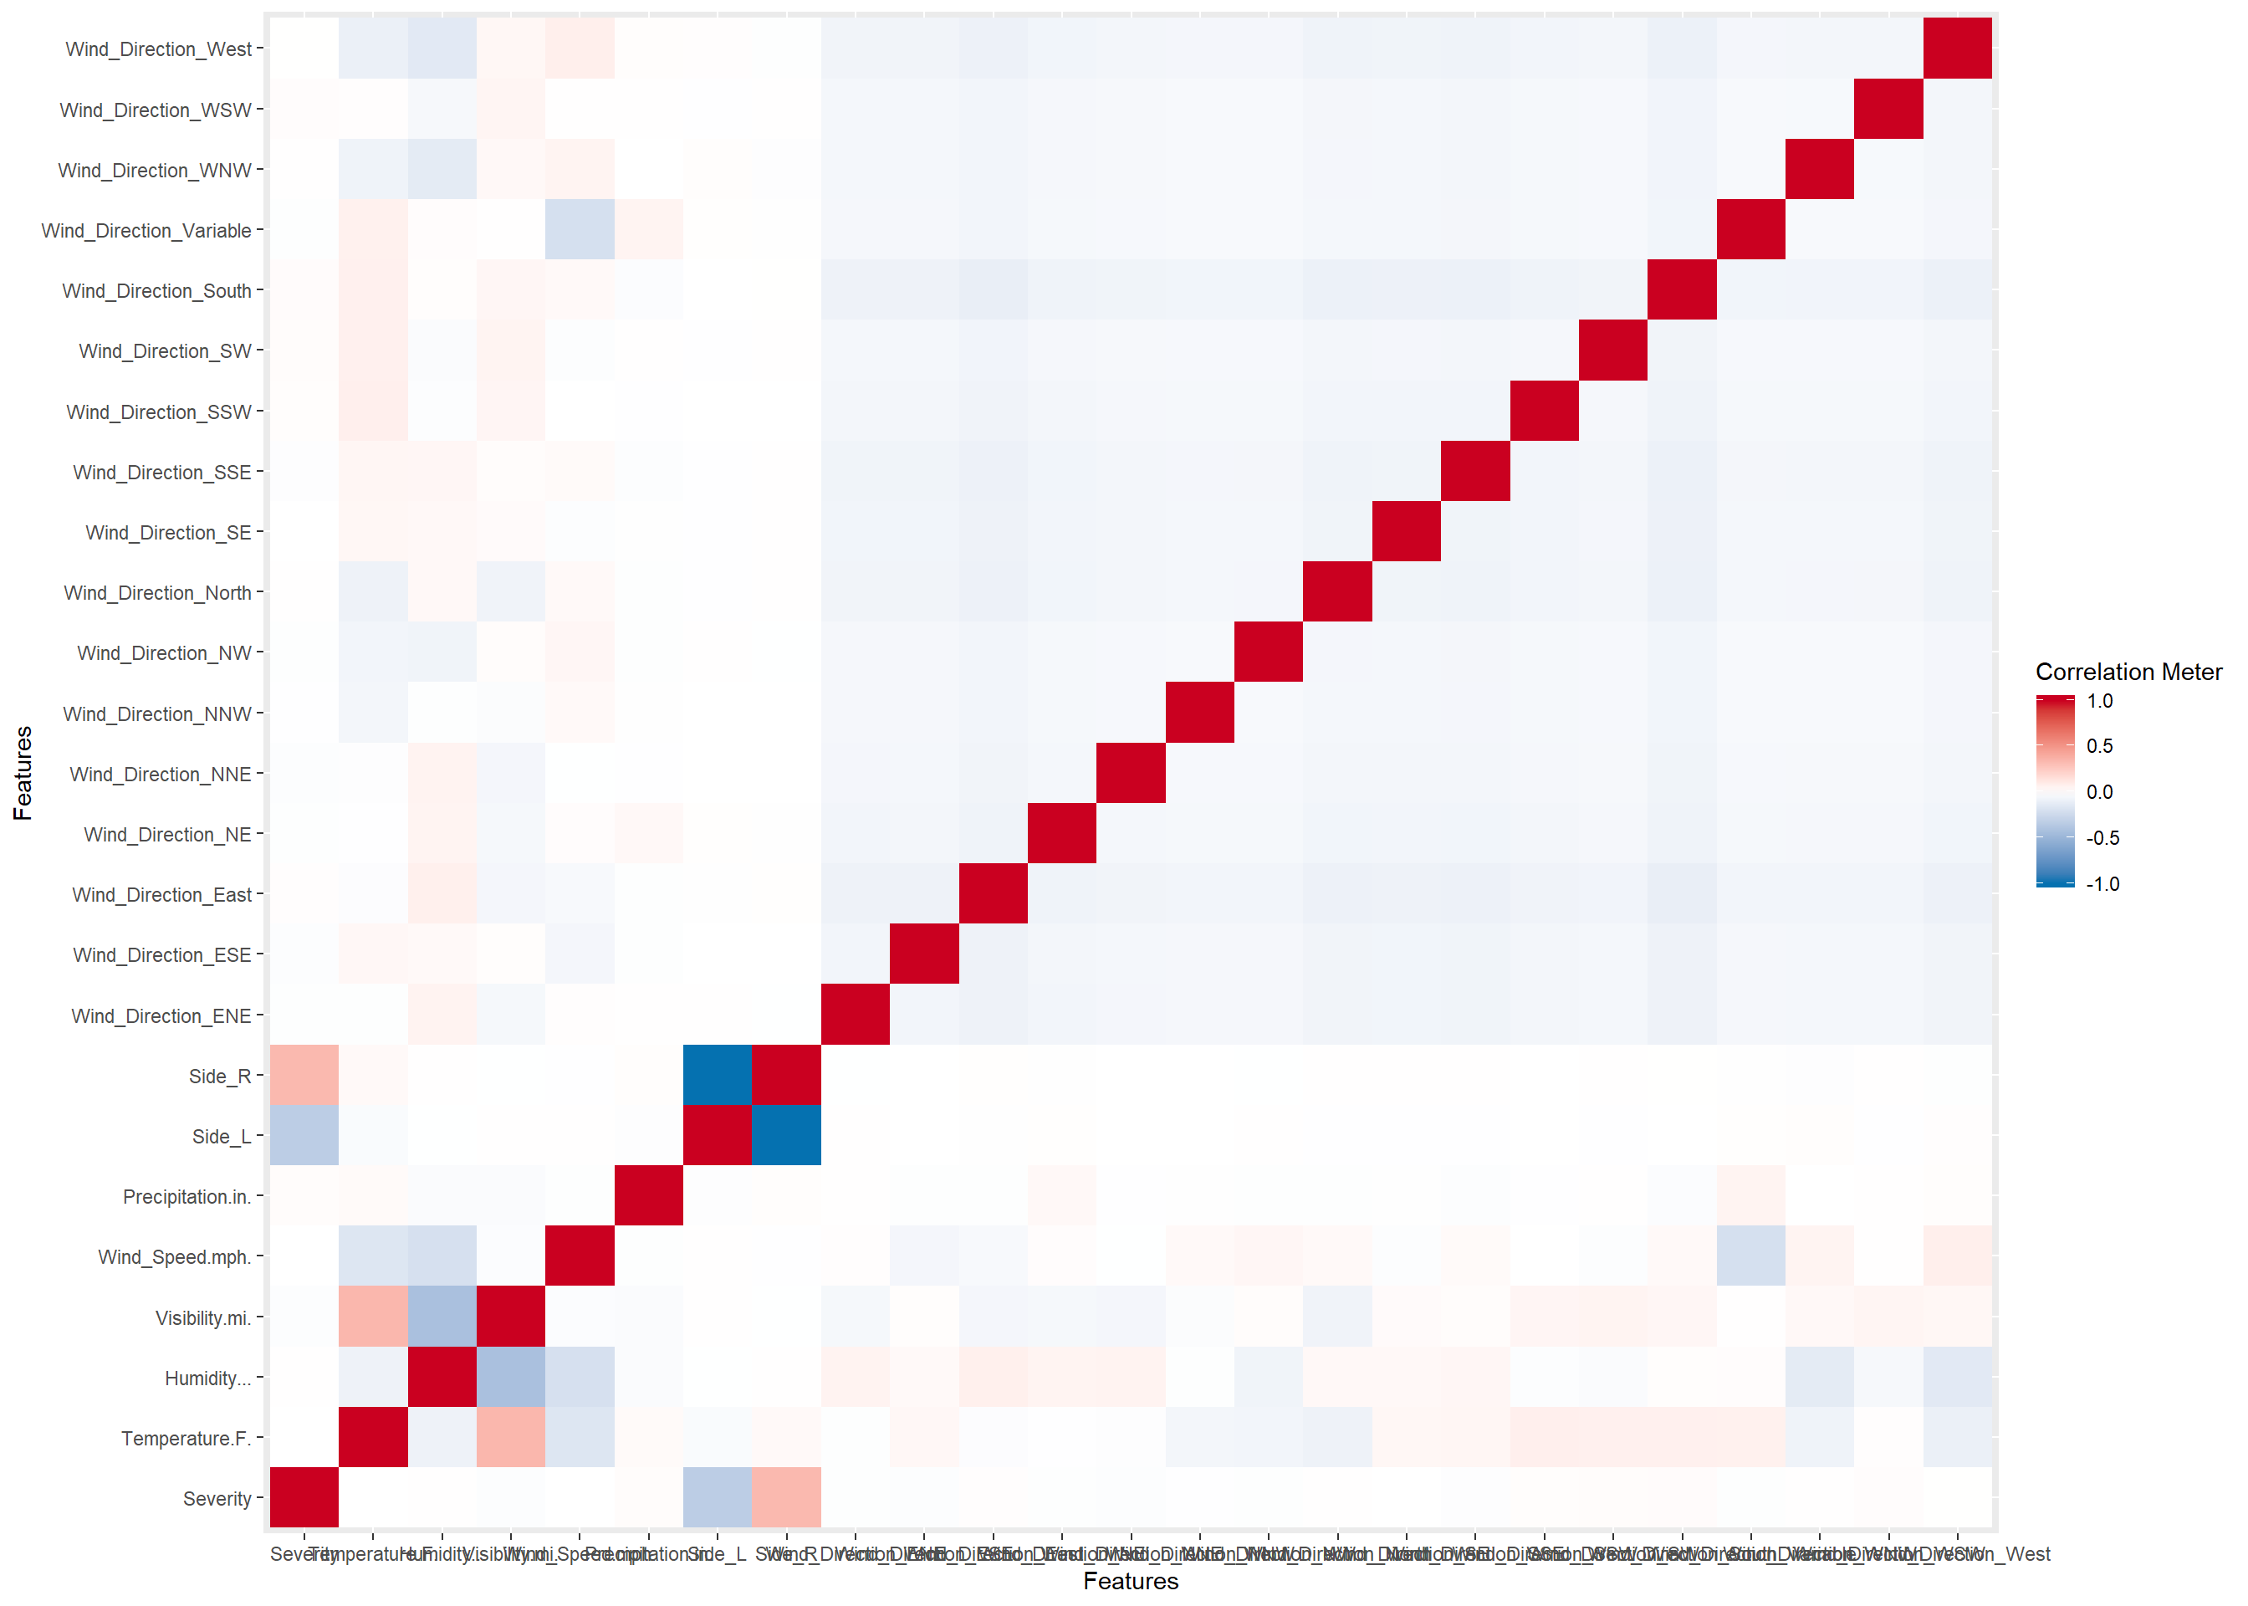

### Principal Component Analysis

## 4 features with more than 50 categories ignored!

## ID: 39956 categories

## Start_Time: 35266 categories

## Street: 10572 categories

## City: 2227 categories

