BIG BATHGATE SURVEY REPORT

2018
BATHGATE COMMUNITY COUNCIL
Email: bathgatecc@gmail.com
Website: www.bathgatecc.com

TABLE OF CONTENTS

INTRODUCTION PAGE 3
WHY
HOW
WHEN
WHAT
RESULTS PAGE 5
QUESTION ONE PAGE 5
QUESTION TWO PAGE 6
QUESTION THREE PAGE 7
QUESTION FOUR PAGE 8
QUESTION FIVE PAGE 9
QUESTION SIX PAGE 12
QUESTION SEVEN PAGE 13
QUESTION EIGHT PAGE 14
QUESTION NINE PAGE 15
QUESTION TEN PAGE 15
SUMMARY PAGE 16
ACTION PLAN PAGE 16

INTRODUCTION

WHY
WHY did the Community Council undertake The BIG BATHGATE SURVEY is the first question we should answer. The Community Council felt that we needed to get some guidance from our community on what was important and what were their priorities. The Council tackles issues and problems that are brought to its attention, but they felt they had to plan ahead and consult with the community about our town to learn the issues important to them. This would allow the council to come up with an action plan which would guide our endeavours’ over the next few years.

HOW
HOW did we do it.? As an organisation with limited resources, we looked around for low cost/no cost solutions. We discovered Survey Monkey which allows you to create an online survey for free with ten questions. This gives you a unique reference link which takes you straight to the survey online. We approached the local Courier nespaper with the story and they arranged a photoshoot and an article in the paper to generate publicity. We wrote to local organisations asking them to tell their members about it and printed off hard copies and distributed them at the Partnership Centre. We also set up a Facebook page and a Twitter account for more publicity. Then we discovered there is no such thing as a free lunch. Survey Monkey is great but if get more than 100 responses and want to get them analyzed and print it off you must move to the next level. The next level is a signed up subscription that costs you about £350 a year. Facebook and Twitter are good tools but only with the people you know, if you want to reach lots of people in Bathgate you must pay for adverts which target who you decide might be interested i.e. people who live in Bathgate, West Lothian. Turns out there is another Bathgate in North Dakota and a Bathgate Avenue in the Bronx just as well we checked. We also advertised in the Highland Games programme last year with a sample of the survey questions.
So we asked the West Lothian Council for help from their Community Council Special Project Fund. We explained what we were doing and what we needed, and they thought about it but eventually agreed to help with a grant of £600.

WHEN
We started last year and every now and again we sent out more letters and more Facebook posts and more Twitter posts and the numbers kept creeping up every time we did it. We decided to let it run over the year end with a view to publishing in Spring. It seems a lot of you were fed up trapped in the house when the Beast from the East was in town as the numbers jumped up. When we checked at the beginning of March to our delight we were over the 700 mark and decided that was enough to give us a good picture of what Bathgate thought about the town.
So, what did Bathgate think about Bathgate? The results are very interesting.
One thing is very clear …people really like Bathgate but do want change and have concerns about the future.

WHAT
WHAT are we going to do with the results? Well we decided to produce this report and after the Community Council has had a good discussion and possibly made some draft plans we will send the results and this report to the Courier, everybody that gave us their email address, Bathgate Community Groups and Facebook and Twitter and West Lothian Council. Everybody will be free to send us their comments and we will finalise our plans and publish them for all to see.
CHAIR of COMMUNITY COUNCIL
RONALD MCLEOD

RESULTS

QUESTION ONE
As a Bathgate Resident/Worker how do you rate living/working in Bathgate ... use this star rating 1-5 with 5 being excellent and 1 being poor

So Above Average and Excellent together makes almost 50%
When added together with Average is makes 89%
3% think Bathgate is Poor
When Poor and Below average are combined it makes 11%

So, it looks like a big positive majority for 3 to 5 stars which looks like Bathgate is seen as a good place to live/work but could be improved.
QUESTION TWO

What is the best aspect of Bathgate for you?
- Transport Links 53.16%
- Shopping Facilities 8.37%
- Community Facilities 13.07%
- Sporting Facilities 19.53%
- Friends and Family 55.95%
- Community Groups 11.16%
- Schools 25.40%
- Entertainment 8.66%
- Eating Out 15.27%

So, two big winners on this question Family and Friends top the poll but only just from Transport Links.
Schools came a strong third which will be good news to Bathgate teachers especially when you consider that not everyone has children at school.
Entertainment and Shopping were very low scores so lots to improve on there. Sporting Facilities made a reasonable show with Community Facilities and Community Groups tacking along behind. So, we like living with our family and friends around us and appreciate we can get anywhere we want fast and effective.

The comments field on this question 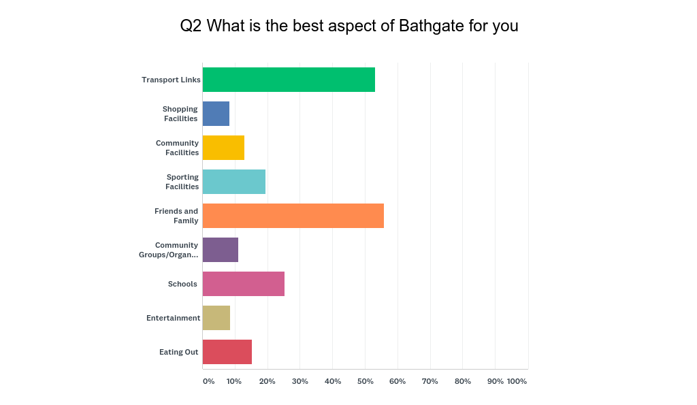
QUESTION THREE

What in your opinion make Bathgate a better place to live

556 responses to this question despite it being framed a bit incorrectly. It should have read “what in your opinion would make Bathgate a better place to live. The good news is most people got it and made suggestions on improving our town. A word analysis throws up a very definite subject: Shops
Just over 30% of the words and phrases in the responses to this question mentioned shops. The next most frequently mentioned word was Community with almost 10% of the mentions in responses. After that the common words or phrases were Bathgate – Facilities – Friendly – Transport – Town Centre – Train - Edinburgh & Bathgate with scores ranging from 7 to 4.5 %.

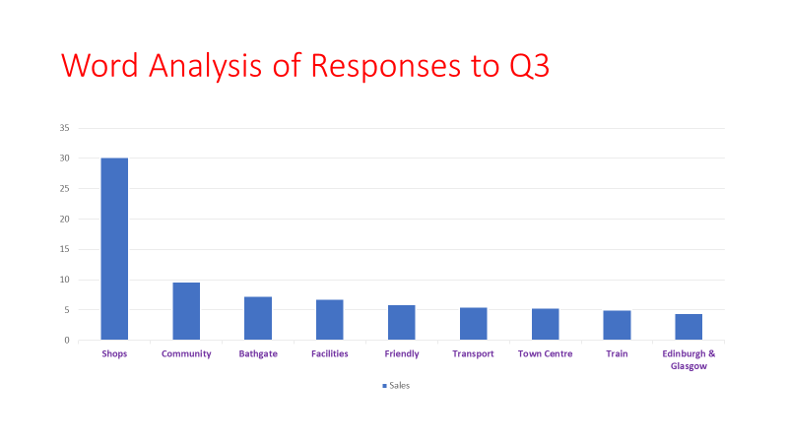

The full actual responses are listed in detail in Appendix 3 and they make very interesting reading. There are lots of very positive comments and suggestions about Bathgate which should form the basis of our action plan and guide our actions.

QUESTION FOUR

What in your opinion is the biggest problem that Bathgate has?
Again, a huge response in terms of comments with over 600 people spelling out their views on Bathgate. Overwhelmingly there is great dissatisfaction with the Town Centre,
- from the type of shops i.e. too many charity, nail bars, beauty, hairdressers, fast food type of shops contributing to a poor impression and lack of choice.
- To the appearance and design of the George Street precinct
- To traffic congestion
- and lack of parking and parking control.
- the lack of restaurants.

There is a noticeable level of concern over crime, drug taking and anti-social behavior too. It raised concern about the low level of police resources.,
Lack of facilities for young people is raised as a concern and Wester Inch is seen as lacking in facilities for that community.
This conclusion is illustrated this time with a “Word Cloud” derived from the responses i.e. the more the words are mentioned in the comments the bigger the word appears in the word cloud. It is a method of analyzing the comments quickly by looking for reoccurring words or phrases.
All the response are printed out in the Appendix Document to this report and again make interesting reading giving a real flavour to the views of our community.

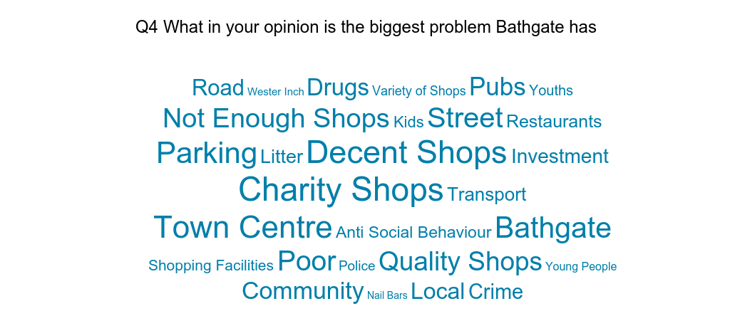

QUESTION FIVE

DO YOU
In this Question we wanted to know a bit about the people that completed the survey and their day to day links with the town and their personal circumstances. Over 700 people responded to the question and we got very interesting information back

DO YOU (tick as many as apply)
Answer Choices | Responses
Volunteer with a local organisation that helps people | 18.39% | 130
Belong to a local sports club or sporting organisation | 30.98% | 219
Work in Bathgate | 24.33% | 172
Commute to another town/city for work | 54.03% | 382
Have Children at a local school | 39.89% | 282
Enjoy Retirement | 10.75% | 76
Not Work (but not retired) | 5.23% | 37
Socialise in Bathgate | 58.56% | 414
Belong to a Club/Choir/Committee/Forum | 12.02% | 85
Study in Bathgate | 1.13% | 8
Use the Bathgate Partnership Centre | 35.50% | 251
Want to volunteer for worthwhile cause | 6.08% | 43
 | Answered | 707
 | Skipped | 4

As you can see from the big response items almost 60% of respondents socialize in the town while at the same time almost 55% of respondents commute to another town/city for work. So, we are a bit of a commuter town, but people socialize locally. Almost 40% have children at a local school demonstrating we are a town with a balanced demographic and a young population to educate and entertain. Perhaps explaining the high usage of our Partnership Centre which is a very popular public facility. Another encouraging result is that over 30% belong to a sporting organisation or sporting club, so a good interest in exercise and competition.
Interesting to note that about a quarter (25%) work in Bathgate which is heathy i.e. local work little commute but may explain the full car parks other than the train station. About 10% of our respondents enjoying retirement with only 5 % not working but not retired. Encouraging to note that over 18% volunteer with an organisation that helps people but that a further 6% would like too. We must make that connection if we can.
Only 12% belong to a club /choir/committee/forum but if you combine it with sporting organisations that’s over 42% being part of some kind of community organisation. They are often the heartbeat of a community.

QUESTION SIX

WERE YOU

born and raised in Bathgate | 38.58%
born in another town/city/village in West Lothian | 29.34 %
born and raised elsewhere in the UK | 29.19 %
born and raised in another country | 2.89 %

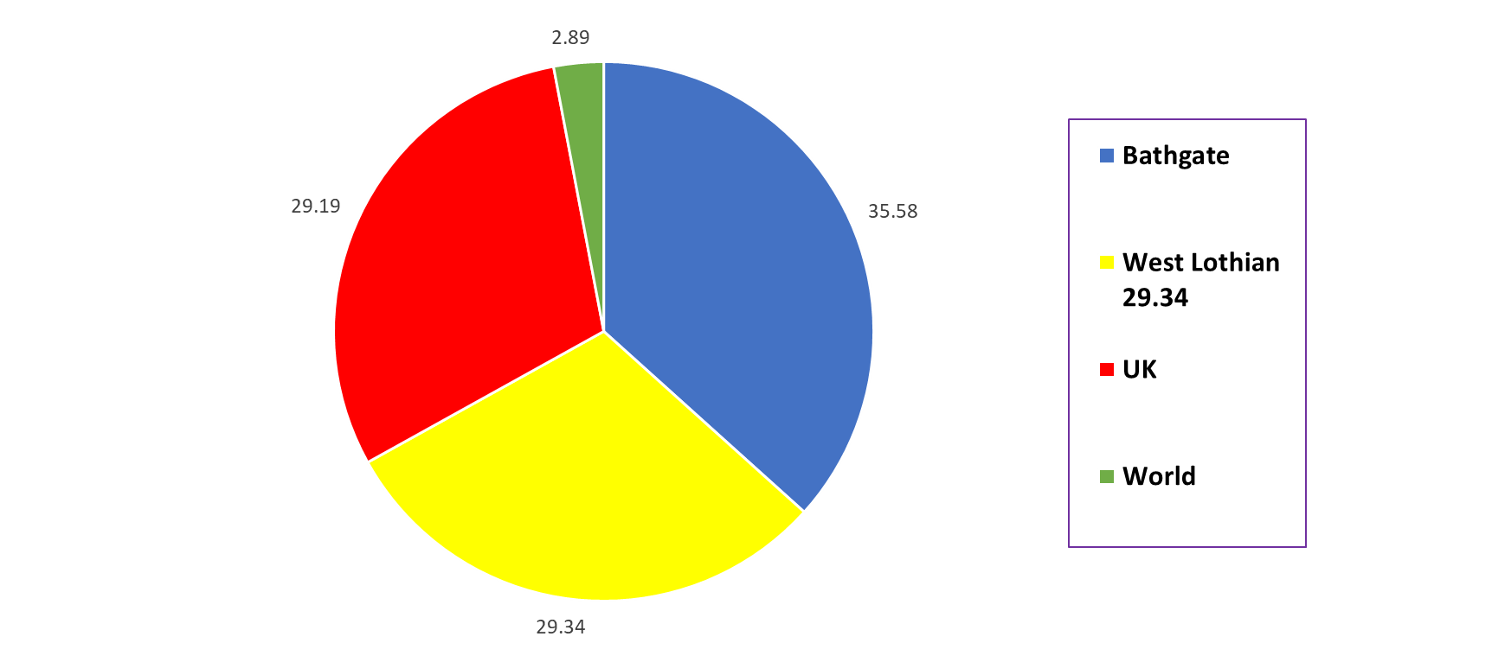
We wanted to know more about the make-up of the people responding and give us an insight into the make-up of the town. With all the development in the town over the last decade how had that effected Bathgate.
It turns out the “Bathgate Bairns” are still very much in the majority and combined with those from other parts of West Lothian make up almost 68% of the population.
A surprising 29% from other parts of the UK demonstrate Bathgate’s attractiveness as a place to move to and set up home.
Under 3% of people from other parts of the world seems to correspond with Scottish levels of immigration.

QUESTION SEVEN

In WHAT AGE RANGE ARE YOU

Under 18 | 0.42%
18 to 30 | 9.44 %
31 to 45 | 42.96 %
46 to 60 | 35.07 %
60 and above | 12.11 %

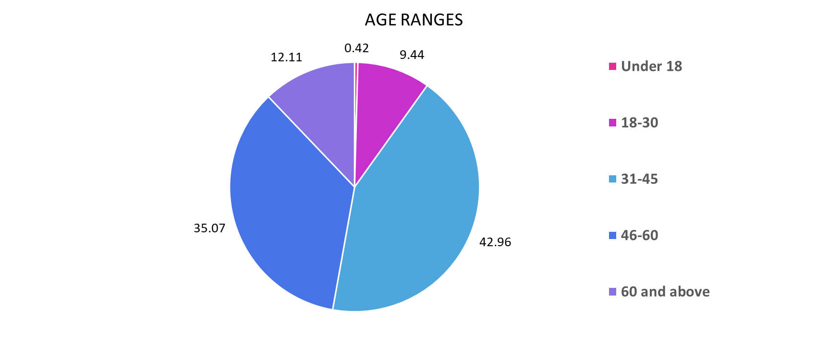
The vast bulk of respondents were between 31 and 60 so presumably settled in and committed to Bathgate in terms of living working and making it their home. We need to compare the stats with the actual demographic stats for Bathgate and will ask West Lothian Council to help with that.
QUESTION EIGHT

WHAT IS YOUR BIGGEST CONCERN at the moment
The response to this question was wide and varied and very interesting and will require a great deal of analysis.
However, a pattern emerges as you read through it. A common word analysis reveals a great deal of concern for Bathgate itself and the shopping Centre in particular. The top mentioned words are - Bathgate, Shops, and Town as you can see on the graph below. It also highlights concerns over council cuts, crime and quality schools, parking and roads. The good thing is that there is a great deal of a desire for the town to improve and a health interest in finding solutions.
All responses are listed in the Appendix of Responses document. They are well worth reading and we are grateful to the citizens of Bathgate for providing us with such a rich seam of comment and ideas,

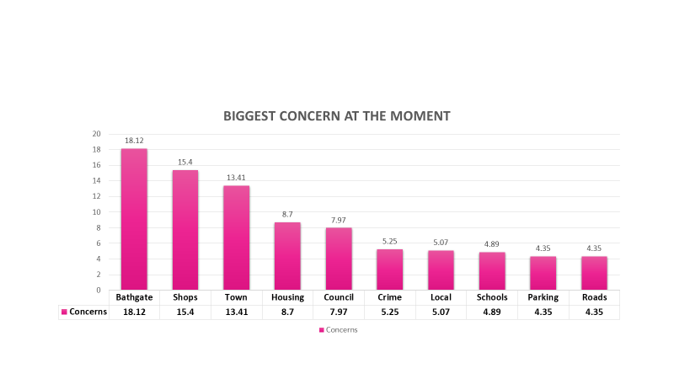
QUESTION NINE

DO YOU WANT A COPY OF SURVEY RESULTS BY EMAIL?

Two hundred and seventy people said yes to this and we will arrange to send them out asap.

QUESTION TEN

WHAT IS YOUR FAVOURITE MOVIE OF ALL TIME

The winner is “Dirty Dancing” closely followed by Shawshank Redemption, then Star Wars and then Grease. The question was asked to bring a serious survey to a light-hearted end and over 500 people responded.
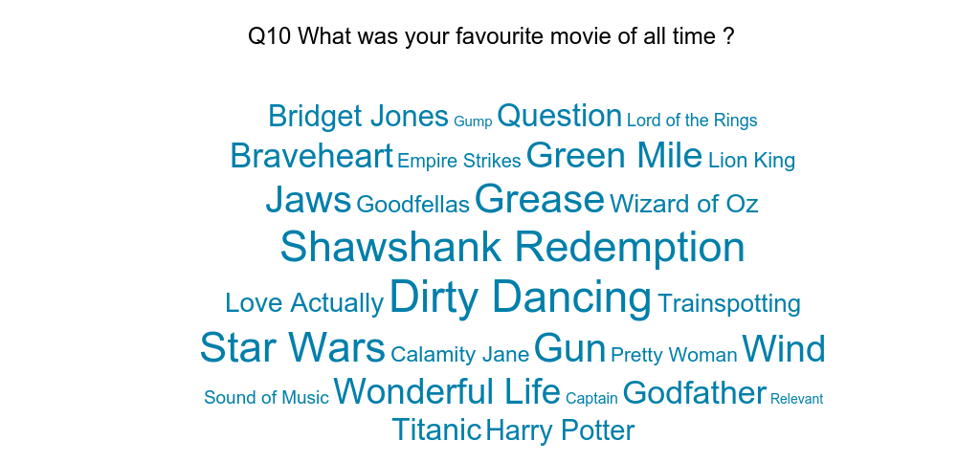

Summary

The first thing to record is our thanks to the hundreds of residents that responded to the survey. The response was far bigger than we expected, and it has given us and the community a real insight into the community’s view on our town. This will be used to plan the Community Councils priorities and guide its activities over the next few years.
There is a high degree of commitment to Bathgate coming from all groups whether it be Bathgate bairns or people that have chosen to live here make a home, work and raise their children. The Centre of the town and the shops raised the most comment in the biggest problems and current concerns questions so that must be a major focus, but crime, parking, roads and schools are all going to feature. The first priority is to read and discuss the outcomes and seek consensus on action.

ACTION PLAN

This must be discussed and agreed and when agreed it will be added to this report for historical perspective. The Community Council will start at its next meeting.

Addendum
The Community Council Accepted the report and agreed to lead a consultation on the results calling a summit of Bathgate Civic Organisations

A Bathgate Summit Meeting was held in May and the note of that meeting has been added to this report:

Bathgate Summit Meeting on the results of the Bathgate Big Survey
Held in the Bathgate Partnership Centre – 8th May 2018 at 6 pm
MEETING NOTES
Background
All Bathgate organisations with an interest in the development of the town were invited to attend a summit meeting as the first step in turning the results of the survey into a concrete strategy.
This meeting was organised to see what might be inferred from the results of the recent survey carried out as part of a wider initiative by the Community Council to solicit from interested members of the community what they most like/dislike about Bathgate and from the responses see what MIGHT be done by both the Community Council and other relevant bodies to turn the town around from its current standing in the Scottish Government’s League Table of urban deprivation where Bathgate ranks in the bottom 20% Unfortunately in spite of the fact that over 700 people completed the survey only nine attended last night’s meeting – over half of whom came for the Community Council. In addition to those members, the police were represented as well as one of the Council’s planning officers, Andrew Cotton, and Cllr. John McGinty. In addition apologies were received from Nairn Paterson and Willie Boyle.
Survey Results
The meeting considered several features raised in the survey including:
a) The lack of ‘decent’ shops in the town; b) The problems with parking and traffic management in general; c) Possible pressure on the town’s schools as it enjoys a rise in the number of new houses being built; d) Lack of facilities for young people; e) The look / feel of the precinct and the Steelyard f) Concern with drug taking and some anti-social behaviour
Discussion
After much lively discussion several points came to the fore as possible ways forward:

a) Exploit more efficiently the town’s history / heritage ; b) Promote the town as a service centre for this part of the county – after all, Bathgate is now the only town in the county – aside from Livingston – which has both branches of the Bank of Scotland and RBS in addition to a range of ancillary services such as lawyers, estate agents as well as a range of other services from dentists to opticians ; from chiropodists to chiropractors! ; the growing restaurant presence and
the recent rescue of the Regal was encouraging in term of refreshing the town’s night time economy. c) Investigate the possibility of establishing some sort of foot path to take folk from the town centre up to the Bathgate Hills in a bid to encourage more hill walkers to visit the town and spend some of their cash (!) ; d) Look at the town’s current art / music scene to see if more could be done with that ; e) Encourage greater co-operation between all the bodies which have an interest in the town’s economic and social development – get rid of the ‘silo mentality’ ; f) Look at the issue of traffic management in the town in the light of the Council’s decision to withdraw funding for several Community Police Officers; g) Re-establish the town’s market or else introducing more seasonal markets in the precinct h) Exploit of excellent communication links i) Finally establish the height of the Knock Hill … ☺

Summing up
As such this is only the briefest summary of what turned out to be a most valuable, informed and engaged meeting which would have not been possible had it not been for the ‘Big Bathgate Survey – ‘from little acorns … ☺

BATHGATE COMMUNITY COUNCIL

