Bathgate Community Council

Community Garden Project 2019

Proposal
That we embark on a new project of establishing a Community Garden in Bathgate utilising the site of the old Community Centre in Marjoribanks Street.
Background

Community Gardening : How it all began
UK residents have relied on community gardens as an important source of food for hundreds of years. During the Second World War, for example, community allotments were set up on inner-city sites to provide affordable fresh fruit and vegetables to the local area.
The contemporary community gardening movement began in the late 1960s with a renewed interest in green spaces in cities. Many community gardens were created when residents transformed vacant sites into green spaces that included vegetable plots and flower gardens. As these spaces evolved, they were used to address social and health problems.

Community gardens today
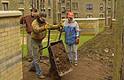The gardens come in all shapes and sizes, according to Caroline Fernandez, the Local Food Project Coordinator of the Women's Environmental Network (WEN). "They can be tiny plots, gardens on roofs, school gardens, private or open to the public."
The scope of what community gardens can achieve also varies widely. They can provide fresh fruit and vegetables, a place for wildlife, improved play areas, an outdoor classroom and safe public spaces that are well-maintained. "What unites all of these green spaces," explains Ken Elkes of the Federation of City Farms and Community Gardens, "is the fact that they are run by a management committee formed by local people, usually working on a voluntary basis."
The Women's Environmental Network (WEN) has been bringing minority women together to form community vegetable and herb gardens as part of the Taste of a Better Future Network for the last seven years. It recognises that such groups have little access to affordable healthy food, particularly traditional fruit and vegetable varieties, or to gardens of their own. WEN's community food growing initiatives encourage women to come out of their immediate family circles by gardening with other people. "Women are able to get out of the house, grow fresh food and learn new skills", says Fernandez.
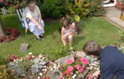Community gardens often bring different cultures and generations together, improving individual and community confidence and bridging the divide between ethnic, political and socio-economic groups. One success story is Bolney Court in Crawley, Surrey where residents turned an overgrown, littered space into a beautiful flower garden.
As part of the Let's Face It and the RHS South East in Bloom campaigns, volunteer residents were able to get the support they needed to clear up 3.7 tonnes of rubbish from the area.
One long-term resident of Bolney Court believes the garden has had a massive impact on the community. "I've lived here for ten years and I didn't really know anyone before we started the work, now we are all friends. We've created a type of village life where everyone looks out for each other." Once intimidated by gangs in the area, residents can now enjoy an attractive and secure environment.
Community gardens are thriving. Food poverty, pressures on food banks and long allotment waiting lists have led to a growing trend in community gardening. These gardens provide a great place for the community to come together, to share and learn new skills, whilst growing fresh local produce. The gardens also provide a multitude of therapeutic and wellbeing benefits.
The BBC has a link you can use to find community gardening projects in the UK
http://www.bbc.co.uk/gardening/today_in_your_garden/community_projects.shtml

The old Community Centre site in Bathgate has been unused and unloved for many years and the idea of a community garden could give it a new lease of life once more serving the community. The site is a fair size with two distinct parts, one flattened rubble and the other a wooded area. There is access to the rubble area from a gate in the Car Park behind the flats in Mid Street. It is well fenced off and secure and the access to the wooded area is from a gate in the wall that divides the two parts of the site. We believe the site is in the ownership of West Lothian Council and as such could be a community asset transfer to the Community Council under the provisions of the Community Empowerment Act.
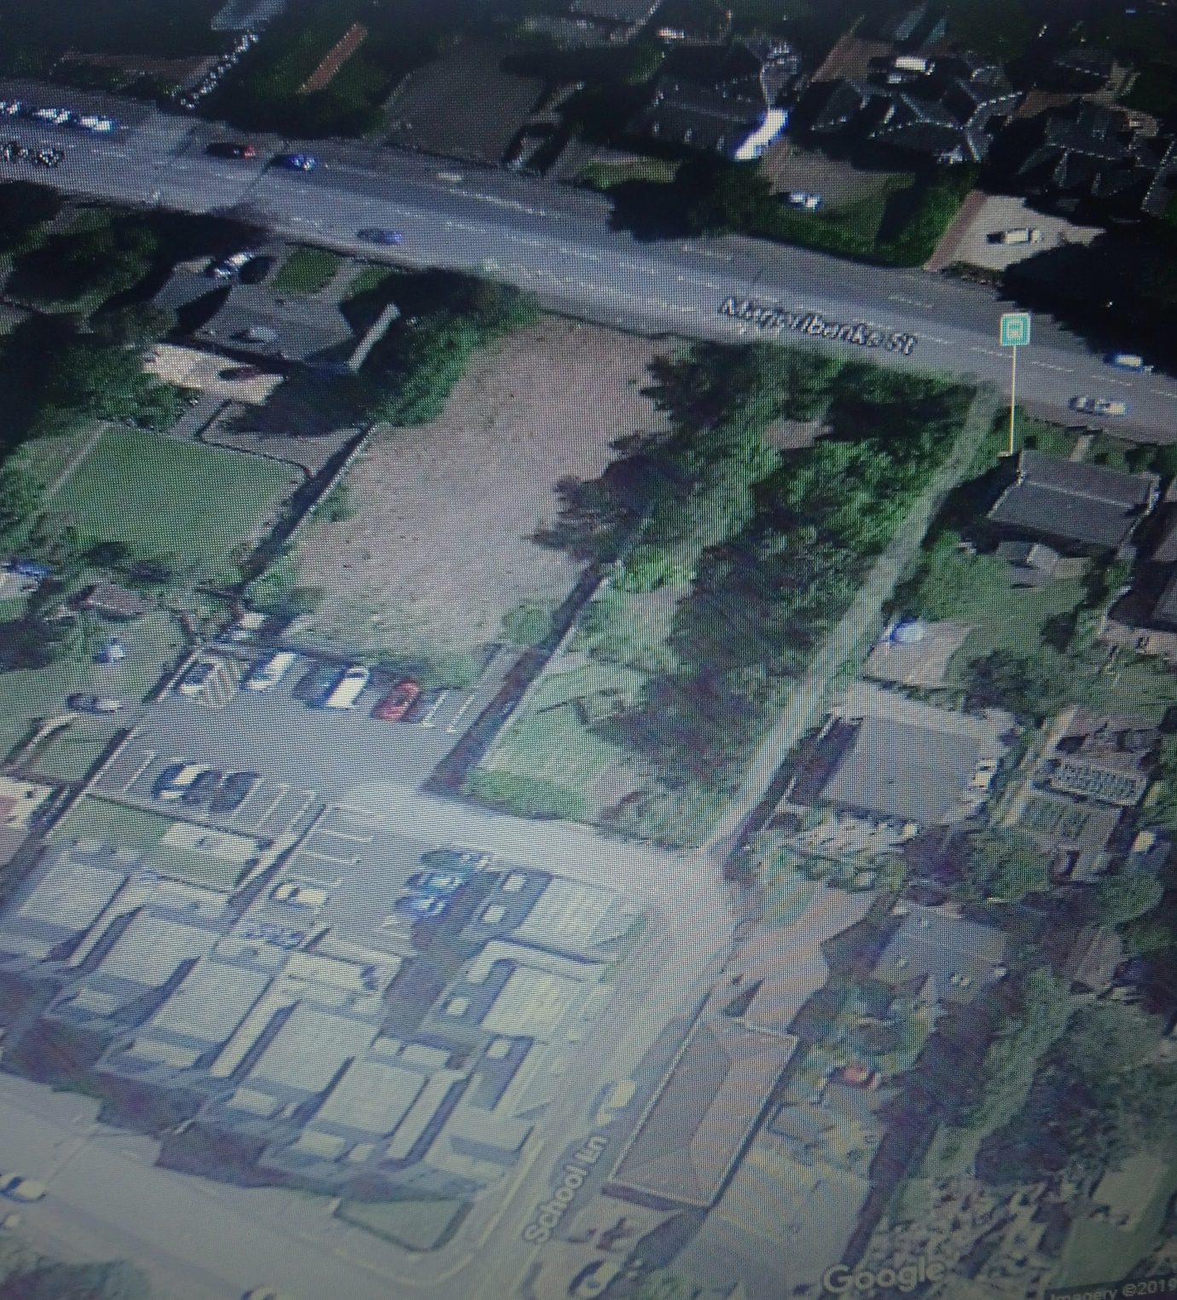

The outline draft proposal is that we create a growing garden using raised beds and good pathways to give us a quick build and a site that can be used by all members of the community including disabled elderly and children. We would also need sheds for storage and greenhouses, plus a hub for refreshments and meetings of volunteers. So, we will need a layout plan as part of our project plan.
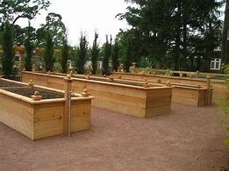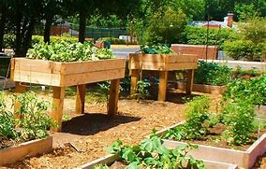

The wooded area could be tidied up with a few added fruit trees and benches and flower beds and made into a nice quiet garden area.
There is lots of help and advice available on the web and other community gardens in Scotland we can get advice from.

Recommendation

That the community council discuss the proposal and if so minded agree to proceed with it.

2nd January 2019

