Annual Report 2021-2022

BATHGATE COMMUNITY COUNCIL

October 2021 to December 2022

Common Good Land
This subject was on our radar back in October 2021 at the first meeting of the new Community council.
We started by responding to WLC request to identify land we thought might be Common Good and we asked a number of questions about the future operation of common good land.
Eventually the council reported back, and we found a lot of land in Bathgate was common good and there were ongoing investigations into a few sites but some sites we had put forward were not common good. The WL council published a Common Good management plan which gave the responsibility for deciding any questions on land to the Councils Executive Committee. We objected to that suggesting the Local Area Committee as a more appropriate decision-making forum this was rejected. We agreed to maintain our position and seek to gain support from the three other Community Councils with Common Good Land for local responsibility.

Housing Developments

We discussed the detrimental impact of uncontrolled housing development on health and care services in West Lothian after this being highlighted by a report from the Health and Care Partnership and the Joint Forum of CC’s. The Joint Forum has warned that building more houses without investment in health, power, transport, and sewage services will bring capacity issues that we scarcely need and will be very difficult to solve in the long term.
We have had a plethora of housing development applications to deal with most of them out with the designated local plan areas. Euston Farm, Sibbalds Brae, East Boghall, Napier Avenue and Wester Inch and the Abattoir Site. West Lothian Council has defended its local plan but one of them although rejected was granted on appeal to the Scottish Government. We opposed them to protect the local plan which we support.
We have also supported Dechmont Community Council oppose the proposed development at Burnhouse Farm, Dechmont, West Lothian Council refused it but the council has received intimation of an appeal to the Scottish Ministers against refusal of the planning application. Again, the land is not designated for housing and an initial intrusion into Bathgate Hills - up from Dechmont and east of the Old Bangour site.
We wrote a letter sent to Graeme Hope Chief Executive regarding our concerns re planning and the issues regarding appeals, housing land supply and the concerns regarding GP services care in the community.
Bathgate Together
We started discussing this in October 2021 and agreed that the Bathgate Community Council should welcome this initiative as it echoes our stance for some time of trying to get a better level of coordination amongst local organisations. In fact, we should lead the way by offering to host the first gathering of Bathgate organisations and groups as well as individuals to bring about this desired cooperation and coordination in our town. The organisation took place and Bathgate Together is up and running and attracting new members every month and the community council is acting as secretary
Kirkton Parish / Bathgate Old Parish Church
The very old church and graveyard came to our attention of needing some care and attention. The BCC agreed to see what we could do. Various efforts were made to seek funds so far unsuccessful. Historic Environment Scotland’s onsite investigation of the pre-Reformation Church on the Edinburgh Road took place and was registered. This is a project we must continue to look for solutions for as this is an important part of the towns history. .
Local Covid Recover Fund
The money allocated to Bathgate was discussed at the Local Area Committee and we formulated a response beforehand and our suggestions were considered at the meeting.
Queens 70 years Platinum Jubilee Celebrations 2nd-5th June 2022
A small committee was formed to draft plans to mark the Platinum Jubilee. This resulted in a booklet called Herons and Helicopter commemorating the town's links with monarchy over the past eight hundred years produced in collaboration with the Bennie Museum and West Lothian Council's Archives and Museums Officer. West Lothian Council had invited two reps from each community council to a ceremony in Linlithgow to mark the Queens 70th Jubilee Agreed to attend.
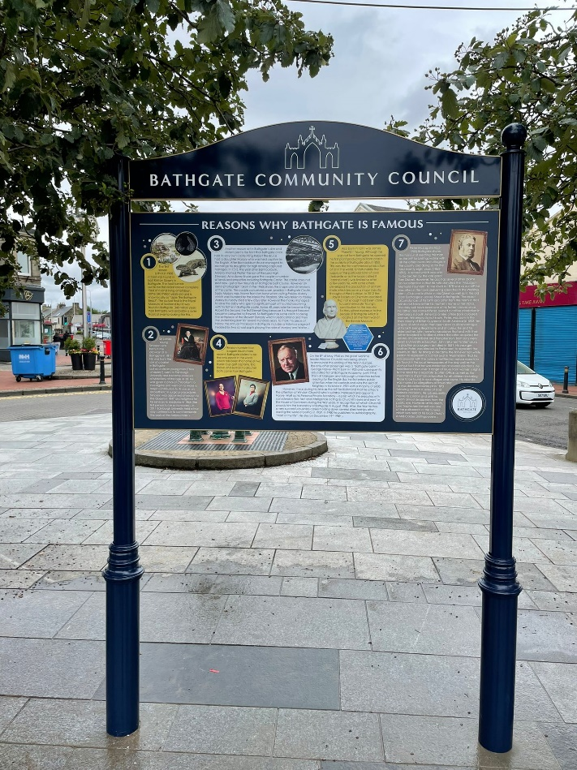
Bathgate Community Development Trust
The community council is delighted that the development trust is up and running and recently had its second AGM. The level of cooperation is very high between the two organisations.
BCC Newsletter

A discussion on the newsletter that was issued via the subscribers on the webpage took place and that has generated 66 subscribers to the newsletter. There was a question over printing of the newsletter, although the only concern was the associated costs. John MacDonald suggested doing the newsletter quarterly. We need to revisit this initiative in the year ahead to progress another channel of communication.

Town Centre Management Committee

The BCC reps reported an overview of the meeting to allocate Capital Investment Funds that will sum up to £140,000
- St David’s Square
- Replace and upgrade the festive lighting.
- 3 x Defibrillators
- Replace the Town Centre lamp banners.
- Christmas Tree real / artificial
- Bathgate Heritage Information Boards
- Refreshing the public art at the railway station.
- Floodlighting the McLagan fountain.
- Continuation of shopfront improvements
- Investigation into the disabled bays at Acredale car park.

Proposal for Reform of Town Centre Arrangements
The Town Centre Management BCC members feel the Town Centre Management Committee is no longer providing the services that are required. It is proposed we wrap up the Town Centre Management Committee and run all local businesses / traders and interested parties’ business through the Local Area Committee as a sub-committee and administered through the local councillors. The WLC has subsequently agreed to undertake a review of its town centres regime and the management structure.

Town Centre Grants

Town Centre Grant Round Two
The welcome to Bathgate signage has finally been erected as has the town centre map and history board as well as the Bennie Museum information board

Town Centre Grant Round Three.
It was drawn to the Community Councils attention that a further round of the grant was on offer and Bathgate Ward had 48k allocated for projects. A discussion was held on the possible bids and the view was that the town needed an Events Fund to encourage several events of an interesting nature to draw people into the town.
We were awarded almost 15 thousand pounds, and this was awarded to local organisations at the last meeting. We hope that this award fund will be a regular feature for the town.

Bathgate Regal Theatre
The Community Council supported the bids made by the Regal Theatre charity organisation to various funds and also agreed to support the proposed large scale upgrading of the theatre.
Bathgate Water
Several meetings were held with the Forth Rivers Trust on the subject of upgrading works to the bog burn. We were disappointed to learn that the lottery funding bid had not been successful, but it was being resubmitted. Following the recent local flooding we will be taking this up as a priority.
Community Wealth Building
The WLC launched this initiative last year along with an investment fund. Three Bathgate organisations applied for funding but were unsuccessful. We will watch for developments with interest.
Investing in Communities Fund 2023-2025

This fund is open for application last year. Community Councils are at the top of list of approved applicants, the fund is to tackle climate change, communities and
regeneration. We applied by June 2022. We put in an application for a Place Project Worker and Communication assistant for several projects,
Allotments/Community Gardens and Kirkton Park upgrade. We agreed manage the project through the Bathgate Community Development Trust.
Local Place Plans
Community Councils were encouraged to submit Local Place Plans to influence the WLC development plan. The planning regime is going through major changes so the position is unclear and there was no financial support forthcoming to assist with this major undertaking, so we have not progressed this.
Provision of Pharmacies in Bathgate

Following a consultation on a potential new pharmacy for Bathgate a good discussion took place on the issues in the service at present A discussion was reported with the manager of Lloyd's at the Bathgate medical centre. The main issues in times were previously on an average 4 day turn around on prescription preparation to a 10 to 15 day turn around. The Manager believed this was directly attributable to them being linked to 3 medical centres and the increase of population and care home residents in the area. It was noted in her opinion that there is a need for 1 and possibly 2 more pharmacies in a 2-mile radius as the backlog is not lifting and in fact, she expects it to get even worse as we enter the winter months. She also cited shortage of staff and a shortage of penicillin as contributing to the backlog, but it was mostly down to increase population in area and increase in care home residents. A subject we must return to this year.

Cran Gevrier Twinning Visit Report
The Community Council was kept fully informed about the Twinning Association activities and the council congratulated them on their recent Organisations Day.
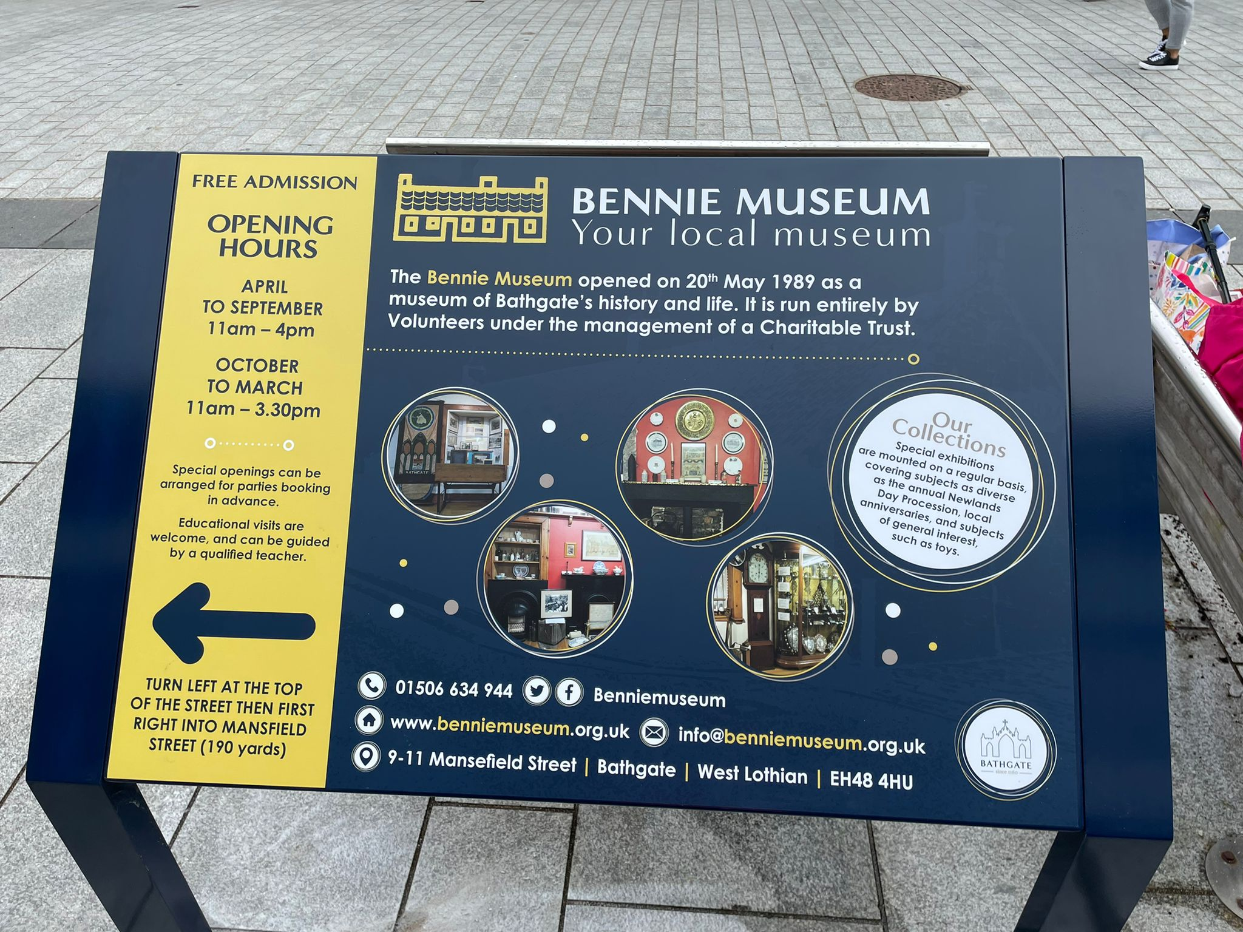
 | 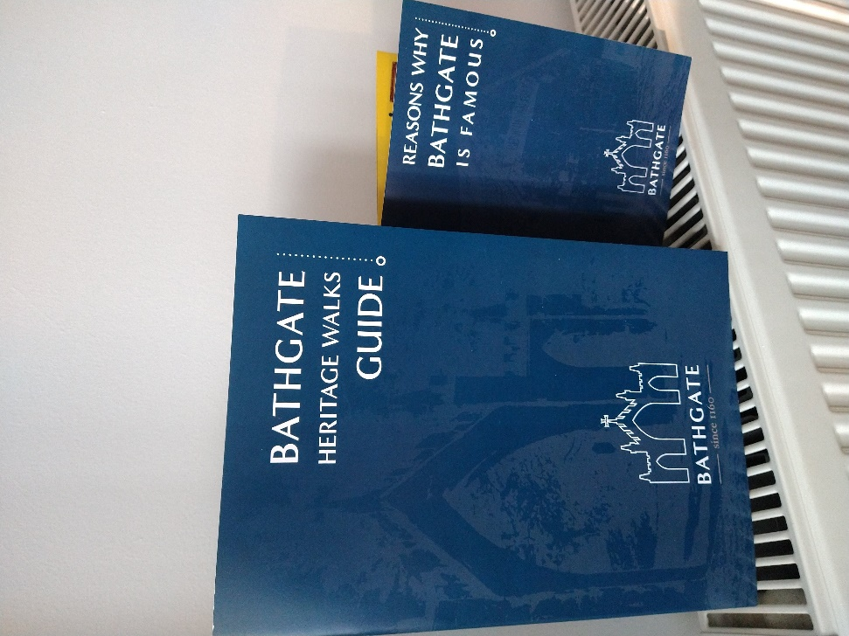 | 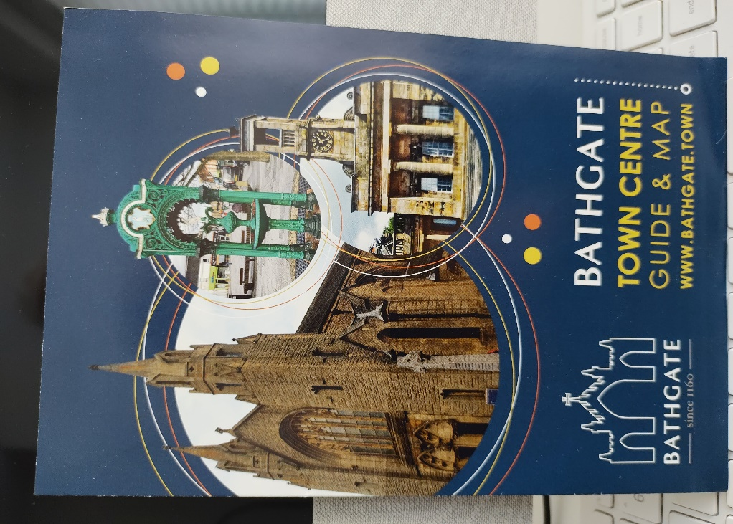

 | RECENT PUBLICATIONS BY BATHGATE COMMUNITY COUNCIL
 | 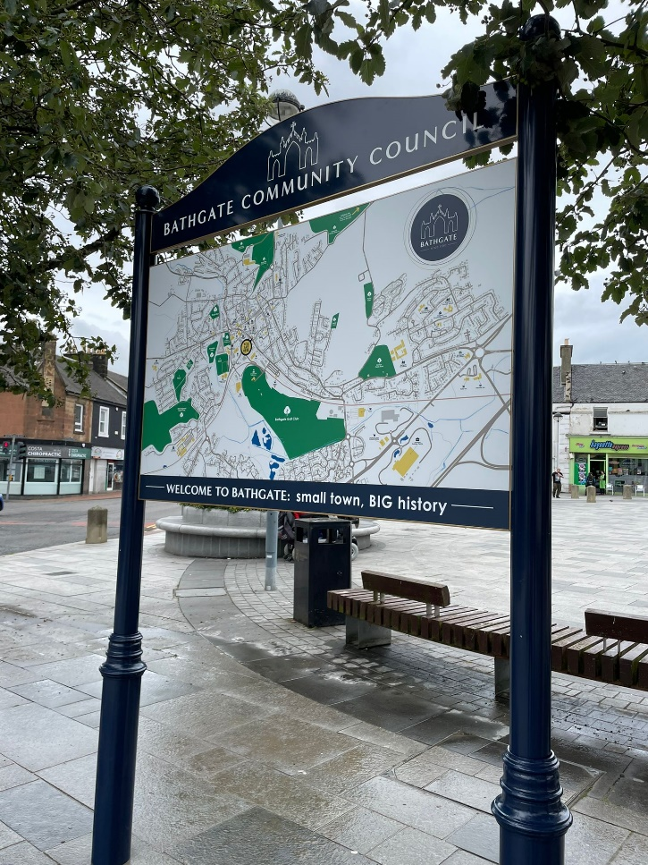 | Town Centre Grant Round Two  The welcome to Bathgate signage has finally been erected as has the town centre map and history board as well as the Bennie Museum information board  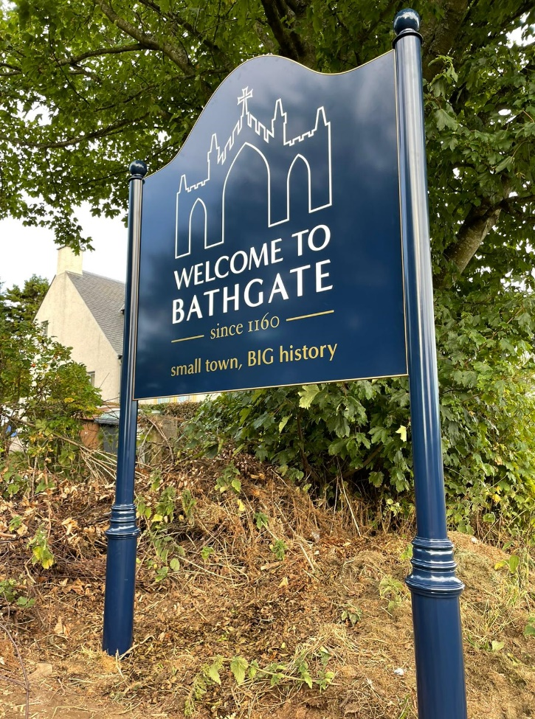

Community Councillors

The Community Council was elected to a four-year term in October 2021 with a healthy number of citizens coming forward to serve. There are however two unfilled seats and volunteers are welcome to put themselves forward.

Contact Bathgate Community Council at bathgatecc@gmail.com

Look up our website at www.bathgatecc.com

Looking forward to another busy year for the Community Council in 2023

Ronnie McLeod Chair
Bathgate Community Council

Bathgate Community Council meets every month on the second Thursday of the month at 7pm in the Bathgate Partnership Centre. Member of the public are welcome to attend all meetings of the council

