Factory Reset Yealink T33

- Hold the centre button of the navigational buttons down for 10 seconds. The screen will bring up a note saying “Reset to factory setting?”.
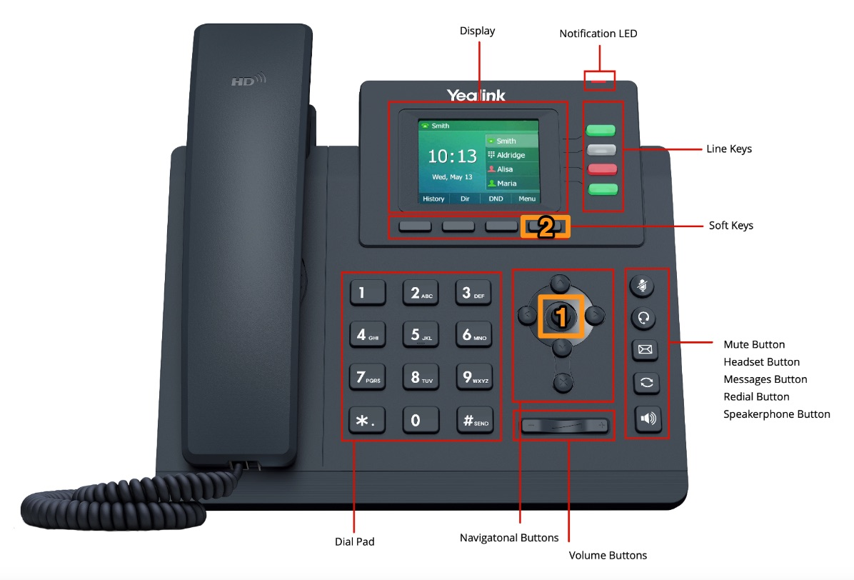

- Press the right hand Soft Key under the screen, under “OK” on screen and the phone will reset. This will reboot once, pickup the config from the server and reboot again.


