Manual Roam - iPhone instuctions

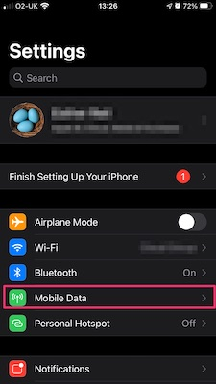

STEPS
- Open Settings on your phone
- Go to Mobile Data / Mobile Service

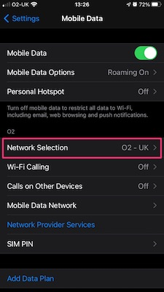

- Select Network Selection

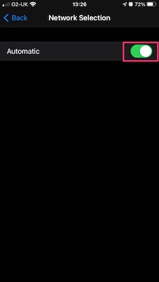

- Turn Automatic Network Selection off

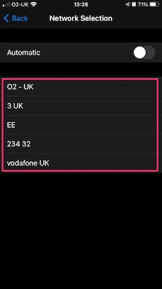

- Try switching between available networks until you find one that works.

Additionally, to control Data Usage you can turn mobile data off by unticking the mobile data, then only turning it on when needed. I would also suggest going to the bottom of the Mobile Data (Service) page and you can “Reset Statistics” , a little further up the page you will see a section showing how much each app has used in the current period. Resetting your statistics will reset your period and you can see how much data you are using while away. There are limits to your free roaming abroad, for example within Europe O2 is limited to 25Gb monthly.

