Setting up Desktop App via invite

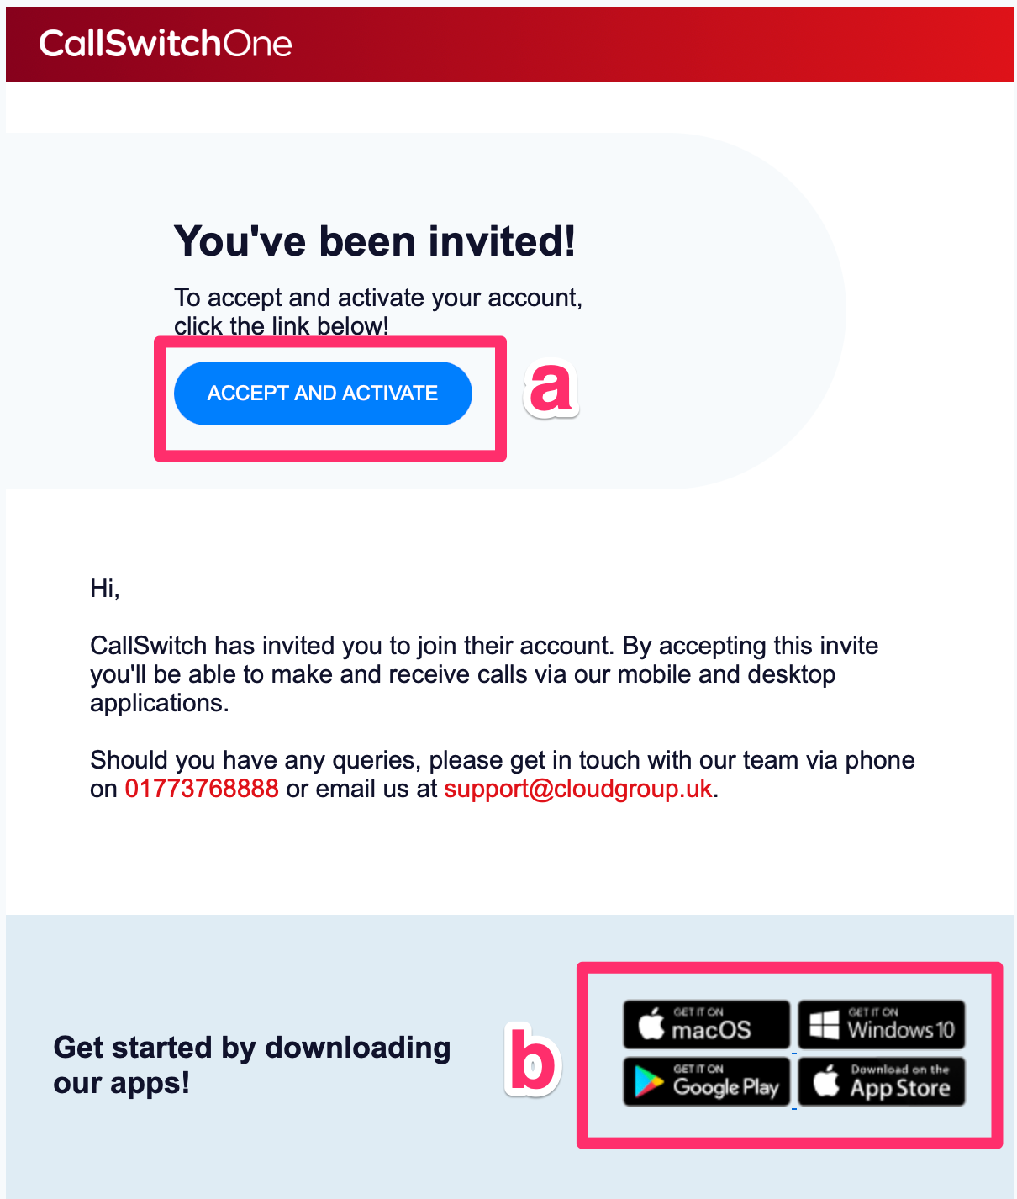

STEPS

a - You should receive a welcome email (as above) click the “Accept and Invite Link” - skip to step c
b - After setting up your login in step c and d click the picture for your operating system, eg… Windows or Mac, to download the app

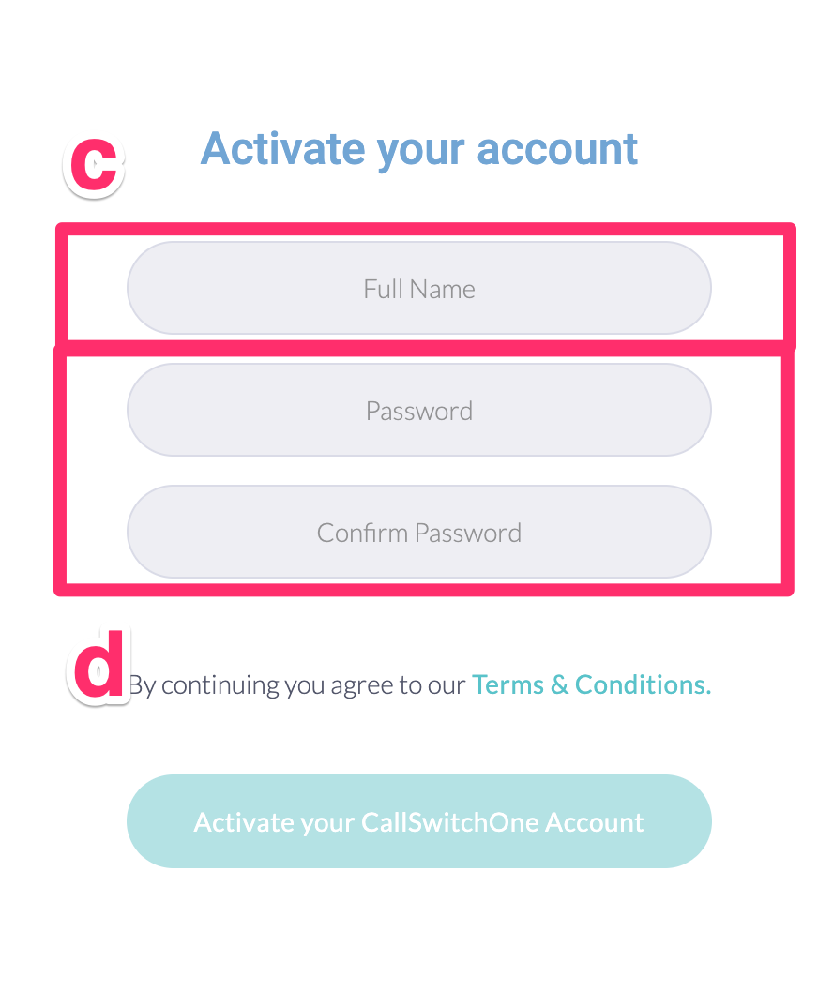
STEPS

c - The “Accept and Invite Link” will take you to a webpage, enter your name
d - Enter and confirm your own preferred password. After you have finished you will be in the web browser version of the app. This is still full featured but the desktop app is recommended as it is able to give better notifications for incoming calls etc… The full desktop app can be downloaded via the links on the welcome email (b) or at https://www.callswitchone.com/downloads/ . Install the desktop app.

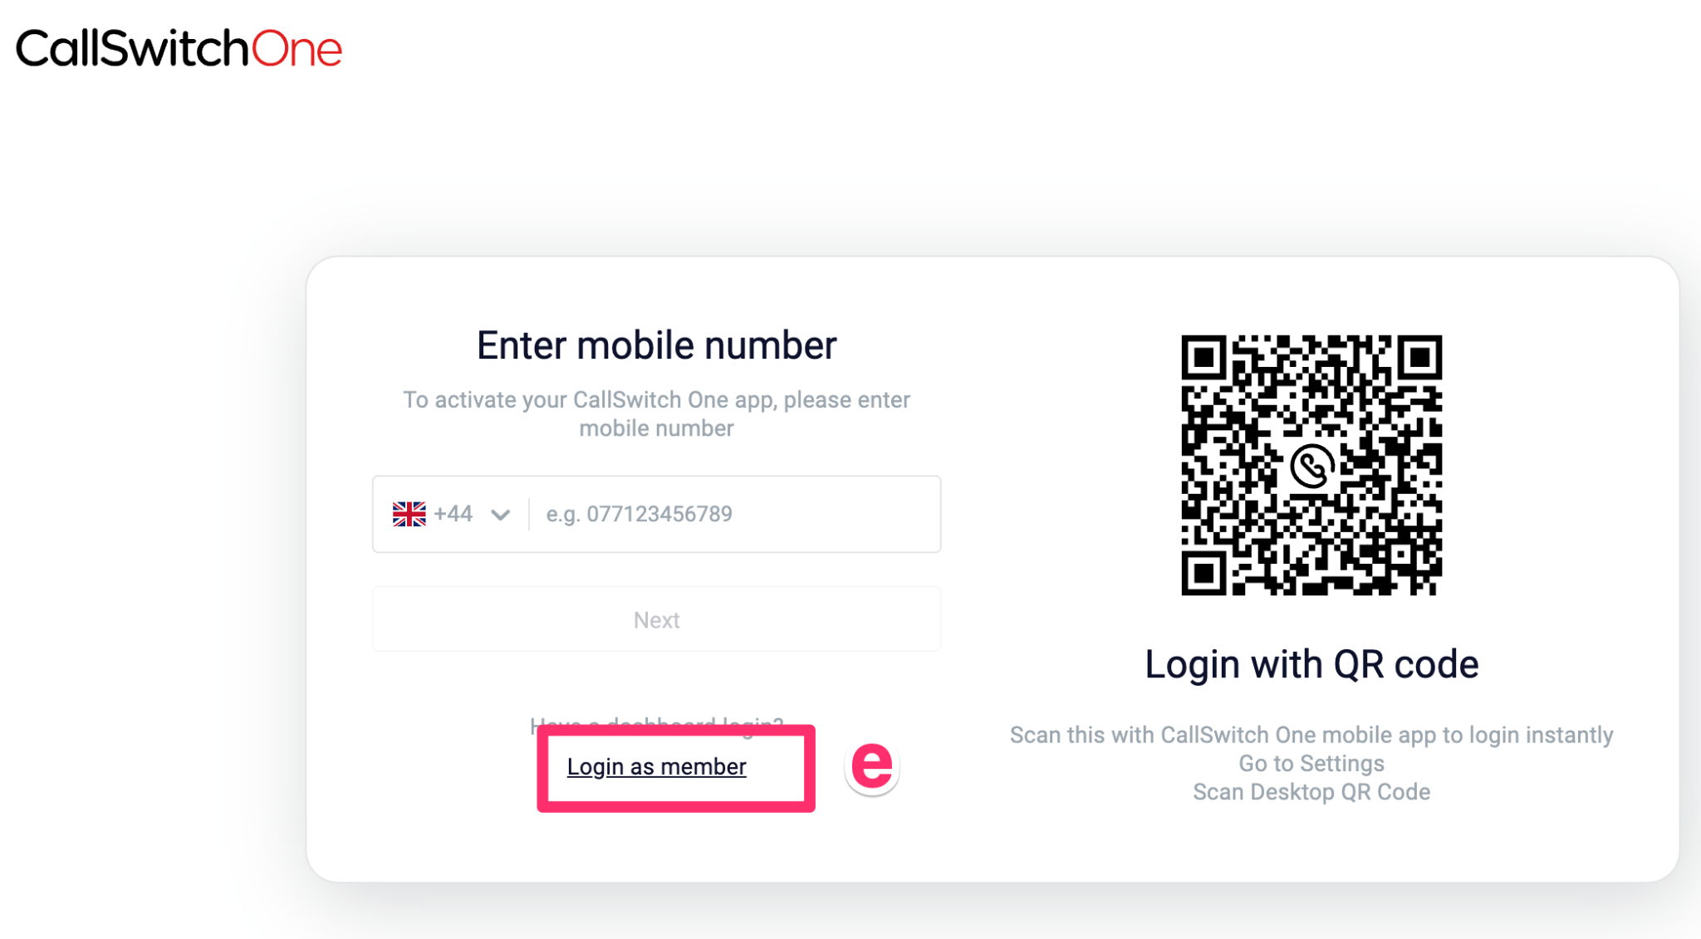
STEPS

e - Open the Desktop App and select “Login as member”

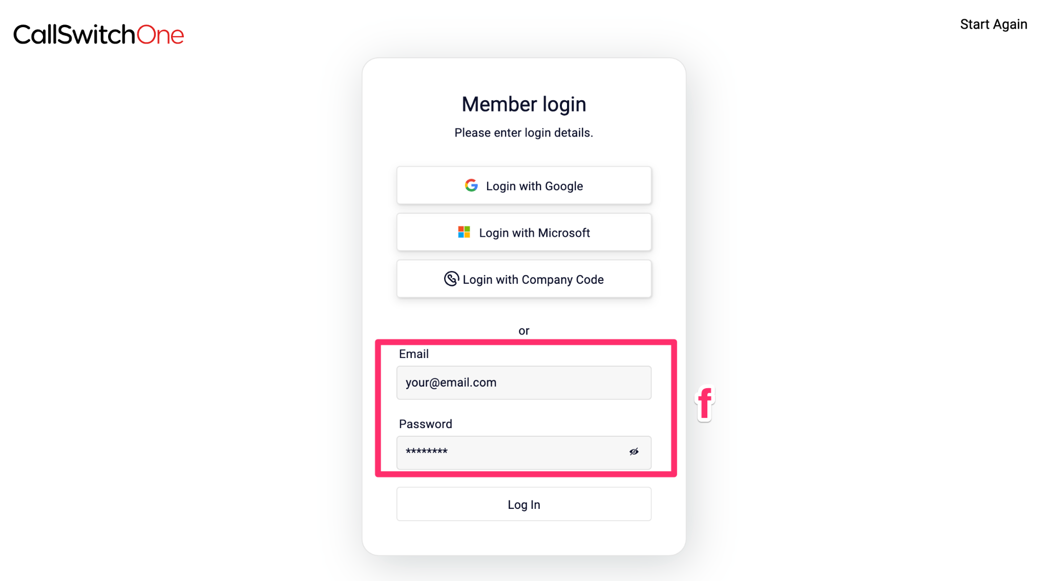
STEPS

f - Enter Email and the password you set earlier after clicking the invite link (d)

