Factory Reset Grandsteam Landline

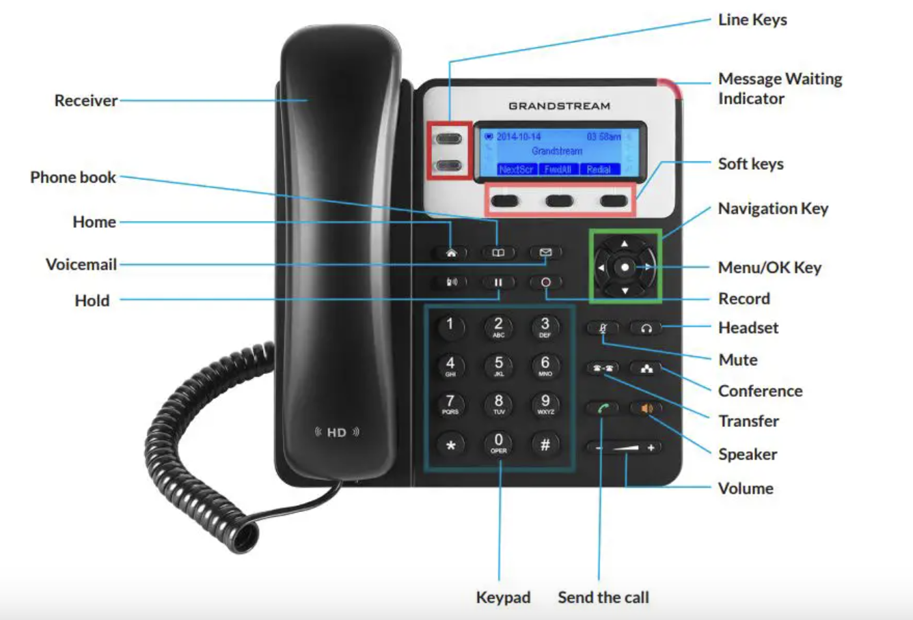

Factory Reset Grandstream GXP1628

- Press the centre button (“Ok”) within the green area, to enter the main menu
- Press arrow down to the option “System”
- Press “Ok” (centre button)
- Press arrow down to ‘Factory Reset”, this is one below “Factory Functions”
- Press ‘Ok’ to select
- Press ‘Confirm’ (middle soft key button under screen)

Factory Reset Grandstream GXP2130

- Press the centre button (“Ok”) within the green area, to enter the main menu
- Press the right arrow to move across to the second page
- Select ‘System’, with the centre Ok button
- Press arrow down to factory reset, at the bottom (NOT Factory Functions)
- Press centre button within green area to ‘Ok’
- Press ‘Yes” (third from left soft key button under screen)



