Installing CS1 Mobile App - Deployment via Invite

APPLE iOS

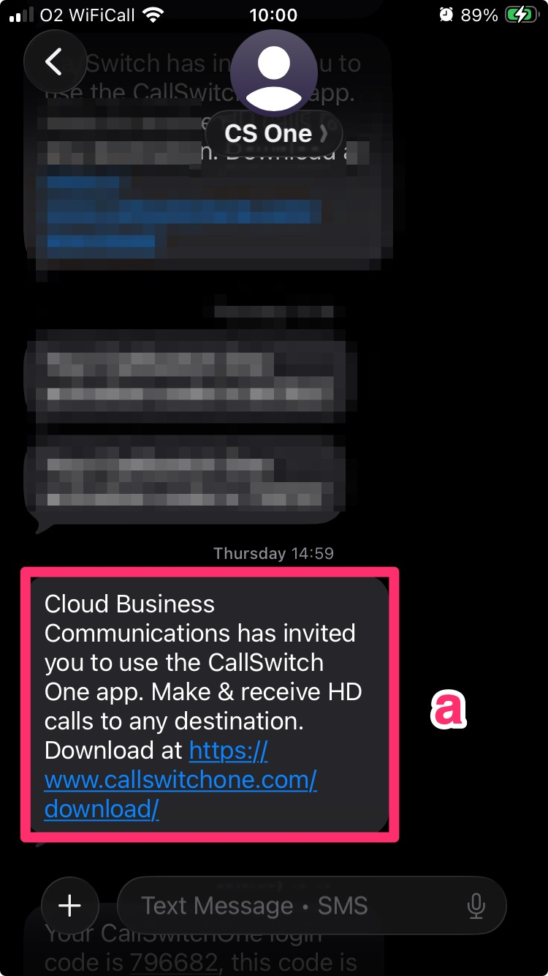 | 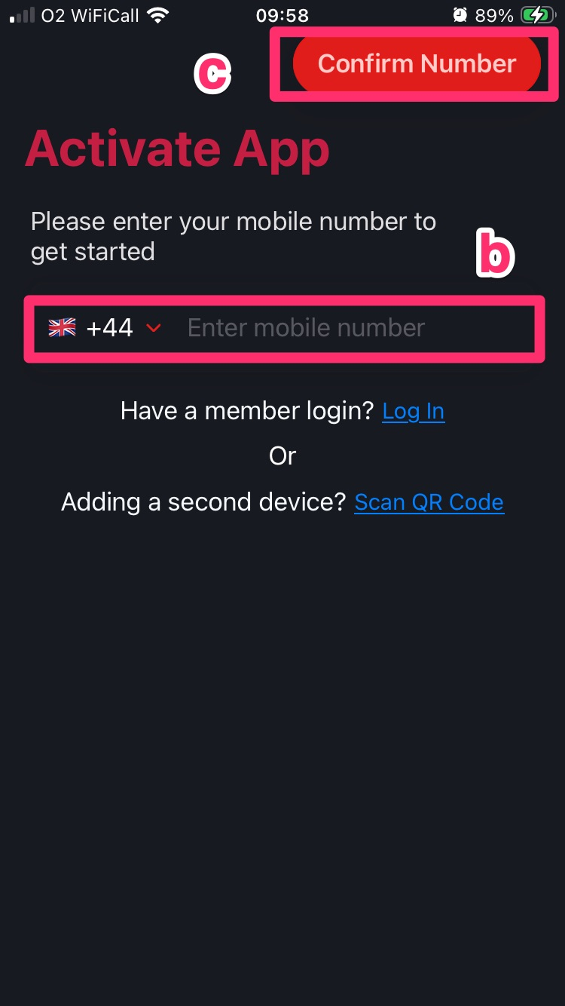

STEPS
a - Users will receive a welcome text. Follow the link to go to the download website. Scroll down select Apple’s App Store to download the “Callswitch One” app. Alternatively download directly from the App store.
b - Enter your mobile number
c - Select “Confirm Number”
d - Select “Confirm” when the number verification box appears
e - You will get a two factor authentication (2FA) six digit pin texted to the mobile number

f - Enter the six digit pin and you will then be setup
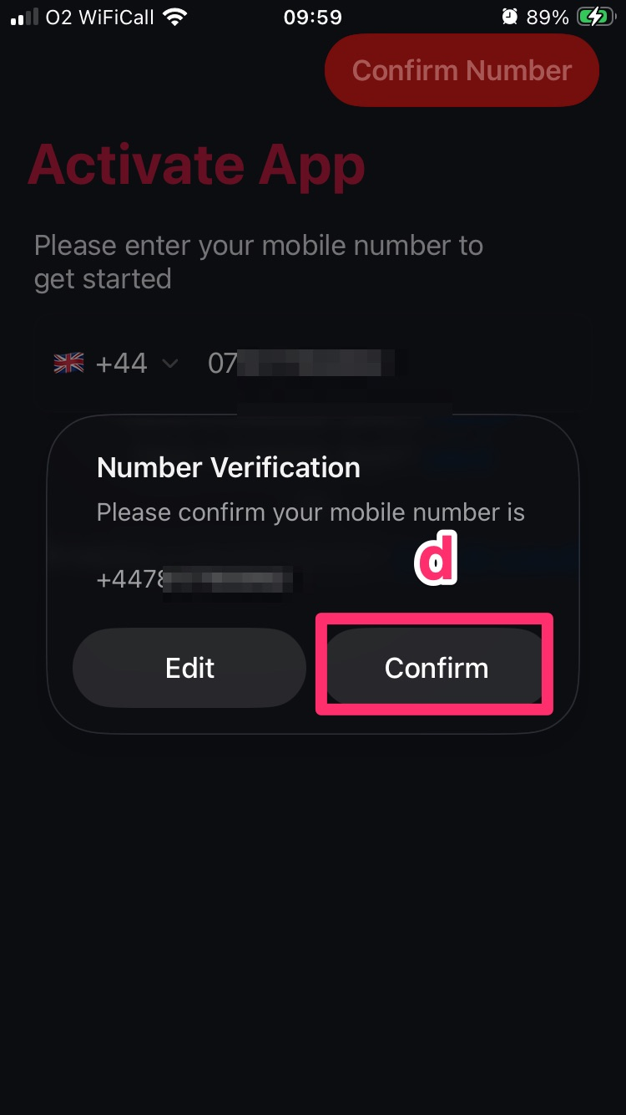 | 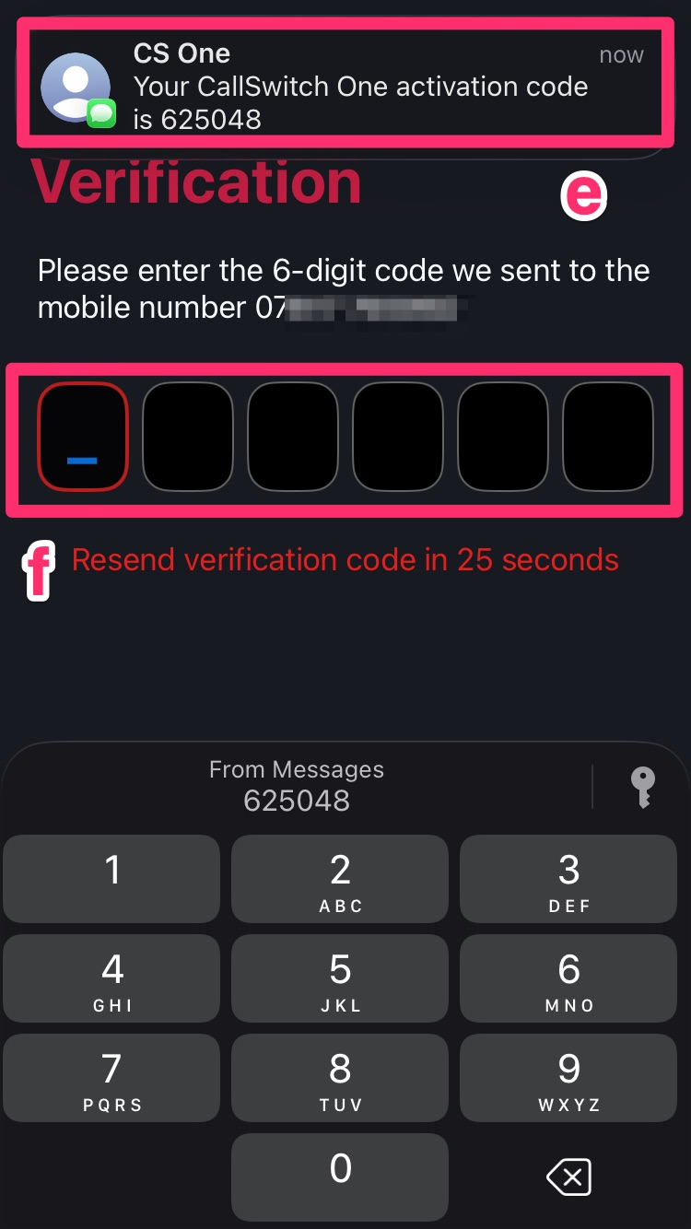
ANDROID

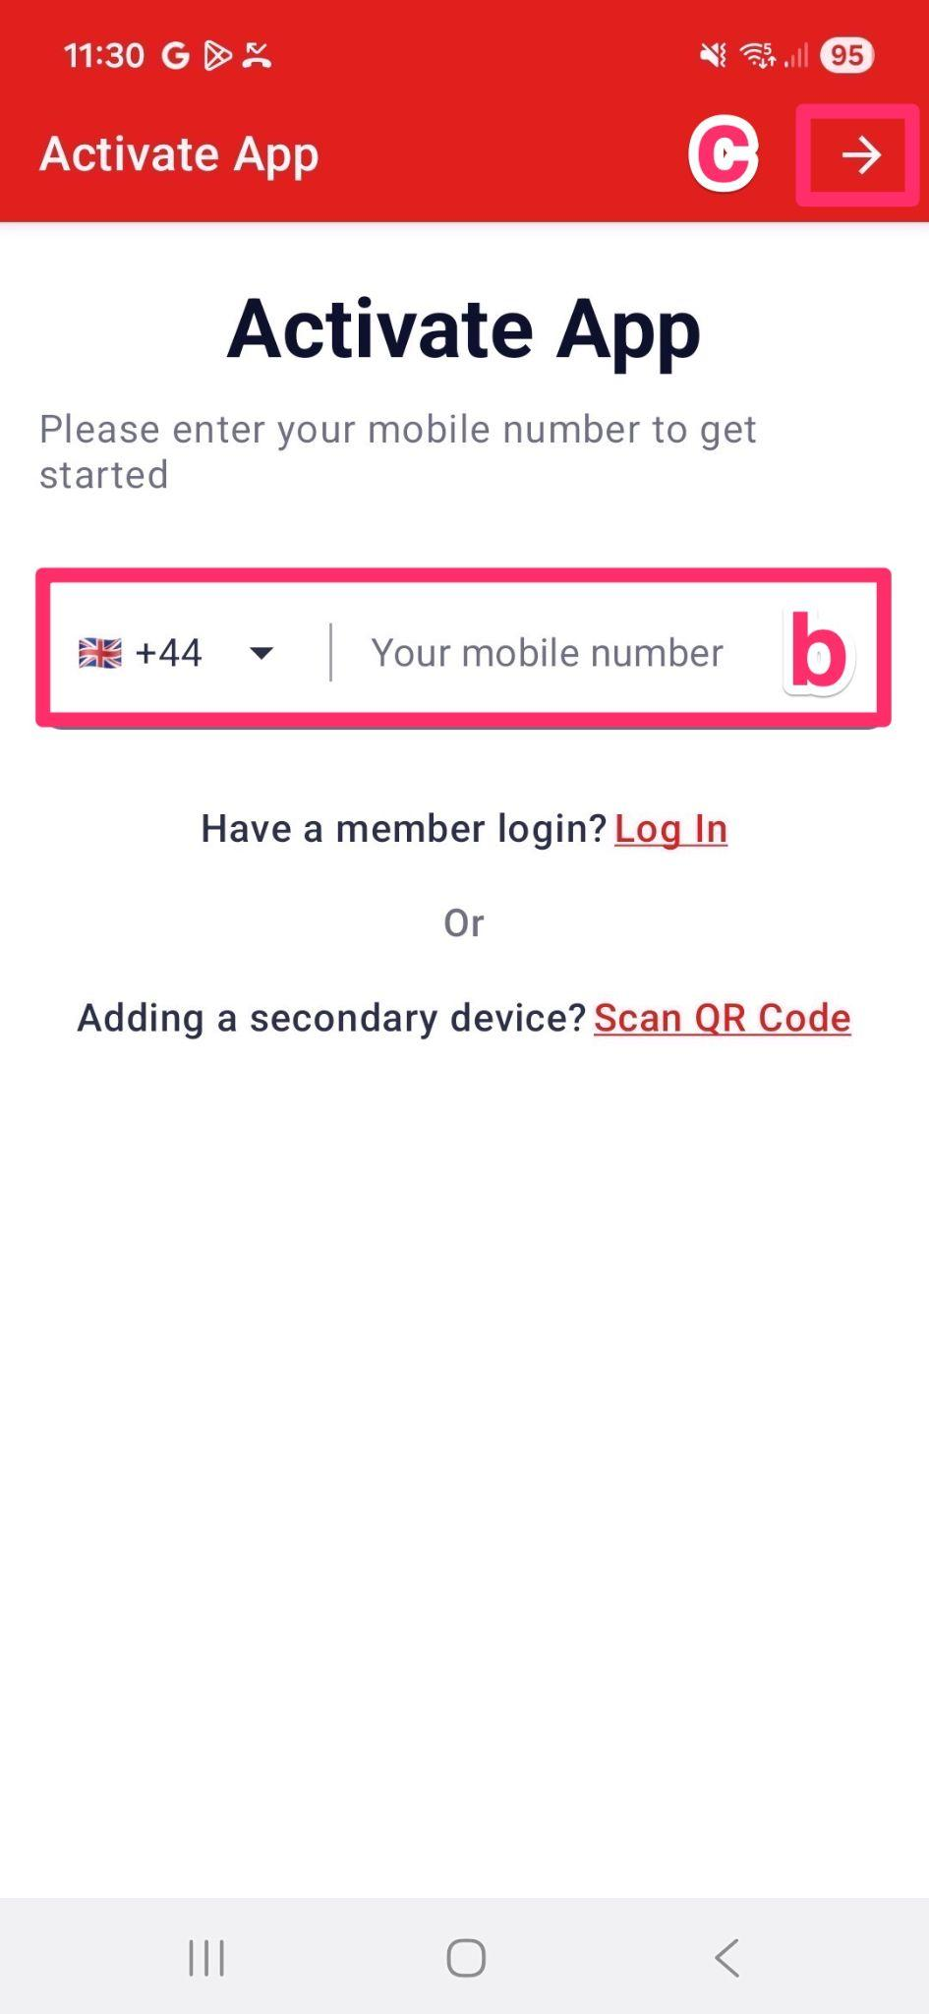

STEPS
a - Users will receive an invite welcome text, then follow the link (https://www.callswitchone.com/downloads/) to go to the website. Scroll down and follow the link to Android’s Google Play Store to download the “Callswitch One” app. Alternatively download directly from the Play store.
b - Enter your mobile number
c - Select the “Next Step” arrow in the top right
d - Select “Continue” when the “Proceed with the following number” verification box appears
e - You will get a two factor authentication (2FA) six digit pin texted to your mobile number. Enter it in the box.
f - Click “Next” in the bottom left or the “Next Step” arrow in the top right to complete.
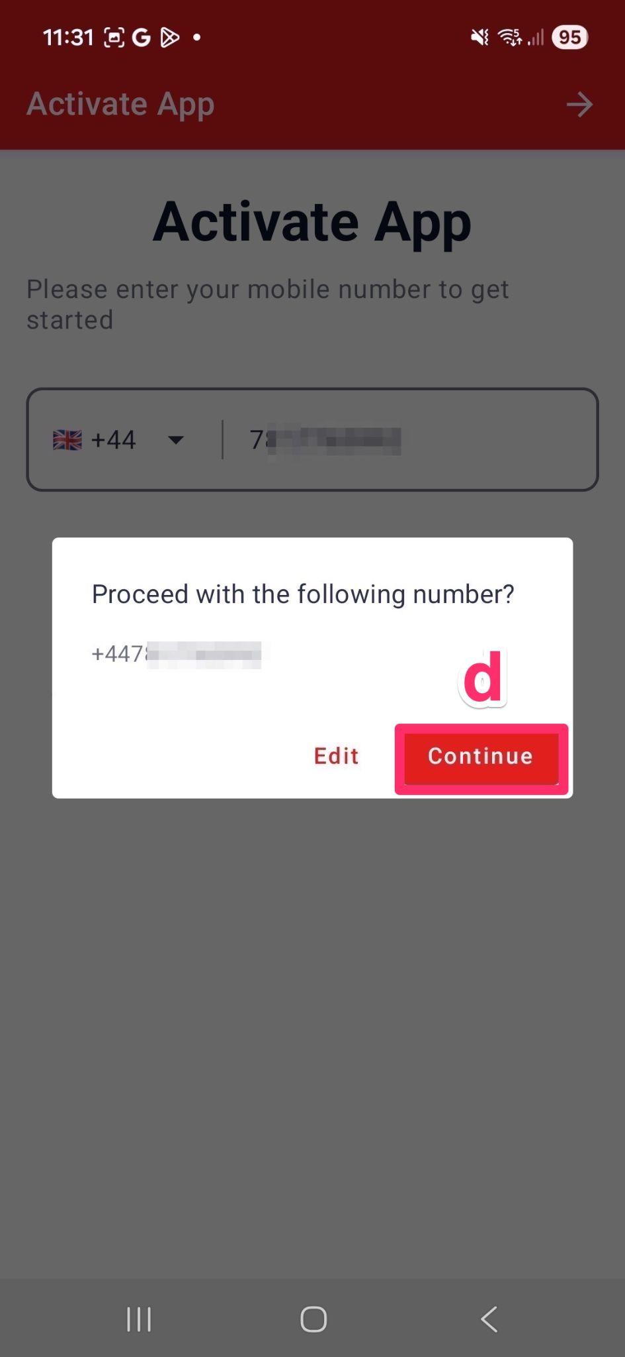 | 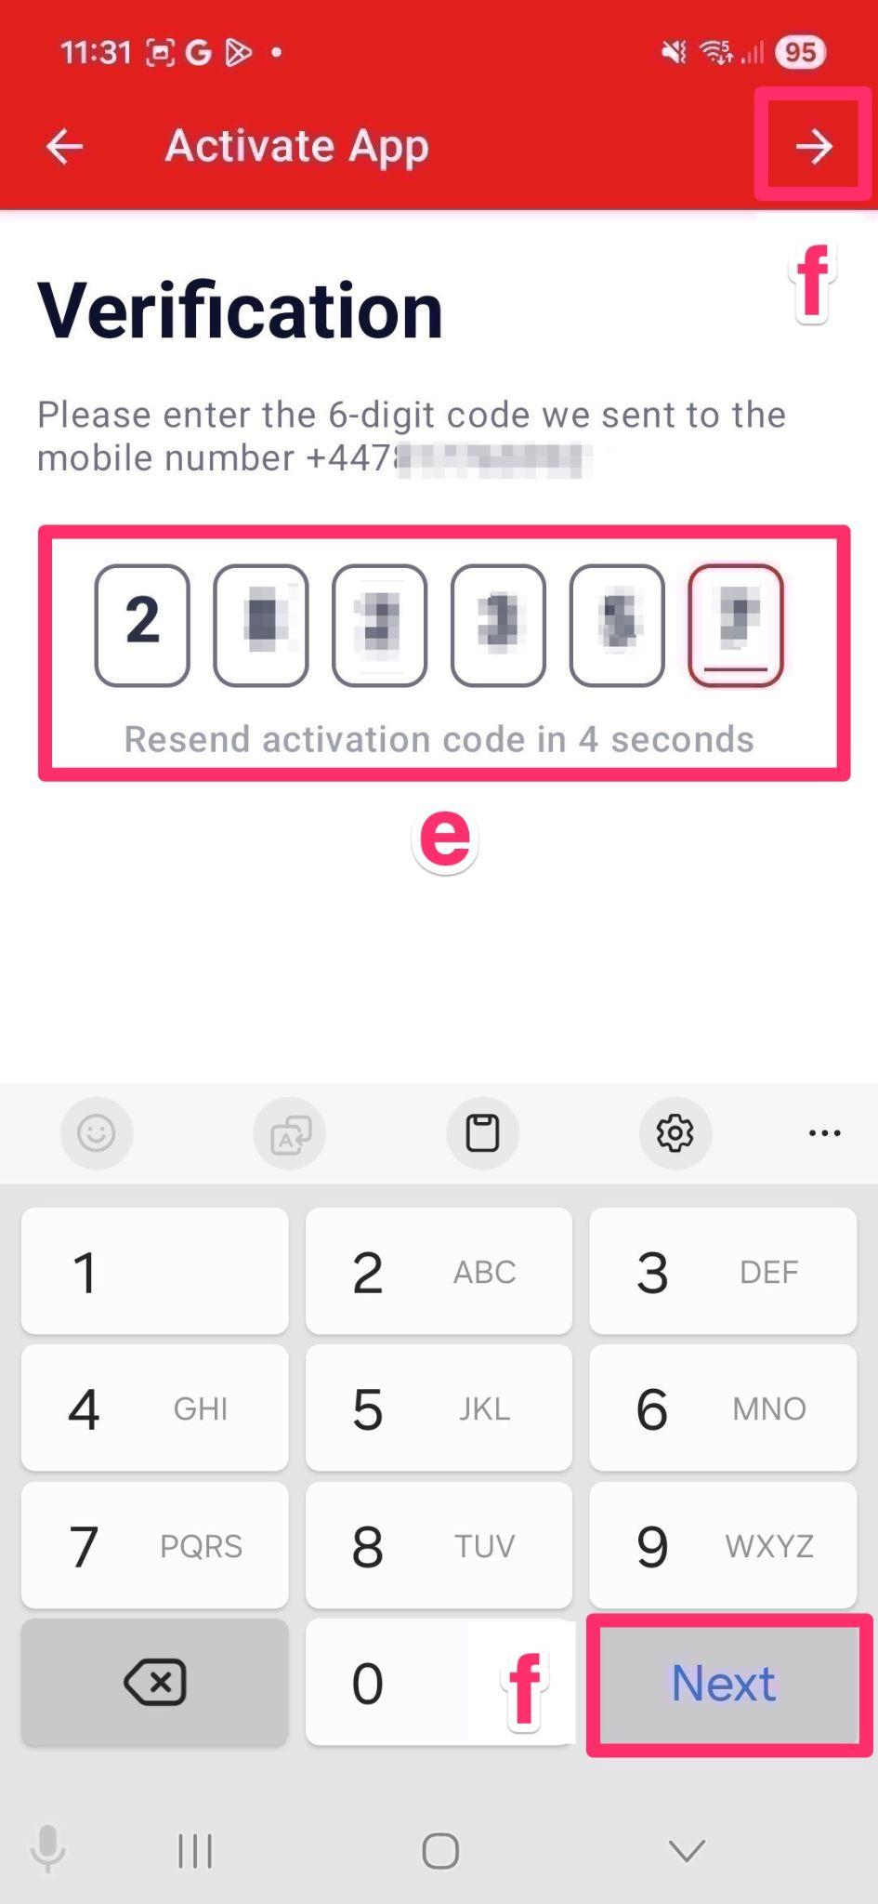

Adding Global Contacts

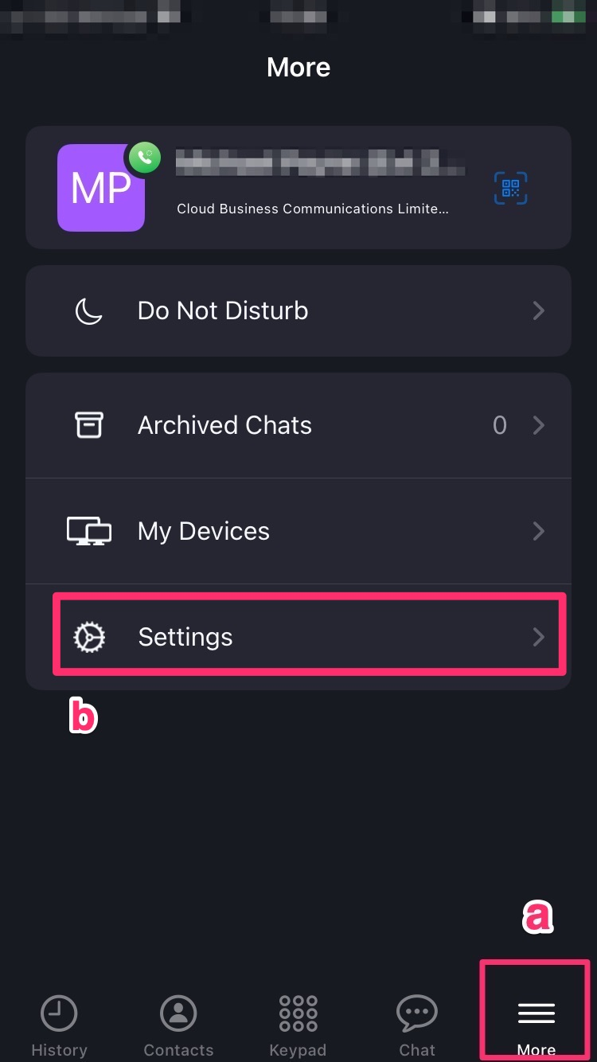 | 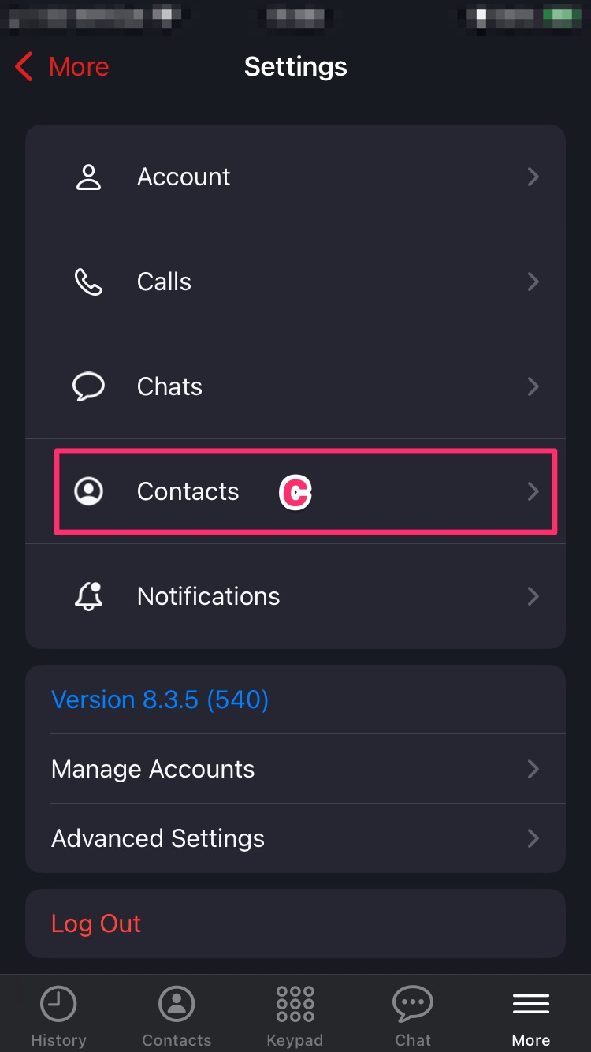

STEPS
a - Select “More” on the bottom menu
b - Select “Settings”
c - Select “Contacts”
d - Select “Phonebooks”
e - Select the books you want, tick the toggles next to any you want to use

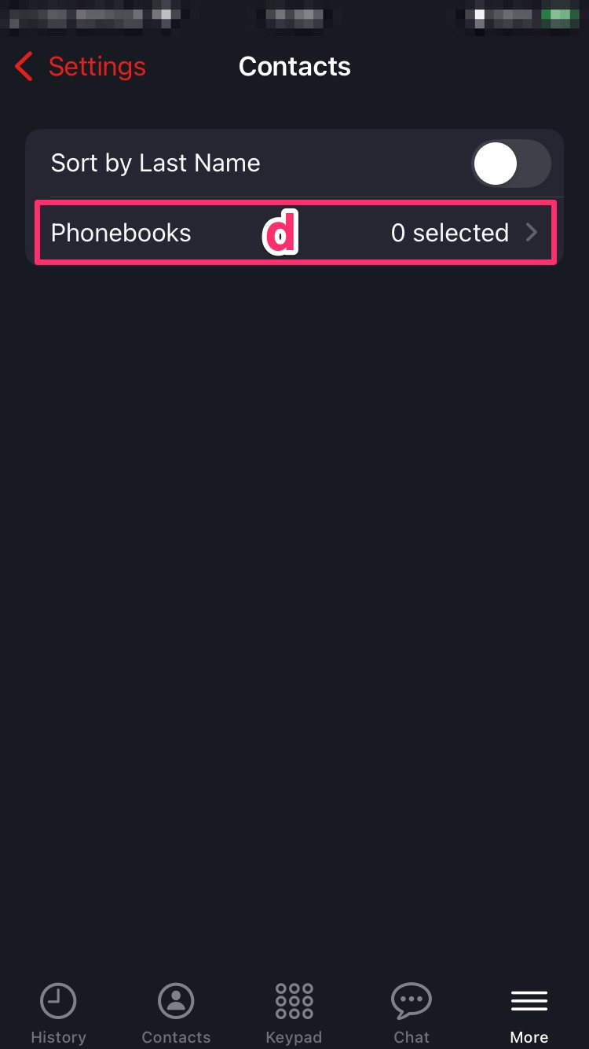 | 

