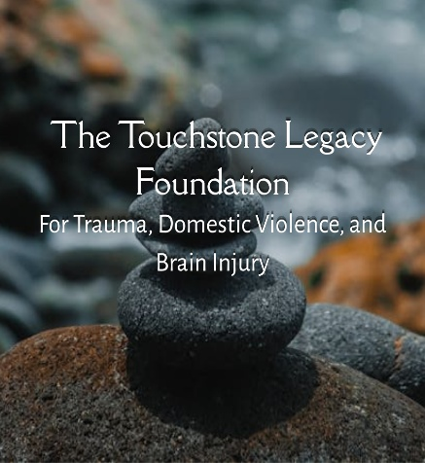
Domestic Violence & Brain Injury
A Quick Awareness Guide
From The Touchstone Legacy Foundation

Why This Guide Exists
Domestic violence is often understood as a social and safety issue. It is also a neurological health issue.
Many survivors of domestic violence experience head impacts, strangulation, falls, or forced movement that can affect the brain. These injuries are frequently invisible, underrecognized, and misunderstood. When brain injury and trauma are not considered together, survivors may be judged, misinterpreted, or blamed for challenges that are actually rooted in injury.
This brief guide exists to:
- increase awareness of the connection between domestic violence and brain injury
- reduce misunderstanding and stigma
- support more informed, trauma-informed responses
It is intended for survivors, advocates, professionals, and community members seeking clarity and understanding.

What This Guide Is (and Is Not)
This guide is:
- Educational and awareness-focused
- Trauma-informed and survivor-centered
- Written in accessible, non-clinical language
This guide is not:
- Medical diagnosis or treatment
- Legal advice
- Crisis intervention or emergency support
If you are in immediate danger, please contact local emergency services or a trusted domestic violence resource.

How Domestic Violence Can Affect the Brain
Traumatic brain injury (TBI) occurs when an external force disrupts the brain’s normal function. While TBIs are often associated with sports or car accidents, they can also occur in the context of domestic violence.
Domestic violence may place survivors at risk of brain injury through:
- blows to the head, face, or neck
- strangulation or reduced oxygen to the brain
- being pushed or thrown, resulting in falls or impacts
- repeated force or shaking
Importantly, brain injury does not always involve loss of consciousness or visible injury, and symptoms may not appear immediately.

Why “Mild” Does Not Always Mean Minor
Many brain injuries are described as “mild” because they are not immediately life-threatening. However, “mild” does not mean:
- mild impact on daily life
- quick or full recovery
- no lasting symptoms
In domestic violence contexts, injuries may be repetitive, meaning the brain may not fully recover between incidents. Multiple so-called “mild” injuries can have cumulative effects.

Why DV-Related Brain Injury Is Often Missed
Brain injuries related to domestic violence are frequently undocumented or unrecognized for several reasons:
- Survivors may avoid medical care due to safety concerns
- Injuries may be minimized or normalized
- Screening is not standard in many DV settings
- Symptoms may be misattributed to stress, trauma, or mental health alone
- Survivors may lack language to describe cognitive or neurological changes
As a result, survivors may live with symptoms that are misunderstood or dismissed.

How Trauma and Brain Injury Can Overlap
Trauma and brain injury can produce similar-appearing symptoms, including:
- memory difficulties
- trouble concentrating
- emotional regulation challenges
- fatigue or sensory overload
- feeling “slowed down” or overwhelmed
Because these experiences overlap, brain injury and trauma are often treated separately—or one is overlooked entirely. Understanding how they interact helps reduce blame and supports more compassionate responses.

Why Awareness Matters
Recognizing the connection between domestic violence, trauma, and brain injury can:
- improve safety planning
- reduce mislabeling of survivor behavior
- strengthen communication and trust
- support dignity and self-understanding
Awareness is not about diagnosis—it is about informed understanding.

A Trauma-Informed Note for Survivors
If you recognize yourself in this guide:
- nothing here implies weakness or failure
- many survivors experience similar challenges
- your experiences are valid
Understanding what may be happening neurologically can be an important step toward self-compassion and informed support.

Where to Go for Help
This guide does not replace direct services. If you need support, consider reaching out to:
- local domestic violence programs
- national DV hotlines
- healthcare professionals familiar with trauma-informed care
If you are in immediate danger, contact emergency services.

About Touchstone Legacy Foundation
Touchstone Legacy Foundation advances trauma-informed understanding at the intersection of trauma, domestic violence, and brain injury. Our work focuses on education, awareness, and systems-level understanding to help make invisible injuries visible.

Next Steps
For deeper learning, including practical reframing guidance and professional training materials, explore the Domestic Violence & Brain Injury Awareness Course from Touchstone Legacy Foundation.

