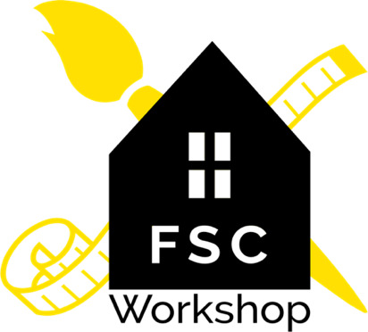

COVID-19 Pre-Screening Health Questionnaire

FSC Workshop Creative Studio is conducting a pre-screening check to mitigate the risk to our staff and students. It is imperative that you complete this form as accurately as possible prior to entering our studio.

I, or any member of my household, have not been exposed to COVID-19 or believe that we have been exposed.

I, or any member of my household, have not traveled to or from a high-risk geographic area in the past 14 days.

I, or any member of my household, have not had any of the following symptoms in the last 14 days.

● Cough
● Shortness of breath or difficulty breathing
● Chills
● Muscle aches
● Sore throat
● New loss of taste or smell
● Severe fatigue

If at any time myself or my family’s symptoms or exposure changes in the next 3 months, and we are able to answer yes to any of the previous statements, I will notify FSC Workshop immediately by email at Fmthomas83@gmail.com.

By signing here, you are attesting that everything you stated above is truthful and accurate to the best of your knowledge.

Please print and bring with you on your first visit to FSC Workshop.

Name(s) of Participants: ____________________________________________________ Printed Parent/Guardian Name: ___________________________________
Signed Parent/Guardian Name: ___________________________________ Date: ________

