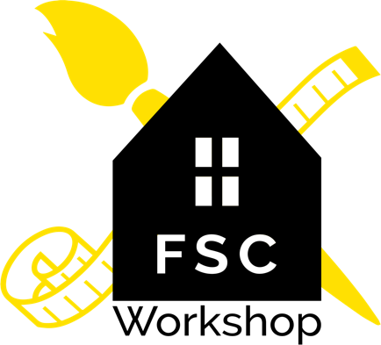

FSC Workshop SUPPLEMENTAL INFORMED CONSENT in the Era of COVID-19

Thank you for your trusting in FSC Workshop. As with the transmission of any communicable disease like a cold or the flu, you and/or your child may be exposed to COVID-19, also known as “Corona virus,” at any time or in any place. Rest assured we will be following all public health guidelines

Despite our careful attention to cleaning, disinfection, and use of personal barriers, there is still a chance that you and/or your child could be exposed to an illness at FSC Workshop, just as you might be at your gym, grocery store, or favorite restaurant. “Social Distancing” nationwide has reduced the transmission of the Corona virus. Although we have taken measures to provide social distancing at FSC Workshop, due to the nature of working with customers, it is not possible to maintain social distancing at all times.

Although exposure is unlikely, do you accept the risk and consent to attending classes at FSC Workshop?

Yes ________ No________

Parent/Guardian Signature_____________________________________

