

**IMPORTANT NOTE:** This Framework was developed in 2020 as part of The Equity Index’s pilot project, during we tested a small number of internal and external indicators with pilot organisations. As such, this Framework is not meant to be comprehensive, but we offer it as a starting point for organisations based in the UK or elsewhere in the Global North that deliver development-focused projects in the Global South to assess how equitable their practices are, and encourage them to reflect on additional dimensions that are relevant to their specific work and context.

Indicator Assessment Framework and Guidance document – for UK/Global North based NGOs, social enterprises and other companies that deliver development projects

#### About The Equity Index

The Equity Index is a UK social enterprise advocating for greater equity across the international development sector. We will measure and track the multiple dimensions of equity in the internal and external workings of UK development organisations to influence meaningful change in their policies, practices, and partnerships. This includes racial and gender equity, equity in knowledge production, in funding, in collaborations and more. We are an anti-racist and feminist organisation that supports the broader decolonising development and Shift the Power movements. You can access all of our materials publicly at [www.theequityindex.org](http://www.theequityindex.org)

#### Principles

The indicators against which The Equity Index will measure progress will be guided by the following general principles:

* Intersectional
* Capture a combination of policy and practice
* More qualitative than the quantitative in nature
* Realistic but also ambitious
* Present a reasonable reporting burden for organisations
* Not a tick box approach to change everything but identify entry points that can lead to meaningful change – kick-start a process

#### Objectives and purpose of the Indicator Framework

This document seeks to collect level 1 responses for organisations that are being assessed under The Equity Index’s pilot project. Organisations are invited to provide answers to the questions outlined in this document as well as evidence in the form of supporting documentation. Responses will be assessed and scored by The Equity Index.

#### How to fill out this document

This document asks your organisation to provide explanations for your organisation’s status under each indicator. This is not compulsory to fill out. You can also just send us the evidence/supporting documentation against indicators. If this is the case, please make this explicit in the “Evidence Provided” section of Sections II and III.

# Table of Contents

Glossary and definitions 5

Part Ia: Essential Information 7

Part Ib: Contextual information 8

Part II: Internal indicators 10

Part III: External indicators 14

Part IV: Any other relevant information 17

# Glossary and definitions

The Equity Index is keen to ensure that we use language that is as equitable and inclusive as possible, recognizing that this may mean different things for different people. We have attempt to represent a diversity of perspectives in the below definitions, and we welcome and invite feedback on both the terms and definitions that we use.

|  |  |
| --- | --- |
| **TERM** | **EQUITY INDEX DEFINITION** |
| **Equity** | We recognise that the term ‘equity’ has a multitude of definitions in different contexts. The Equity Index uses the term to refer to a general process of ‘levelling an unequal playing field’ between the Global South and Global North, through organisational policies and practices that do not discriminate against marginalised groups, a fairer distribution of resources, and more equitable partnerships. |
| **Internal equity** | A term used by The Equity Index to refer to an organisation’s internal policies and practices on racial and gender equity, disability and LGBTQI inclusion, and more, and in general focuses on whether the organisational culture feels equitable. |
| **External equity** | A term used by The Equity Index to refer to various dimensions of an organisation’s approach to partnership with organisations in the Global South, including the ways in which funding is distributed, programmes are designed and implemented, and governance and responsibilities are distributed. |
| **Global South and Global North** | There is no single, agreed definition of the terms Global South and Global North and we acknowledge that many actors in the sector do not use this language. While there is therefore no perfect term, The Equity Index prefers this term to the less equitable equivalent ‘developing countries.’  The Global South refers broadly to a grouping of countries and people that experience economic marginalisation within the global system and have elements of a shared history of colonisation and exploitation. This is largely the same grouping within which are most often the net receivers of foreign aid, although many Southern donors also exist. The global North refers to countries and people traditionally referred to as ‘the West,’ that tend to be net foreign donors to countries in the global South. |
| **Racial, gender, disability and LGBT equity and inclusion** | The Equity Index will measure different aspects of internal equity based on personal characteristics, emphasising the importance of fair treatment and equality of outcomes. This is applied universally regardless of race, gender, disability or sexual orientation and gender identity. |
| **Intersectionality** | Originated by Black feminist scholar Kimberlé Williams Crenshaw in 1989, the concept of intersectionality refers to the ways in which different social identities and categorisations interact to reinforce systems of privilege and oppression.  It is a complex concept, and in the context of the Index we use it to ensure we measure equity from a wide range of different and intersecting angles. |
| **Women** | By women, we mean anyone who self-identifies as female in their gender identity, including transgender women, which may or may not correspond with the sex they were assigned at birth. |
| **People of Colour (PoC)** | People who identify as a racial or ethnic minority in the UK, including members of diaspora communities in the UK. We acknowledge that people will self-identify in different ways and may prefer other terms to People of Colour, including Black, Asian and Minority Ethnic (BAME) and Black, Indigenous, People of Colour (BIPOC), mixed race, or by their specific race and/or ethnicity (for instance Black or Asian). |
| **People with Global South nationality/ background** | This refers to people who were born and raised in a country or countries in the Global South that are currently based in the UK (regardless of whether they have naturalized as citizens of the UK or another country in the Global North, or whether they hold dual nationality between South/North). |
| **Disabled people/ People with disabilities** | People who identify as having a disability. Under the [UK Equality Act](https://www.gov.uk/definition-of-disability-under-equality-act-2010), this is classified as a physical or mental impairment that has a ‘substantial’ and ‘long-term’ negative effect on your ability to do normal daily activities. |
| **Board** | A non-partisan body that provides non-binding strategic advice to the management of your organisation. For corporate and other organisations that have an international development department and a separate board covering this work, please include data for this (rather than the overarching organisational board). |
| **Senior Management Team (SMT)** | This represents the most senior staff in your organisation, i.e. the Director and Founder level staff often overseeing strategic direction, vision and business development.in charge of operational running of your organisation including finance, procurement and management. For corporate and other organisations that have an international development department, we are looking for data on the most senior members of this specific team (rather than the organisation as a whole). |
| **Commitment** | A public statement outlining an intention to achieve a goal, with clear and measurable steps for achieving it, or a statement outlining an intention to achieve a goal that has been disseminated to all concerned parties. |

# Part Ia: Essential information

|  |  |
| --- | --- |
| NAME OF ORGANISATION |  |
| NAME OF PERSON FILLING OUT THIS DOCUMENT |  |
| POSITION |  |
| DATE OF SUBMISSION |  |
| LIST OF DOCUMENTS ATTACHED AS EVIDENCE | |
|  | |

# Part Ib: Contextual information

The objective of this section is to gather information about your organisation that will serve as a means to assess and score indicators.

Please provide answers and corresponding evidence, where applicable to the following questions:

#### 1.1 REGISTRATION AND STATUS

|  |
| --- |
| 1. Is your organisation a part of a larger organisation with headquarters (HQ) or head office elsewhere? Please provide details of length of existence of parent organisation and location of HQ. |
|  |
| 1. What are your organisation’s main sectors of work? |
|  |
| 1. In what countries does your organisation implement projects? Please list all. |
|  |

#### 

#### 1.2 STAFF, SENIOR MANAGEMENT TEAM AND BOARD

|  |
| --- |
| 1. How many Boards do you have, if any? How many people sit on the Board(s)? |
|  |
| 1. How many people form your Executive or Senior management team? |
|  |
| 1. How many full-time staff do you have in your UK office? If you have a separate International Development team, please specify how many full-time staff do you have in that team in your UK office. |
|  |
| 1. Do you have an operational Human Resources (HR) department with staff that are separate from the Senior Management Team, Founders and Directors? |
|  |

#### 1.3 PROJECT DELIVERY

|  |
| --- |
| 1. Please provide a list of countries where you have implemented projects in the last five years. |
|  |
| 1. Please provide a list of countries where you are registered either as a subsidiary organisation or work through a legally registered organisation. |
|  |
| 1. How many active projects do you currently have in the Global South? |
|  |

# Part II: Internal indicators

This section outlines indicators that measure internal equity within your organisation. Please provide documentary evidence for each indicator.

|  |  |
| --- | --- |
| **Indicator I-1.1 | Please provide the number/percentage of staff under each sub-category mentioned below that currently work as full-time staff or full-time equivalent[1] within the UK team.**  *In the explanation, please specify instances where categories overlap (for example X number of women who are also a person of colour and are disabled)* | |
| **Women** |  |
| **Persons of Colour** |  |
| **Persons with Disabilities** |  |
| **Persons identifying as LGBTI** |  |
| **Persons with Nationalities from the Global South** |  |
| **Explanation** | **Evidence Provided** |
|  |  |

|  |  |
| --- | --- |
| **Indicator I-1.2 | Please provide the number/percentage of Board members that fall under each sub-category mentioned below.**  *In the explanation, please specify instances where categories overlap (for example X number of women who are also a person of colour and are disabled)* | |
| **Women** |  |
| **Persons of Colour** |  |
| **Persons with Disabilities** |  |
| **Persons identifying as LGBTI** |  |
| **Persons with Nationalities from the Global South** |  |
| **Explanation** | **Evidence Provided** |
|  |  |

|  |  |
| --- | --- |
| **Indicator I-1.3 | Please provide the number of Executive/Senior members that fall under each sub-category mentioned below.**  *In the explanation, please specify instances where categories overlap (for example X number of women who are also a person of colour and are disabled)* | |
| **Women** |  |
| **Persons of Colour** |  |
| **Persons with Disabilities** |  |
| **Persons identifying as LGBTI** |  |
| **Persons with Nationalities from the Global South** |  |
| **Explanation** | **Evidence Provided** |
|  |  |

|  |  |
| --- | --- |
| **Indicator I-2.1 | Has the organisation made a measurable public commitment to promoting internal equity in all forms (race, gender, disability, sexual orientation, and more) that is intersectional in its approach?** | |
| **YES** | |
| **NO** | |
| *If yes, please provide an explanation of your approach and if possible, public commitment per category.* | |
| **Explanation** | **Evidence Provided** |
|  |  |

|  |  |
| --- | --- |
| **Indicator I-2.2 | Does your organisation provide its staff with opportunities to anonymously provide feedback on how equitable the culture of the organisation feels? If yes, have you acted on any suggestions received as part of this feedback mechanism? Please provide details.**  *In the explanation, please highlight the extent to which this system is available to and used by minoritised staff and any efforts made by your organisation to make this accessible to minoritised staff.* | |
| **YES** |  |
| **NO** |  |
| **Explanation** | **Evidence Provided** |
|  |  |

|  |  |
| --- | --- |
| **Indicator I-2.3 | Has your organisation dedicated resources (human and/or financial) to promote internal equity in the UK office?** *Please provide details of what these resources are, including percentage of expenditure dedicated to this purpose from your annual budget and number of staff dedicated to these initiatives.* | |
| **YES** |  |
| **NO** |  |
| **Explanation** | **Evidence Provided** |
|  |  |

# 

# Part III: External indicators

*This section measures equity in your organisation’s engagement with external actors and partners, with a particular focus on those based in the Global South.*

|  |  |
| --- | --- |
| **Indicator E-1.1 | How many organisations from the Global South do you currently partner with across your projects (defined as organisations registered in the Global South owned by nationals of the country and staffed in majority by nationals of said country)?** | |
| **Response (Please provide a number)** |  |
| **Explanation** | **Evidence Provided** |
|  |  |

|  |  |
| --- | --- |
| **Indicator E-1.2 | Are partner organisations from the Global South meaningfully engaged in the design, co-creation, management, decision-making and implementation of a project? How do you know?** | |
| **Design and co-creation (Yes/No)** |  |
| **Management, including project Executive/Senior management (Yes/No)** |  |
| **Implementation (Yes/No)** |  |
| **Decision-making at the strategic and operational level (Yes/No)** |  |
| **Funding decisions (Yes/No)** |  |
| **Explanation** | **Evidence Provided** |
|  |  |

|  |  |
| --- | --- |
| **Indicator E-1.2b | Do you have mechanisms through which you regularly collect feedback from your partner organisations about the state of the partnership and if so, does your organisation proactively respond to the feedback and suggestions received? Please provide details and examples.** | |
| **Explanation** | **Evidence Provided** |
|  |  |

|  |  |
| --- | --- |
| **Indicator E-1.3 | What percentage of the total project value of your three largest projects in the last 12 months has been given directly to partner organisations from the Global South?** | |
| **Response** |  |
| **Explanation** | **Evidence Provided** |
|  |  |

|  |  |
| --- | --- |
| **Indicator E-1.4 | Are members from your Global South partner organisations represented in meetings with donor organisations and with what frequency?** | |
| **Explanation** | **Evidence Provided** |
|  |  |

# Part IV: Any other relevant information

|  |
| --- |
| **Would you like to share any other information with us, about the efforts that your organisation has made towards equity? Is so, please describe it here and provide supporting documentation.**  *We invite you to provide us with an overview of your approach to equity, any unique HR and/or organisational policies that promote equity within your organisation and across your partnerships.* |
|  |

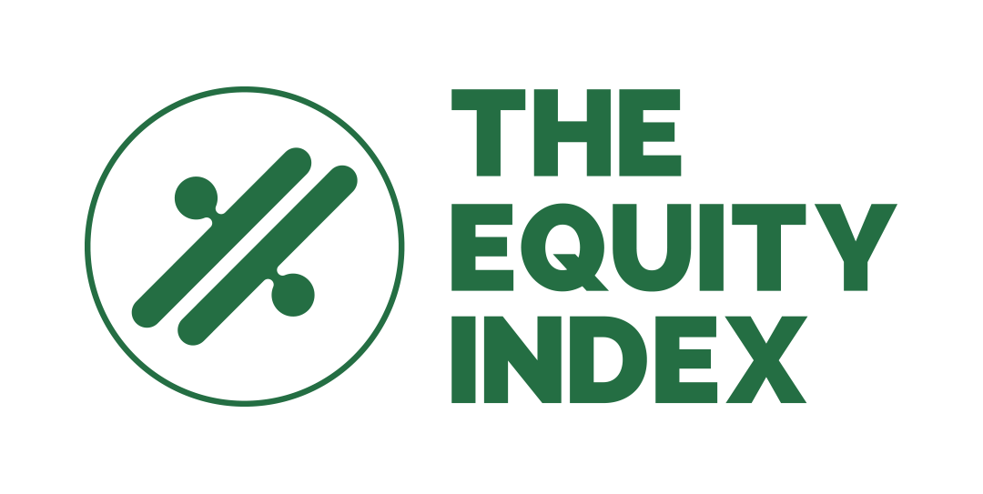

Please write to us if you have any questions, feedback, or anything else that you would like to share.

**Alex Martins:**[alex@theequityindex.org](mailto:alex@theequityindex.org)

**Lorriann Robinson:** [lorriann@theadvocacyteam.co.uk](mailto:lorriann@theadvocacyteam.co.uk)

1. By full-time equivalent, we mean staff who may be on consultancy or part-time contracts but have roles equivalent to a full-time employee.