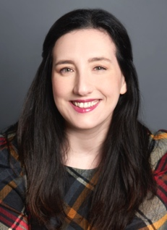
Cristen Stephansky

Height: 5’6”
Hair: Brown
Eyes: Green

Theatre – Representative List

The Haverton Howler | Ruthie Caldwell | Cumberland Theatre
Die, Mr. Darcy. Die | Louisa May Alcott | Best Medicine Rep
Diana of Dobson’s | Miss Morton | Endangered Species Theatre Project
Rules for Writing Christmas Cards | Mom | Best Medicine Rep
An Independent “Claus” | Santa’s Friends | Best Medicine Rep
A Shayna Maidel | Rose | Peace Mountain Theatre
Lost in Yonkers | Gert | Peace Mountain Theatre
Klecksography –Temple Snakes | Lucinda | Rorschach Theatre
Lettice and Lovage | Miss Framer | South Park Theatre
Everyone’s a Critic | Inspector | The Highwood Theatre
Play | W2 | Arcturus Theater Company
The Point (Women’s Voices Festival) | Julie | Arcturus Theater Company
Across A Crowded Room | Her | Pittsburgh New Works Festival
Two Lines | Rebecca | Pittsburgh New Works Festival
Passing | Emma | The Indian Ocean Theatre Company
Artful Justice | Doris Doolittle | Wisdom Productions
Glory Us | Seersha | Rabble Crew Productions
Deranged Durang | Zelda | LALA Theatre
Judgment Call (Reading) | Auxiliary Elizabeth | NextStop Theatre Company

Television & Film – Representative List

Dogs finding Cats PSA | Lead (Host) | 4 & 9 Productions
Academic Industrial | Lead (Mom) | 2U, Inc.
Blast from the Past! (Ep. 6 DNA) | Lead (Rosalind Franklin) | Fairfax Public Access
Bob Bell Ford Commercial | Supporting (Salesperson) | Freedom Digital
Americans For Pharma Reform | Supporting (Mom) | The Strategy Group

Education
National Conservatory of Dramatic Arts - 3-year program
Carnegie Mellon University, MBA
Penn State Erie, BS Honors Biology (Minor Economics)
Additional skills - Singing (Alto; 2 Octaves: G to G), Standardized Patient, Certified Paranormal Investigator, 1940s Hairstyles (Hair “Victory” Rolls & Pin Curls), Advanced Improv, Impersonations/Accents (British - Received Pronunciation (RP) and Cockney, Yiddish, American Southern, Eastern European)

