Cal Neva Driving Club 2026 Dates

Driving Workshops 2nd Wednesday of each month
Held at various local venues
2/11/26
3/11/26
4/8/26
5/13/26
6/10/26
7/8/26
8/12/26
9/9/26
10/14/26
11/11/26
12/9/26

CNDC Horse Driving Trial Series
5/9/26
6/20/26
7/12/26

*** Cal-Neva Driving Club does require membership to participate in our workshops, clinics and shows, the membership is annual and very reasonable ($10 youth, $25 adult and $40 family).

Other Club Dates that offer driving 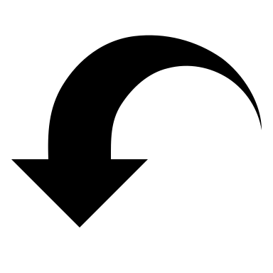

Fallon Horseman’s Association – Fallon Nevada (shows on Saturday & Gymkhana on Sunday – they offer driving divisions on both days).
May 2-3, 2026
May 30-31, 2026
August 8-9, 2026
September 19-20, 2026

Plumas Sierra Fair Driving show – Quincy California
August 29, 2026

