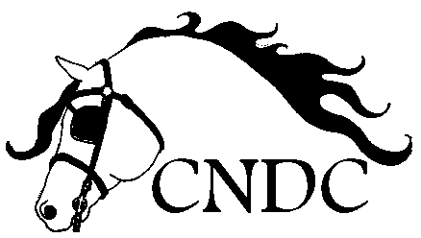

Cal Neva Driving Club
Membership application 2024

NAME:__________________________ DOB: _________________

ADDRESS:______________________________________________

HOME PHONE:______________ CELL:_____________________

EMAIL ADDRESS: _______________________________________

MEMBERSHIP TYPE AND ANNUAL DUE AMOUNTS:
___ADULT ($30)
___YOUTH – under 19, written guardian approval required ($10)
___FAMILY ($50) Please list family members on reverse side

WELCOME, NEW MEMBERS!
With CNDC, you’ll embark with fellows such as yourself on journeys to explore the sport of driving equines. CNDC offers educational outings, clinics, schooling and training competitions, play-days, vehicle, tack and harness swaps, fellowship, trail ride/drives and much more. We are a group of a wide variety of driving disciplines, with breeds of all sorts and sizes. CNDC is also open to riders and folks just hooked on the magic of horses and equines in harness. Join us and let’s roll!

Cal Neva Driving Club
CNDC
calnevadriving.com
calnevadriving@gmail.com
Mail to: 160 El Dorado Ave., Dayton, NV 89403

