Your RAC Leadership Council
Annette Miller | Chair
 | Co-Chair
Phil Bowling-Dyer | Treasurer
Grant Chen | Secretary
Cesar Escalante | Outreach Coordinator
Alvirdia Owens | Parliamentarian
RAC Contact: | hooverrac@gmail.com
Website | hoover-fosterrac.com
Facebook | HooverFoster
Nextdoor | Hoover-Foster
Instagram | hoover.rac
See the back of this agenda for additional helpful community contact information.
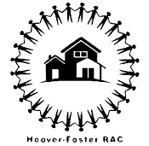
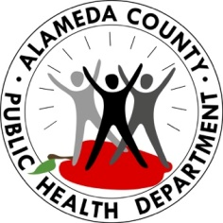

Hoover RAC Meeting
LOCATION: Zoom 867 4562 7618

DATE: January 6, 2021
START TIME: 6:00 PM
END TIME: 7:30 PM

MEETING MINUTES

Time | Topic (Who) | Notes
6:00 – 6:10 | 1. Introductions (Annette Miller) | 12 members present.  Annette, Phil, and Grant from leadership team present.
6:10 – 6:30 | 2. Pamela Price for Alameda County District Attorney (Pamela Price) | Did not attend
6:30 – 6:50 | 3. MLK Day Volunteer Event Planning (Annette Miller and Grant Chen) | Monday, January 17 from 10-12  Meet at 30th and MLK  Bring masks, gloves, litter pickup sticks  Masks will also be provided if needed  We will pick up litter along MLK  COVID friendly snacks are welcome  We may have lunch at Nibs afterwards for those who would like to join  Future projects could be:  Trash can mosaics  MLK corridor project coordinated with Keep Oakland Beautiful $5,000 grant  Beautifying bus stops
6:50 – 7:00 | 3. Community Announcements | Grant and Annette:  San Pablo Corridor grant for $2,000. Looking for someone to lead this work.  Ray Kidd:  West Oakland Neighbors is also doing this work and is planning to give the grant money to participants in the focus group. They are looking to get the work done by January 2022. They want 15 participants from the neighborhood to weigh in on San Pablo infrastructure. Participants should be diverse and representative of the neighborhood.  Jared Spencer  https://westoaklandhealth.org/ Children’s Vaccination Event Sat. Jan 8, 2022, 9am to 1pm. West Oakland Health Center.  Omicron COVID spike is the largest that we have ever had. The crisis is that so many people are out sick. Staffing at hospitals is so low they are in a crisis. Hospitalizations for COVID are low. If you are vaccinated, Omicron is not going to hit you as hard as other variants. Doctors are needing to triage and determine who gets limited treatments.  Here's an article: https://www.webmd.com/lung/news/20211223/remdesivir-hospital-covid#:~:text=Dec.,basis%2C%20a%20new%20study%20says  Raf is in an MSW program and is thinking about state policy for California and can share via email.  There may be a teacher sick out strike tomorrow.  Thanks to everyone who came out to the three Friday night events in December. We gave out toys to kids, engaged members of the community, gave out COVID vaccines, and more.

*See Reverse for More Information

