Your RAC Leadership Council
Annette Miller | Chair
 | Co-Chair
Phil Bowling-Dyer | Treasurer
Grant Chen | Secretary
Cesar Escalante | Outreach Coordinator
Alvirdia Owens | Parliamentarian
RAC Contact: | hooverrac@gmail.com
Website | hoover-fosterrac.com
Facebook | HooverFoster
Nextdoor | Hoover-Foster
Instagram | hoover.rac
See the back of this agenda for additional helpful community contact information.
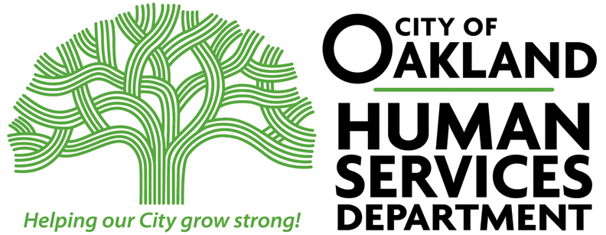
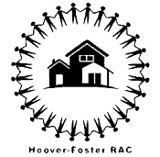
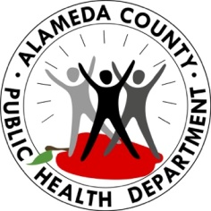

Hoover RAC Meeting
LOCATION: Zoom 867 4562 7618

DATE: April, 2021
START TIME: 6:00 PM
END TIME: 7:30 PM

MEETING MINUTES

Time | Topic (Who) | Notes
6:00 – 6:10 | 1. Introductions (Phil Bowling-Dyer) | Favorite summer activity  15 members present  Phil, Grant, Annette, and Alvirdia from leadership team present
6:10 – 6:25 | 2. Grant Opportunity (David Peters) | West Oakland Race and Equity Report. History of redlining, racism through home loans, and segregation. Howard Terminal project develops a Community Benefits fund that would go towards the community. City Council approved the environmental impact report. This left out Chinatown, so Chinatown asked for a seat at the table to have a say in the process of the project. David is recommending that West Oaklanders participate in the process for Howard Terminal. You can speak to council, write councilmembers, attend the Community Benefits meetings, etc. Luxury condos would be required to put 2.5% of transfer taxes to the community benefits fund.
6:25 – 6:40 | 3. Community Foods Next Steps | Last month we had a meeting about Community Foods and what next steps could be done.  Ray was happy about the turnout with intelligent questions and good discussion. The building is not being well maintained from graffiti. But there is a mural going up now. Mandela Foods co-owner is discussing a possible co-op, but the site is too big for Mandela Foods.  David thought it was a good meeting. This failure has implications for food desserts across the country. The site could be activated for events in the parking lot. There are groups interested in acquiring the site for different uses. If people are interested in acquisition and usage, reach out to David Peters.  Phil was happy the community came together. The trust that owns the building cares about projects like this. But the financial side was challenging.  Whitney said that CFM was never meant to be a standalone store. It wasn’t necessarily an anchor store without other businesses on San Pablo. Could be beneficial for a West Oakland business improvement district.  Ms. Cook asked if anyone has reached out to Brahm Amadi to get his thoughts on next steps.  David Peters said the building will not become condos due to the financing of the building. The building must stay a business for at least 5 more years. He also reached out to Brahm, who is on hiatus. But legally, it will take a long time to foreclose on Brahm and take control of the property. Community Vision is in full control of the property.  Janny will share info on a talk that Brahm will be giving. It’s important to continue conversation about the building. The YMCA has also been neglected.  Ray got a message from Carroll Fife planning another meeting about CFM.  https://urban-adamah.secure.force.com/WebEvent?eid=food-justice-film-screening-the-store-w-community-foods--2022414  https://www.facebook.com/events/703861637466635  David Peters: I'd like to invite you to an upcoming special screening of the film I've been making all these years about the rise and recent fall of Community Foods Market. The screening will be Thursday, April 14 in Berkeley. I'd especially like it if you can join us for this special event, and for you to do your best to spread the word to the West Oakland and CFM communities--shoppers, board members, staff, etc. I think this will be an especially meaningful event, a way to honor all the faith, love, intention, and hard work that folks put into the store.
6:40 – 6:55 | 4. In-Person RAC Meetings (Phil Bowling-Dyer) | What do people think about meeting in person?  Generally positive. Depends on the surge. Hybrid?  St. Mary’s may be a potential option that has a good setup for virtual meetings. But vaccination is required. Janny will ask if that’s possible.
6:55 – 7:10 | 5. Earth Day Clean-Up April 21, 22, 23 (RAC, St. Mary’s, Angela Moore (Neighborhood Service Coordinator NCPC), SAHA) | Janny is planning 3 wonderful events on Brockhurst and San Pablo on April 21 from 11-1. Some are geared towards seniors. West Oakland Indicators Project, Waste Management, Trader Joe’s, and Starbucks will be presenting. April 22 from 11-1 is a senior only event and luncheon screening a Will Smith movie. On April 23 as well from 11-1 is a clean-up on Brockhurst and San Pablo with Angela Moore and St. Mary’s.
7:10 – 7:30 | 6. Community Announcements | WOCAN BrownLikkaFriday #BLF Outdoor Season Opener - 4/29, 6 PM, 855 Brockhurst. Presentation by $OAK team.  WOBE (West Oakland Benefits for Equity) - 1st Sat of the month, 10-12, Zoom  https://www.eventbrite.com/e/black-liberation-walking-tour-tickets-260631294217  Did you know the City of Oakland is in the process of updating its General Plan for the first time since the 90's? This document will guide the growth and development of the City for the next 20 years! The Plan will cover all areas of living in Oakland including housing, transportation, noise, safety, environmental justice, and more. We are working to ensure that residents, whose voices have not historically been a part of the process, get to contribute to the development of the Plan! To prepare for these conversations, Deeply Rooted is holding a community education workshop to review the past and present policies that led to today's conditions in housing and environmental justice. Hear from Oakland unhoused leader Needa Bee (The Village in Oakland), environmental justice leader Ms. Margaret Gordon (West Oakland Environmental Indicators Project), Professor Margaretta Lin (Just Cities) and researcher Diana Benitez (Just Cities). Join us as we collectively ground ourselves in what's happened, and how we see Oak  https://www.oaklandca.gov/events/housing-and-environmental-justice-grounding-workshop-2  FOHDPL is hosting a fundraiser selling gourmet popcorn. Ships directly to your home. 50% of proceeds go to the library. Starts April 29 https://popup.doublegood.com/s/25bot0d5  FOHDPL is hosting a pop up street corner library on Earth Day on April 23 on Brockhurst at St. Mary’s to give away books.  Garden cleanup happening on April 16th at Hoover Elementary  Keep Oakland Beautiful is having a fundraiser event. If you can, tickets are here: https://www.eventbrite.com/e/earth-day-wrap-up-tickets-288856155537

*See Reverse for More Information

