Your RAC Leadership Council
Annette Miller | Chair
 | Co-Chair
Phil Bowling-Dyer | Treasurer
Grant Chen | Secretary
Cesar Escalante | Outreach Coordinator
Alvirdia Owens | Parliamentarian
RAC Contact: | hooverrac@gmail.com
Website | hoover-fosterrac.com
Facebook | HooverFoster
Nextdoor | Hoover-Foster
Instagram | hoover.rac
See the back of this agenda for additional helpful community contact information.
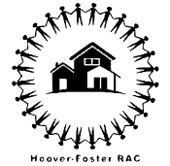

Hoover RAC Meeting
LOCATION: Zoom 867 4562 7618

DATE: May 5 2021
START TIME: 6:00 PM
END TIME: 7:30 PM

MEETING MINUTES

Time | Topic (Who) | Notes
6:00 – 6:10 | 1. Introductions (Phil Bowling-Dyer) | Something someone given to you. 16 members present.
6:10 – 6:25 | 2. Oakland 20 Year Plan (Ruslan Filipau from Oakland General Planning Office) | Khaliha Hayes and Diana Perez: The Oakland General Plan is being redone. This is the first time it is being redone in 20 years. It provides a plan for things like housing, open space, safety, racial justice and equity, environmental justice, climate change, and more. There will be multiple phases of community engagement. The state requires cities to incorporate elements of environmental justice.  Oakland 2045 General Plan | Community Events and Public Hearings https://www.oaklandca.gov/topics/meetings-and-events  main website: https://www.oaklandca.gov/topics/general-plan-update  all community events: https://www.oaklandca.gov/topics/meetings-and-events  we have two reports with lots of data - the EJ Baseline that we went over today and the map atlas that has more baseline data for the city  https://www.oaklandca.gov/topics/oakland-2045-general-plan-project-documents  West Oakland Reforestation Plan, 2013  https://drive.google.com/file/d/1UzxcHwn7KW_tpG8JX-RSD5uMndMUpJQf/view?usp=drivesdk  https://www.oaklandca.gov/resources/oakdot-geographic-equity-toolbox  Hydrogeology and Geochemistry of Aquifers Underlying the San Lorenzo and San Leandro Areas of the East Bay Plain, Alameda County, California.  https://pubs.usgs.gov/wri/wrir024259/ca0443text.pdf  The Tree Division is currently starting community engagement for the Urban Forest Master Plan: https://publicinput.com/Oaklandtrees  Thank you for your time and attention, and for the great feedback. Looking forward to continuing the conversation. Here is my complete contact information: https://www.oaklandca.gov/staff/diana-perez-domencich
6:25 – 6:40 | 3. Attitudinal Healing Connection and WOCAN (Amana Harris) | Please fill out West Oakland Cultural Assets Survey here: https://docs.google.com/forms/d/e/1FAIpQLScQkut-35c_XRWS4hB2CS6aY21pCL53821DbLjNNyz5oJHOrQ/viewform  Survey attempts to engage people about protecting cultural assets in the community such as murals and art. The super heroes project engaged students at Hoover Elementary over two years to gather their hopes and dreams. These are in the murals under the 580 freeway.  Share your thoughts on the survey to get your input.  Inspiring video: https://www.kqed.org/arts/13824746/young-oakland-superheroes-fight-for-their-mural  here is one article of how storytelling / cultural protective factors can lead to improved health outcomes for youth: https://www.walshmedicalmedia.com/open-access/culture-as-a-protective-factor-the-use-of-storytelling-in-a-teen-pregnancy-and-sti-prevention-curriculum.hccr.1000127.pdf
6:40 – 6:55 | 4. In-Person RAC Meeting in June (Phil Bowling-Dyer) | June RAC meeting will be in person at St. Mary’s Center. Hybrid options will be available.
6:55 – 7:30 | 5. Community Announcements | Brigitte Cook: Victim outreach for OPD. People are eligible for victim compensation for  The Cat Program hires people who are either formerly incarcerated or unhoused to clean the streets. Mostly in Clawson or the southern part of Hoover Foster. Collaberation with Hoover Foster and West Oakland Neighbors for June 25th from 10-1 to have people come out and focus on West Grand and San Pablo. Bring in the city and Ken Houston to do some deep cleaning of the homeless encampments around there. Block party. True Vine Ministries will have tables and resources.  Flyer: 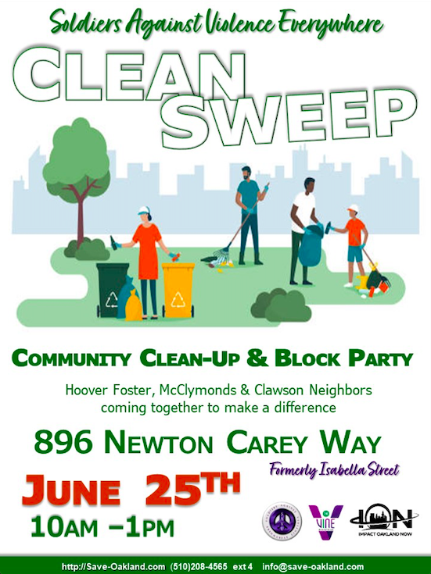  Brigitte Cook (510)238-6790 BCook@oaklandca.gov  https://www.oaklandca.gov/resources/victim-and-witness-assistance  WOCAN had a successful Brown Likka Friday. Will resume on May 13 and be on May 20 and May 27. There will be a speaker series of political candidates. 6 PM at David Peter’s house. Speakers start at 7 PM.  Invite everyone to AHC 24th annual artist exhibition on May 21st 2-5PM at 3115 West St. Some art may be available for sale. www.ahc-oakland.org  FOHDPL hosting a poetry contest for local youth. May 1st to May 28th  The winning student will present to city council.  Vote yes on measure C to support libraries without raising taxes. Contact Ms. Cook or Karen for a lawn sign.  Amos White  Founder & Chief Planting Officer  100K Trees for Humanity  amos@100ktrees4humanity.com  415.489.0074  Our Plan: http://bit.ly/100KTrees2030ss  Press Release  https://docs.google.com/document/d/14425P9Tzhugt9me7eYcM_vx6Z9Lge2HscGu6MOnuy38/edit  www.100ktrees4humanity.com

