Task and services are but not limited:

* Jump start vehicle
* Tire pressure check
* Unload items from vehicle
* Vacuum vehicle
* Gas vehicle
* Pick up/ drop off (T.V., Plants, and Plywood, packages etc.
* Pressure wash

1. Patio furniture
2. Garage floor
3. Porch
4. Siding

* Setup or put away patio furniture
* Limited yard disposal (+ cost)
* Remove spider-webs
* Clean gutters
* Low voltage lights
* Exterior holiday wreathes
* Garage shelving
* Shrub trimming
* Tree trimming
* Dog patch grass (+ cost)
* Turn on/off exterior water supply for hoses
* Turn on/off water supply for sprinklers
* Water plants in or outside

[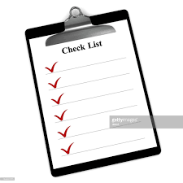](https://www.google.com/imgres?imgurl=https://media.gettyimages.com/photos/clipboard-checklist-picture-id184401615&imgrefurl=https://www.gettyimages.com/detail/photo/clipboard-checklist-royalty-free-image/184401615&docid=grjJAi2FU4g0tM&tbnid=QACHiNKfM4QnkM:&vet=1&w=1024&h=1024&bih=790&biw=1670&ved=0ahUKEwi1q_Xos-DbAhWvq1kKHWI6DrYQMwjPAShHMEc&iact=c&ictx=1)

* Change furnace filters
* Battery replacement
* Move furniture
* Get decorations down/up
* Replace lightbulbs
* Exchange smoke detectors
* Add salt to water softener
* Check on your house
* Check on your pets
* Check on you
* Set timers
* Hang pictures
* Adjust clocks
* Errands