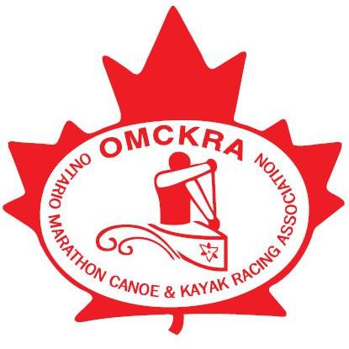
OMCKRA Membership Form

Pay online at https://raceroster.com/memberships/4897/omckra-2026 or
Send this form and an e.transfer to omckra@gmail.com or
mail this form and a cheque made out to OMCKRA to: OMCKRA, 23 Patrick Drive, Aurora ON L4G 2A6
Name:
Address
Phone: |  |  | Email
Fee schedule |  |  | Enter Fee ($) |  | Date of birth (dd/mm/yyyy)
Individual/Race Organizer (per race) |  | $50
Full Time Student or <18 yr. as of Jan 1, 2026 |  | $40
Family (Child <20 yr. as of Jan 1 with parent)  Parent to provide family info (Max 4 adults) |  | $70
List family paddler names & birth dates below or use separate page |  |  |  |  | Date of birth (dd/mm/yyyy)
Fair play agreement, waiver and concussion policy must be agreed to by members: As a Member of OMCKRA, I agree to behave in a sporting way, with a sense of fair play and to follow the rules and directions of Organizers of OMCKRA Sanctioned or Recognized Events. Waiver: I have read and agree with the full waiver printed below. I hereby waive and release any and all claims against Ontario Marathon Canoe Kayak Racing Association (OMCKRA) and its directors, volunteers and staff, for any and all damages or injuries arising out of participation in any events or activities by me and/or my dependents and/or my guests. I hereby grant for the minors listed above, as their parent or legal guardian, permission to participate in OMCKRA sanctioned events and activities. Rowan's Law (concussion policy): I confirm that I have reviewed the Concussion Awareness Resources document at the Ontario government site: https://www.ontario.ca/page/rowans-law-concussion-awareness-resources
RELEASE FROM LIABILITY AND ASSUMPTION OF RISKS - OMCKRA
1. I acknowledge that the activities involve risk, dangers and hazards inherent in canoeing, kayaking and associated outdoor water sports (the Inherent Risk). And further acknowledge that in addition to the inherent risk the Activities involve certain additional risks, dangers, an d hazards, some of which may include (but are not limited to): physical exertion for which I may not be prepared; weather extremes, including sudden and unexpected changes, dangerous water conditions, including cold water and movement, waves, currents, rapids and white water, collision with natural and man-made objects, including rocks and other boats, and equipment malfunction or failure (collectively the Additional Risks).
2. I acknowledge that the enjoyment and excitement of my participation in the activities is derived, in part from the Inherent Risk and the Additional Risks and I agree to freely accept and fully assume all risk of personal injury, death, property damage or less, resulting from any cause whatsoever, including but not limited to the Inherent Risk and the Additional Risks and active or passive negligence, imprudence, lack of skill, error of judgment, breach of contract or breach of statutory duty of care on the part of the Organizer or the Ontario Marathon Canoe and Kayak Racing Association (OMCKRA). For greater certainly and without limiting the foregoing, I acknowledge that I use the equipment and facilities of the Organizer and OMCKRA with understanding of the nature, condition and state thereof and entirely at my own risk and acknowledge that I am solely responsible for the safety of my person and property and that the Organizer and OMCKRA assume no responsibility whatsoever for the safety of my person or property in connection with the Activities.
3. I waive any and all claims I may now and in the future have against and release and forever discharge from liability and agree not to sue the Organizer and/or OMCKRA for any personal injury, death, property damage or less sustained by me as a result of my participation in the Activities due to any cause whatsoever, including but not limited active or passive negligence, imprudence, lack of skill, error of judgment, breach of contract, or breach of statutory duty of care on the part of the Organizer or OMCKRA.
4. I agree to save harmless and indemnify the Organizer and OMCKRA from and against any and all liability for any personal injury, death, property damage or less to any third party, resulting from my participation in the Activities or in the operation of the Organizer.
5. I agree that I am responsible for all costs of rescue or medical attention rendered to me or for my benefit, arising from the Activities and I agree to indemnify the Organizer and OMCKRA from any and all liability in respect of any and all such costs.
6. I acknowledge that in signing this waiver and release I am not relying on any oral, written or visual representations or statements made by the Organizer or OMCKRA.
7. I agree that this Waiver and Release shall in all respects be governed by and interpreted in accordance with the laws of the province of Ontario.

Full Name:_____________________________________ Signature: ___________________________________________

Note: Members receive annual meeting notices and newsletters via e-mail, are eligible to vote, are covered for insurance in OMCKRA sanctioned events and may apply to participate in provincial and national awards competitions. Personal information collected by OMCKRA is used to provide services to our members. These services require administrative responsibilities such as documentation of insured events and instructor registration. A limited information membership list (names and city) is provided to race organizers for insurance purposes. Private information is never given to anyone by OMCKRA for other reasons. People registering for OMCKRA coaching or who have taken part in an insured event may receive membership information from OMCKRA in the next calendar year.

