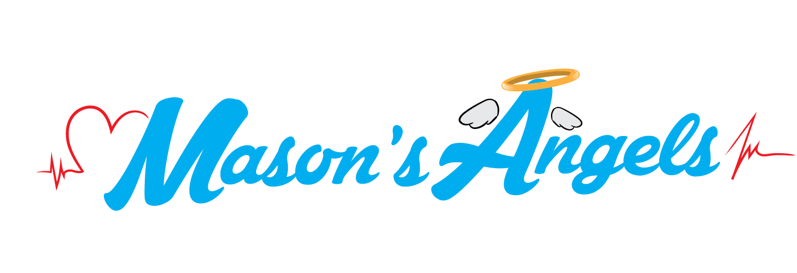

Family & Friends,
We are proud to announce the beginning of a new chapter with Mason's Angels. Our nonprofit organization is officially a 501c3. To those who have supported Mason's Angel's in the past, we are genuinely grateful for your contributions.
To be one of the first OFFICIAL donors of Mason's Angels 501c3 we kindly ask you consider contributing $25, $50, $100, $200 or more. Donations can be made at paypal.me/masonsangels OR make check payable to:
Mason's Angels
79 Sawgrass Dr
Laplace, LA 70368
Thank you, genuinely, in advance for your love & support. Visit masonsangels.org for additional info or feel free to email us at give@masonsangels.org.

Team Mason
www.masonsangels.org

