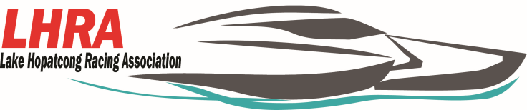

**2020 New Jersey State Power Boat Races**

**September 26-27, 2020 at the Hopatcong State Park**

**Official Race Program Ad Options**

All ad copy must be provided in one of the following hi-res electronic formats- PDF or a JPEG. All artwork is due on or before September 5th, 2020 emailed to [lakehopatcongracingassociation@gmail.com](mailto:lakehopatcongracingassociation@gmail.com). All artwork will be printed exactly as provided; no changes or corrections will be made to it. Business cards do not qualify for a larger ad then a business card ad.

Inside Cover……….…………………………………………………………………………………………………………..$ 700.00

Full Page Ad- 8.5x11……………………………………………………………………………………………………….$ 600.00

Half Page Ad- 8.5x5.5………………………………………………………………………….............................$ 300.00

Quarter Page Ad- 4.25x5.5…………………………………………………………………………………………….$ 150.00

Business Card Ad……………………………………………………………………………………………………………$ 100.00

Payment Method: Amount Paid $ _____________________ Check # _______________________

Company Name _________________________________________________________________

Contact:________________________________________________________________________

Address:_______________________________________________________________________

Phone#:_______________________________________________________________________

Email:_________________________________________________________________________

**Checks made payable to: Lake Hopatcong Racing Association**

**Mailing Address: Po Box 155 Lake Hopatcong, NJ 07849**

Advertiser’s signature_______________________________________________________

Thank you for your advertising support and look forward to seeing you at the race!!!!!

Receipt for payment: Lake Hopatcong Racing Association is a non-profit organization Tax # 22-5154765

Check # ______________ Amount _________________ Ad size ______________________________

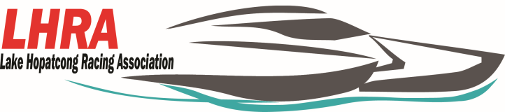

**2020 New Jersey State Power Boat Races**

**September 26-27, 2020 at the Hopatcong State Park**

**Vendor**

All vendors must have certificate of insurance listing LHRA, APBA and State of New Jersey Department of Environmental Protection Division of Parks and Forestry as additional insurers.

The addresses are:

**State of New Jersey Department of Environmental Protection Division of Parks and Forestry**- 6 Lakeside Blvd, Landing, NJ 07850,

**APBA**- 17640 East Nine Mile Rd Po Box 377 Eastpointe, MI 48021-0377.

**LHRA**- Po Box 155 Lake Hopatcong, NJ 07849

For food Vendors we will also need the NJ Health Application. All certificates must be to us by the event date or emailed to [lakehopatcongracingassociation@gmail.com](mailto:lakehopatcongracingassociation@gmail.com). If you have any questions please contact Jennifer at (973)876-3727.

**Fees:**

**$150.00(a weekend) for a food vendor**

**$100.00 (a weekend) for any other type of vender.**

Vendor:_______________________________________________________________________

Contact:______________________________________________________________________

Address:______________________________________________________________________

Phone#:______________________________________________________________________

Email:_______________________________________________________________________

Payment Method: Amount Paid $ _____________________ Check # _____________________

**Checks made payable to: Lake Hopatcong racing Association**

Advertiser’s signature__________________________________________________________

.

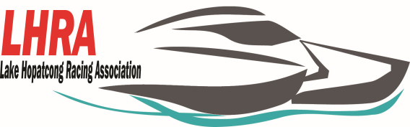

**2020 New Jersey State Power Boat Races**

**September 26-27, 2020 at the Hopatcong State Park**

**Hydroplane Sponsor $500.00**

Your companies name will appear on a Hydroplane that will be competing in the two- day event. The cost includes the production of the vinyl lettering and a framed 8x10 photo. Your company will also be announced during the heat racing and the finals. Your boat could be the 2020 New Jersey State Champion!!

**Silver Package $1000.00**

* Program Book-You will receive a half page ad in our souvenir event program.
* Sponsorship will be mentioned on the PA during both days of the event.
* Access passes to the pits Qty. 5
* You will have the opportunity to demo, sell product, and offer information at an on-site booth. (size is 10x10)

**Bronze Sponsor Package $1500.00**

* Program Book-You will receive a full page ad on the back cover in our souvenir event program.
* You will have the opportunity to demo, sell product, and offer information at an on-site booth. (size is 10x10)
* Sponsorship will be mentioned on the PA during both days of the event.
* Access passes to the pits Qty. 5
* Your banner displayed on the event grounds.