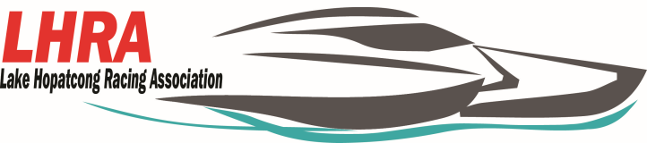

**2020 New Jersey State Power Boat Races**

**September 26-27, 2020 at the Hopatcong State Park**

**Vendor**

All vendors must have certificate of insurance listing LHRA, APBA and State of New Jersey Department of Environmental Protection Division of Parks and Forestry as additional insurers.

The addresses are:

**State of New Jersey Department of Environmental Protection Division of Parks and Forestry**- 6 Lakeside Blvd, Landing, NJ 07850,

**APBA**- 17640 East Nine Mile Rd Po Box 377 Eastpointe, MI 48021-0377.

**LHRA**- Po Box 155 Lake Hopatcong, NJ 07849

For food Vendors we will also need the NJ Health Application. All certificates must be to us by the event date or emailed to [lakehopatcongracingassociation@gmail.com](mailto:lakehopatcongracingassociation@gmail.com). If you have any questions please contact Jennifer at (973)876-3727.

**Fees:**

**$150.00(a weekend) for a food vendor**

**$100.00 (a weekend) for any other type of vender.**

Vendor:_______________________________________________________________________

Contact:______________________________________________________________________

Address:______________________________________________________________________

Phone#:______________________________________________________________________

Email:_______________________________________________________________________

Payment Method: Amount Paid $ _____________________ Check # _____________________

**Checks made payable to: Lake Hopatcong racing Association**

Advertiser’s signature__________________________________________________________

.