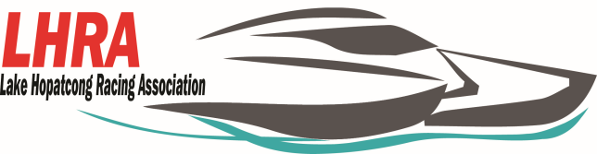

**P*.O. Box 155***

***Lake Hopatcong, NJ 07849***

**Membership Application**

The **Lake Hopatcong Racing Association (LHRA)** was formed in the mid 1960’s to promote the sport of Power Boat Racing in the Lake Hopatcong Area. Since this time, members of the LHRA have been competing in events around the country in events around the country sanctioned by the **American Power Boat Champions (APBA)** with great success. LHRA has several members who have become national champions, national high point champions and world record holders. LHRA has members who have been racing for more than 25 years and members who have never been in a race boat. **The LHRA members meet the second Tuesday of every month.**

If you are interested in becoming a part of this exciting sport, please join us!!!

Name: ________________________________________________________________________

Address:_______________________________________________________________________

City:_________________________State:_____________________________Zip:____________

Cell Phone:_____________________________________________________________________

E-mail:________________________________________________________________________

Membership: Individual $25.00 Annually_____________________________________________

Family $40.00 Annually (up to 2 additional) Names________________________________________________________________________

______________________________________________________________________________

Signature:______________________________________________Date:___________________

Paid ___________________________________________

For More information please contact us via email at [lakehopatcongracingassociation@gmail.com](mailto:lakehopatcongracingassociation@gmail.com)

Make checks payable to LHRA..