Hydro-Ultra Plus Application
Lexington County Landfill, SC
July 1, 2013

Hydro-Ultra Plus was added to the hydroseeding slurry at 5 gallons per acre and applied June 17th, 2013. Below picture is germination as of July 1, 2013.

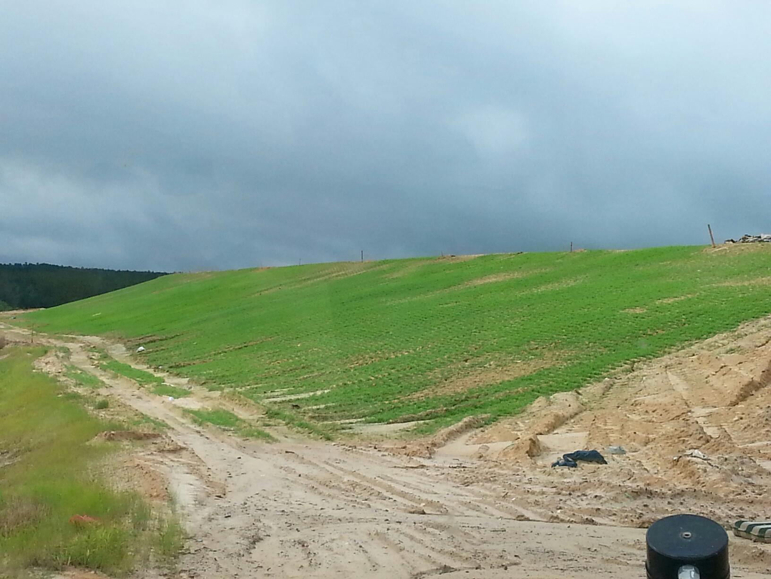

Below pictures were taken at the site on September 20th, 2013

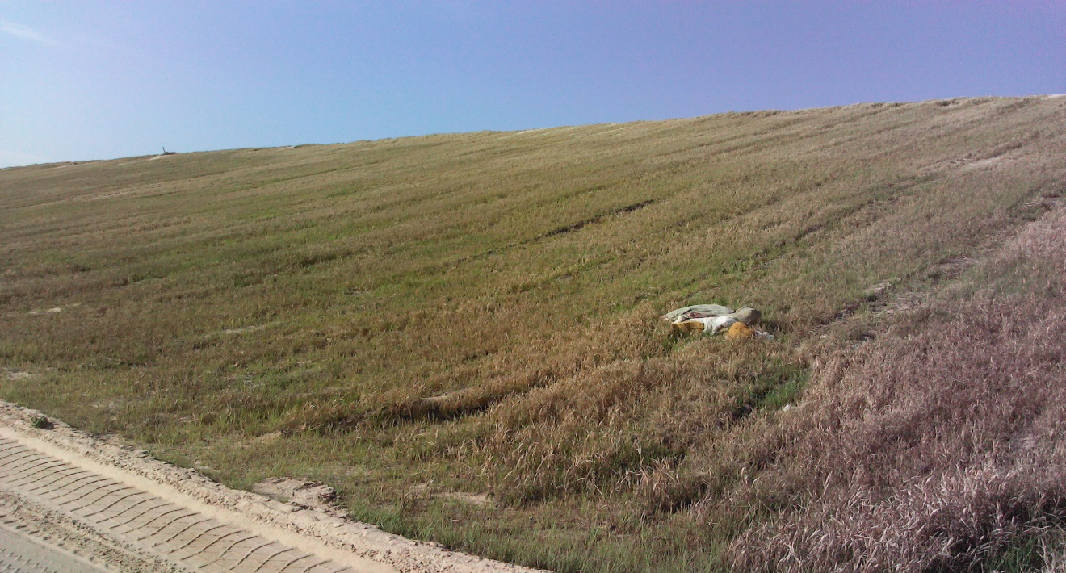

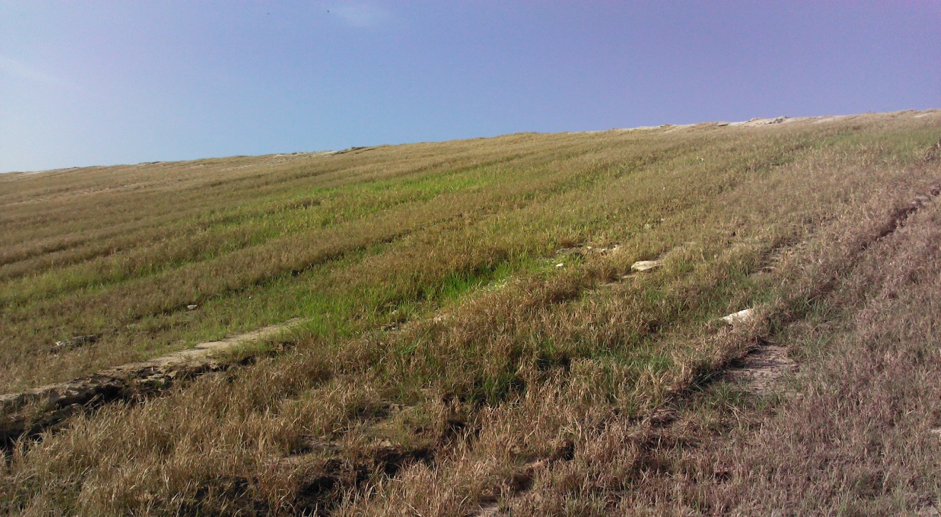

Below pictures taken on April 2nd, 2014

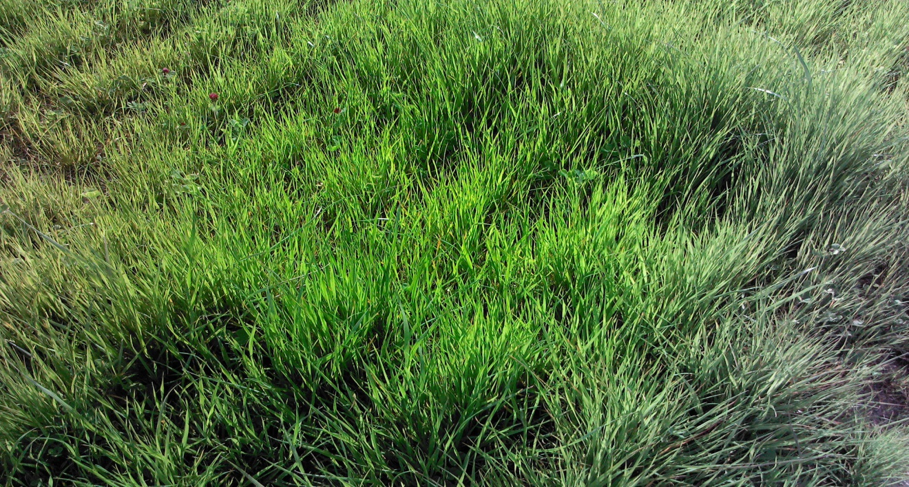
Stayed green all winter.

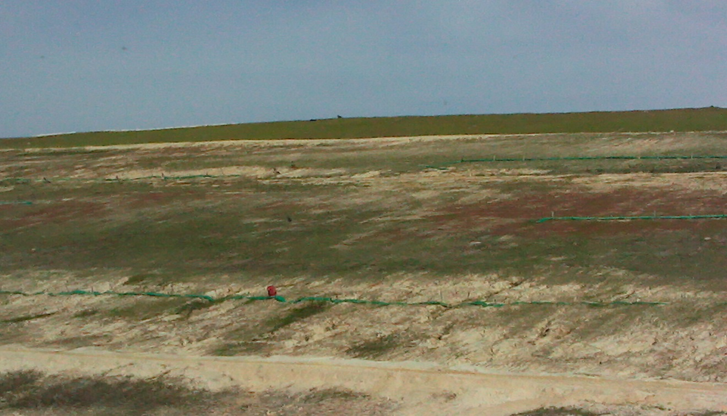
Hydroseeded area sprayed on June 17th, 2013, stayed green through the winter when temperatures dipped into the teens.

