**Chicken Gyros**

**TZATZIKI sauce:**

* grate a cucumber about 1/2 - 3/4 cup & squeeze out juice
* 1 1/4 cups Greek yoghurt, preferably full fat
* 1 tbsp lemon juice
* 1 tbsp extra virgin olive oil (or more if you want richer)
* 1 garlic clove, minced
* 1/4 tsp salt
* ½ teaspoon dill.
* Black pepper

**SALAD:**

* ▢3 tomatoes, *desseeded and diced*
* ▢3 cucumbers, *diced*
* ▢1/2 red Spanish onion, *peeled and finely chopped*
* ▢1/4 cup fresh parsley leaves *(optional)*
* *Dill*
* ▢Salt and pepper

**MARINADE :**

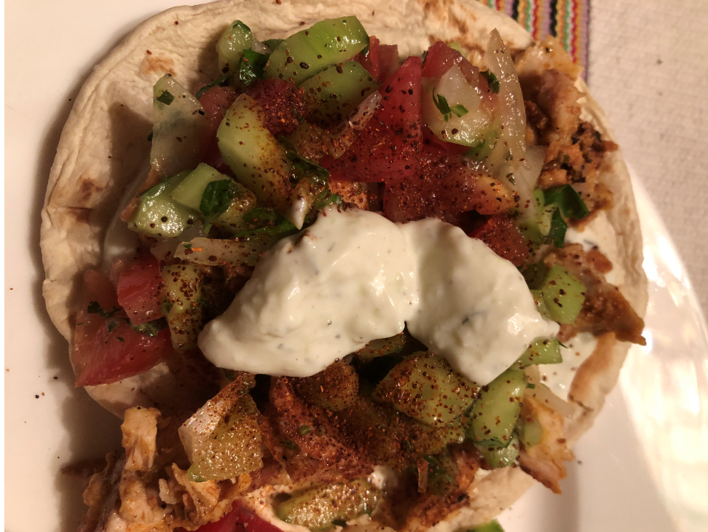

* 1.5 cups Greek yogurt
* Juice from 1 large lemon
* 1/2 cup olive oil
* 1 tablespoon kosher salt
* 1 tablespoon garlic, minced
* 1 tablespoon coriander powder
* 1 tablespoon paprika
* 1 tablespoon ground cumin
* 1 tablespoon oregano
* ½ teaspoon cayenne pepper
* 1 teaspoon cinnamon
* 1 teaspoon black pepper

**Preparation:**

Take 4 – 5 lbs of boneless chicken thighs or thinly sliced breast and marinate from 4 hours to overnight.

Skewer the chicken thighs on the vertical skewer with larger slices on the bottom

Cook for 60-90 minutes at 450 deg. F. rotating periodically until internal meat thermometer reaches 165 Deg. F

In a heated flatbread spread tzatziki and add chicken and salad, top with more tzatziki and sprinkle with hot or mild chili powder.

Enjoy