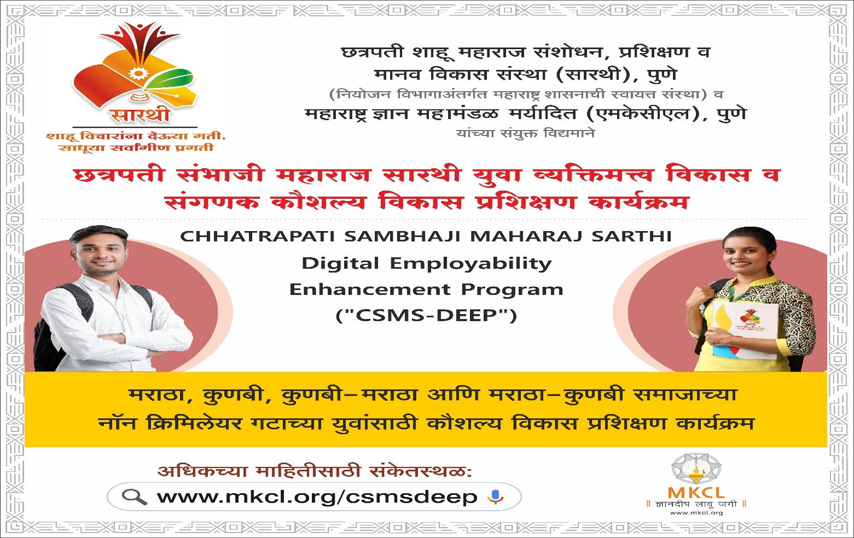
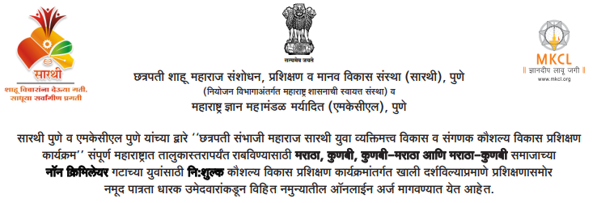

CSMS-DEEP Diploma
CSMS-DEEP will have 4 modules each of 120 hours. Candidates successfully completing all the 4 modules will receive CSMS-DEEP Diploma. The details of the modules are as shown in Table below:
1 | CSMS-DEEP Diploma Module 1: ECS  (120 hrs) | Certificate in English Language Skills, Communication Skills and Soft Skills
2 | CSMS-DEEP Diploma Module 2: ITS  (120 hrs) | Certificate in Basic Information Technology Skills  (For Employability Enhancement)
3 | CSMS-DEEP Diploma Module 3: DS-BDS  (120 hrs) | Certificate in Domain Specific Basic Digital Skills  In this Module, Candidates is expected to select any one employment domain as Elective such as data management / financial accounting / ... etc. from modules on multiple optional domains provided by MKCL.  Candidate is expected to master the digital skills in the chosen domain.
4 | CSMS-DEEP Diploma Module 4: DS-ADS  (120 hrs) | Certificate in Domain Specific Advanced Digital Skills  In this Module, Candidate is expected to take simulated real-life hands-on work experience in the chosen employment domain in Module 3 so as to attain and enhance employability.

Module Details
CSMS-DEEP will have 4 modules each of 120 hours. Candidates successfully completing all the 4 modules will receive CSMS-DEEP Diploma.

The details of the modules are as shown in Table below:
1 | CSMS-DEEP Diploma Module 1: ECS  (120 hrs) | Certificate in English Language Skills, Communication Skills and Soft Skills
2 | CSMS-DEEP Diploma Module 2: ITS  (120 hrs) | Certificate in Basic Information Technology Skills  (For Employability Enhancement)
3 | CSMS-DEEP Diploma Module 3: DS-BDS  (120 hrs) | Certificate in Domain Specific Basic Digital Skills  In this Module, Candidates is expected to select any one employment domain as Elective such as data management / financial accounting / ... etc. from modules on multiple optional domains provided by MKCL.  Candidate is expected to master the digital skills in the chosen domain.
4 | CSMS-DEEP Diploma Module 4: DS-ADS  (120 hrs) | Certificate in Domain Specific Advanced Digital Skills  In this Module, Candidate is expected to take simulated real-life hands-on work experience in the chosen employment domain in Module 3 so as to attain and enhance employability.

In Third Module, candidate is expected to select any one employment domain as Elective. There are 10 Electives as mentioned below. Candidate has a choice to select any 1 Module out of below 10 available options. In Fourth Module, candidate is expected to take simulated real-life hands-on work experience in the chosen employment domain in Module 3.
Sr. No. | Elective / Track | Course Name
1. | Data Entry & Data Management | Data Management with Advanced Excel
2. | Accounting | Financial Accounting with Tally. ERP 9 & GST + MS Excel and Accounting as Information System
3. |  | Advanced Financial Accounting and Advanced Excel
4. | Designing | Desktop Publishing (DTP)
5. |  | Web Designing
6. | Hardware & Networking | Hardware & Networking
7. | Programming | Mobile App Development
8. | Digital Freelancing | Digital Freelancing
9. | Management | Retail Management
10. |  | Banking, Financial Services & Insurance (BFSI)

Each module is of 120 hours’ duration with 99 hours of training spread over 6 weeks, 6 days per week, 3 hours per day. Each day is divided into 3 sessions each of 60 minutes. Remaining 21 hours of supervised continuous comprehensive personalized online assessment of 3.5 hours per week. i.e. on a weekend the candidate has to be present at the TSP ALC for 3 + 3.5 = 6.5 hours.
Entire Program Duration is, thus, 480 hours spread over Six Months.

Program Online Application
- CSMS-DEEP Diploma registration will be implemented in two batches in a year (Six month of each).
- Candidates are expected to apply at least 30 days before commencement of their desired batch.
- Candidates should apply online on the CSMS-DEEP Portal for registration for a particular batch and upload the scanned images of documentary proofs of their eligibility and give their choice of nearby MKCL shortlisted ALC for seeking admission and undergoing training of CSMS-DEEP Diploma.
- Candidates may seek local support for online application, if required, from nearby MKCL shortlisted ALC.
- MKCL ALC chosen by the candidate shall use its login to the CSMS-DEEP portal and verify the candidate’s data and supporting documents and confirm his/her eligibility by following step by step process in the registration software on the portal.
- Respective LLC will verify each Candidates details from their login.
- SARTHI Authorities will finally approve the Candidates details from their login.
- Registered (approved & verified) candidate shall pay to MKCL through the respective ALC a security deposit of Rs.2000/- so as to confirm his/her admission to the First Module of CSMS-DEEP Diploma.
- After reconciliation of receipt of security deposit, MKCL will admit the candidate for the First Module by issuing the login credentials for the Module to her/him.
- After successfully completing the First Module, the logins for Second Module will be issued by MKCL after carrying forward the previously paid security deposit. Concerned candidate will get Certificate of First Module within specified period.
- After successfully completing the Second Module, the logins for Third Module will be issued by MKCL after carrying forward the previously paid security deposit. Concerned candidate will get Certificate of Second Module within specified period.
- After successfully completing the Third Module, the logins for Fourth Module will be issued by MKCL after carrying forward the previously paid security deposit. Concerned candidate will get Certificate of Third Module within specified period.
- After successfully completing the Fourth Module, security deposit of Rs.2000/- will be refunded to concerned candidate through MKCL ALC. Concerned candidate will get Certificate of Fourth Module along with CSMS-DEEP Diploma within specified period.

Program Learning Medium
Modules 1 and 2 under CSMS-DEEP will be offered in English and Marathi. However, to seek access to global employment opportunities in digital economy, it is advisable that the candidates may prefer learning in English Medium. It is in this context, Module - 1 has to be dedicated to English Language Skills and allied skills required to navigate confidently in global digital economy. Modules 3 + 4 under CSMS-DEEP will be offered only in English.

Program Learning Methodology
All the 4 modules mentioned above are to be learned in eLearning mode in MKCL’s Authorized Learning Centers (ALCs) on an internet-ready multimedia computer with specified configuration with a connected headphone. The candidates will be assisted by dedicated expert Learning Facilitators in the ALCs.

Program Validity Period
- The validity period of candidature of an admitted candidate shall be 12 months wef. the date of confirmation of admission. As such, the candidates not able to complete CSMS-DEEP Diploma ideally in 6 months due to college exams or such other exigencies may get a reasonable number of extra months to complete it.
- The candidate has to complete the all modules sequentially within the validity period.
- S/he will be able to enter and learn every next module only after successfully completing the current module in every respect.
- The security deposit of the candidates unable to complete the CSMS-DEEP Diploma successfully within the validity period of 12 months shall be forfeited. Such candidates shall be given certificates only for completed modules, if any, by MKCL and SARTHI.

Certificate
- Those Candidates who will successfully complete the entire Module and pass the final exam, such Candidates will get ‘Module wise Certificate’ jointly certified by SARTHI & MKCL.
- Those Candidates who will successfully complete all the 4 Modules and pass the final exam of all the 4 Modules, such Candidates will get ‘CSMS-DEEP Diploma - Certificate’ jointly certified by SARTHI & MKCL.

CSMS-DEEP Eligibility
- Candidate should be between 18 to 45 years of age on the date of registration;
- Candidate should be 10th Standard passed;
- Income Certificate of Parent / Guardian Less than 8.00 lakhs (Non creamylayer)
- Maharashtra State Domicile Certificate.
- Candidate should produce valid documentary proof/s as stipulated by SARTHI to prove that s/he is belonging to SARTHI’s Target Group (Maratha, Kunbi, Maratha-Kunbi and Kunbi-Maratha).
- Document Submission by Candidate:
  - Caste Category: Maratha
    - ‘Maratha Caste Certificate and Non-Creamy Layer Certificate OR ‘EWS Certificate’
  - Caste Category: Kunbi
    - OBC Certificate
    - Non-Creamy Layer Certificate OR Income Certificate of last 3 years
  - Caste Category: Kunbi-Maratha
    - OBC Certificate
    - Non-Creamy Layer Certificate (Date of Issue, Certificate valid upto) OR Income Certificate of last 3 years
  - Caste Category: Maratha-Kunbi
    - OBC Certificate
    - Non-Creamy Layer Certificate OR Income Certificate of last 3 years
- Common Documents:
  - AADHAAR card
  - Domicile of Maharashtra Certificate
  - 10th Pass Certificate / Marksheet
  - Date of Birth & Age Proof
  - Photo & Sign

General Terms & Conditions
- Candidate need to provide the correct information (personal, academic, etc.). If application / admission got cancelled at any given stage due to the wrong / false information provided by Candidate, then it will be the sole responsibility of the concerned Candidate for any kindly of action in this regard by appropriate authority.
- Candidates application will be considered only based on the first come first serve basis and the availability of the intake capacity for the respective ALC and overall quota of this project.
- Candidates application will be considered based on the fulfillment of all the requisite criteria’s stipulated by SARTHI and MKCL from time to time.
- Candidates cannot claim or force to any of the authority for the application / admission / selection / placement process.
- Candidates shall abide by the various Rules, Regulations, Code of Conduct, Guidelines, Communications, and Norms issued and specified by SARTHI & MKCL from time to time.
- SARTHI and MKCL may use contact & other details for any promotional or business-related activities.
- If any Candidates tries to take the undue benefit in any means by contacting directly or indirectly to SARTHI and / or MKCL and / or MKCL’s Network Partner by email, letter, telephone, social media, etc. then we will reject the application / candidature of that Candidate without giving any reason.
- SARTHI and MKCL reserves the right of granting and/or rejecting approval to any Candidate, without assigning any reason/s whatsoever to anyone.
- SARTHI and MKCL reserves the right to modify the terms and conditions of the entire process without any prior notice and SARTHI & MKCL shall not be liable to anyone for any such modification/s.

