**Official 2025 Washington Parish Fair Shirt**

**& Parade Bag now available for pre-order**

| **We appreciate your support!**  **Shirts purchased as pre-orders raise money for your school**  **and the Washington Parish Free Fair!** |
| --- |

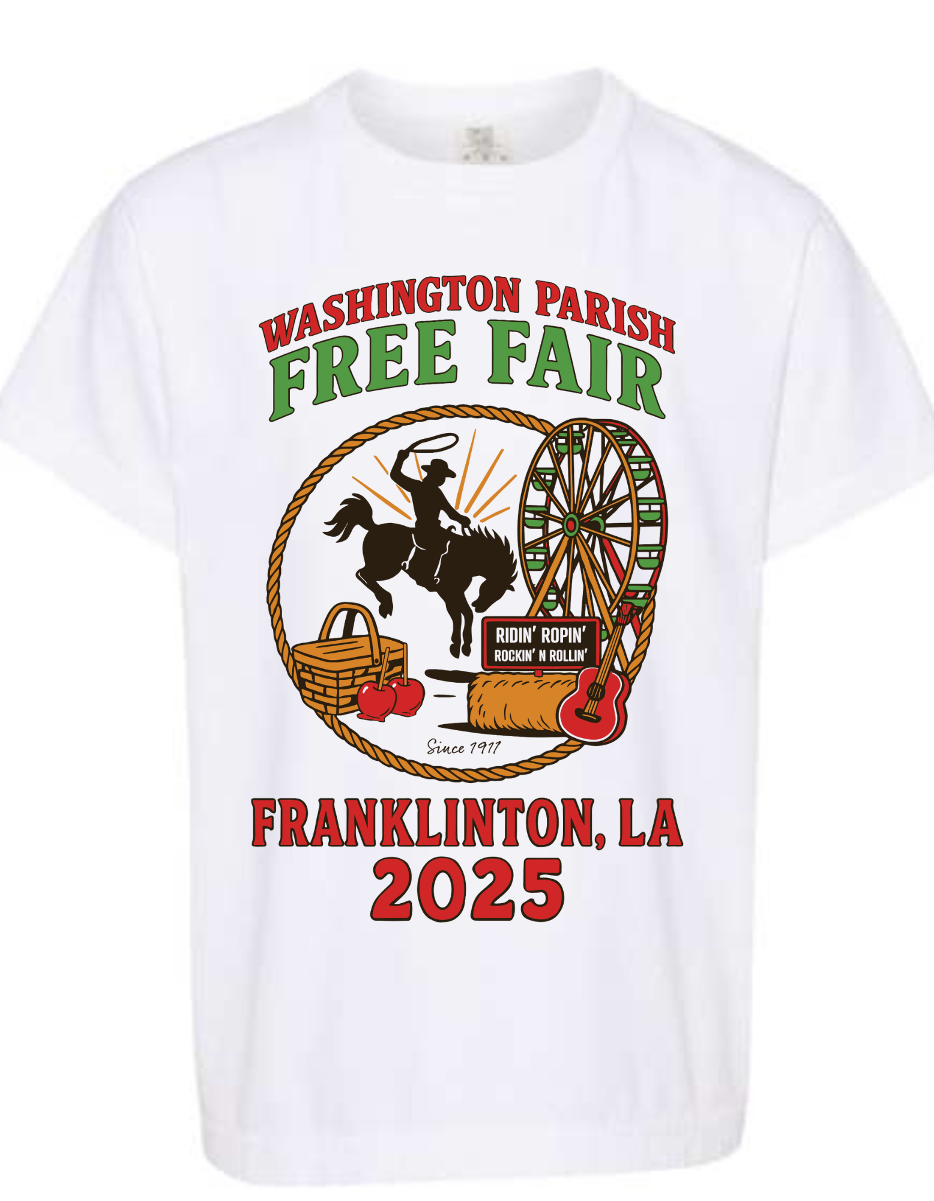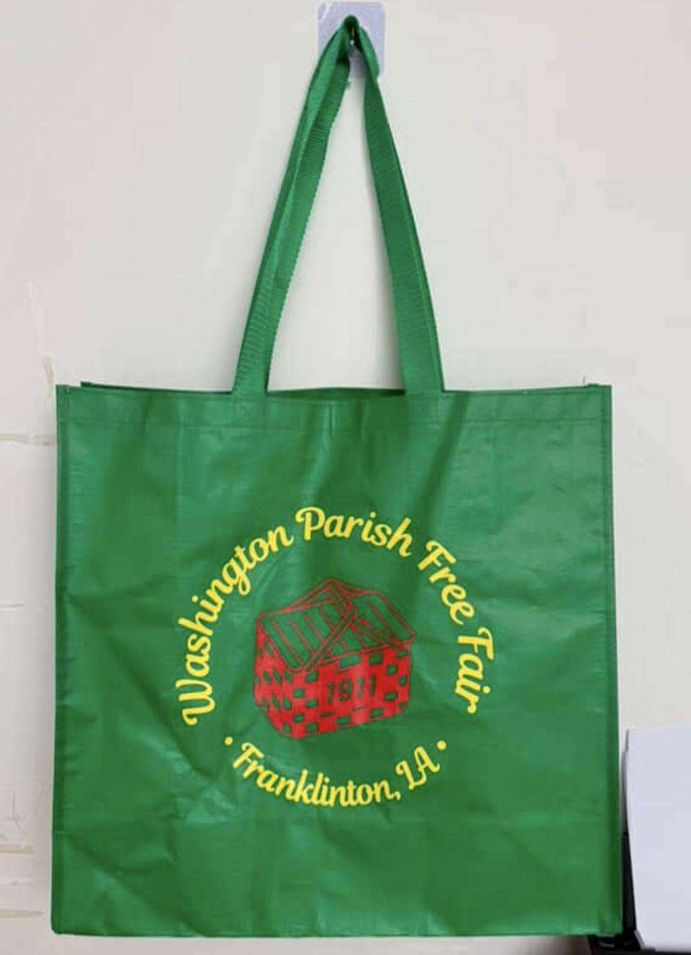

Shirts are a screen printed front design on a white comfort colors t-shirt.

**NEW ITEM ALERT!!! - Parade Bags are $5 each and are green with a red and yellow design.**

**SHIRTS are $22 each \***(upcharge for 2x and 3x)

**Order deadline is September 11, 2025**

SCHOOL: ___________________________________________________

STUDENT NAME: ____________________________________________

GRADE: __________ TEACHER: __________________

YOUTH SIZES: ____ Youth Small ADULT SIZES: _____ Small

____ Youth Medium _____ Medium

____ Youth Large _____ Large

_____ X Large

**ADDITIONAL $2 charge…** _____ 2X

**ADDITIONAL $4 charge…** _____ 3X

Total # of Shirts _________ x $22 each = ____________ Total

Total # of Shirts _________ x $24each = ____________ Total (2x)

Total # of Shirts _________ x $26 each = ____________ Total (3x)

**Total # of Parade Bags ______ x $5 each = _________ Total**

**Check# ______ or Cash______ Grand Total of Purchase $_____________**

**(make checks payable to your specific school)**