**BGS Homecoming Shirt Order Form**

**Lights Camera BUCS!**

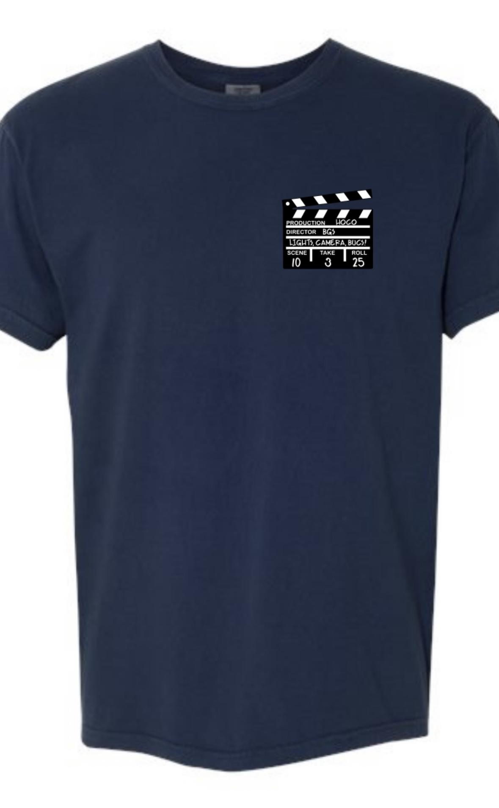

Back DesignFront Design

Shirts are a front and back design on a navy comfort colors t-shirt.

**Shirts can be worn to school any day during homecoming week!**

**SHIRTS are $25 each \***(upcharge for 2x and 3x)

**Order deadline is September 5, 2025**

STUDENT NAME: ____________________________________________

GRADE: _______________ TEACHER: ______________________

**YOUTH SIZES**: ____ Youth ExtraSmall  **ADULT SIZES**: _____ Small

____ Youth Small _____ Medium

____ Youth Medium _____ Large

____ Youth Large _____ X Large

**ADDITIONAL $2 charge…** _____ 2X

**ADDITIONAL $2 charge…** _____ 3X

Total # of Shirts _________ x $25 each = ____________ Total

Total # of Shirts _________ x $27each = ____________ Total (2x & 3x)

**Check# ______ or Cash______ Grand Total $_____________**

**(make checks payable to BGS)**