Line Brushing Supplies:
https://a.co/d/gLtZJmg
Chris Christensen Dog Brush, Mark VIII RoundSlicker Brush, Groom Like a Professinal, Stainless Steel Pins, Lightweight Beech Wood Body, Ground and Polished Tips
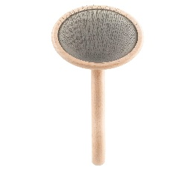

https://a.co/d/dEUYwgv
Metal Dog Grooming Comb | Removes Tangles & Matts | Dematting Pet Combs | Detangler For Matted Hair | Best Comb For Poodles, Goldendoodles, Doodles & Long Haired Dogs (Large) [We Love Doodles]
