**Line Brushing your Doodle**

We all love the look of long flowing doodle hair. But to maintain that requires daily brushing and weekly line combing. Princess Eevee had 8” of hair at one point!

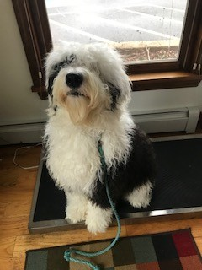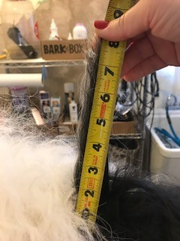

Daily brushing can be done with a slicker brush, a pin brush or a comb. Doodle owners swear by the Chris Christensen slicker.

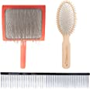

Weekly line brushing is needed to double check daily brushing.

Start by parting a small portion of hair with the comb.

Brush hair beneath the part with the slicker brush.

Part the hair about half an inch above and repeat. Continue to do this till you have the whole dog done.

Below is a picture of areas and priority of brushing

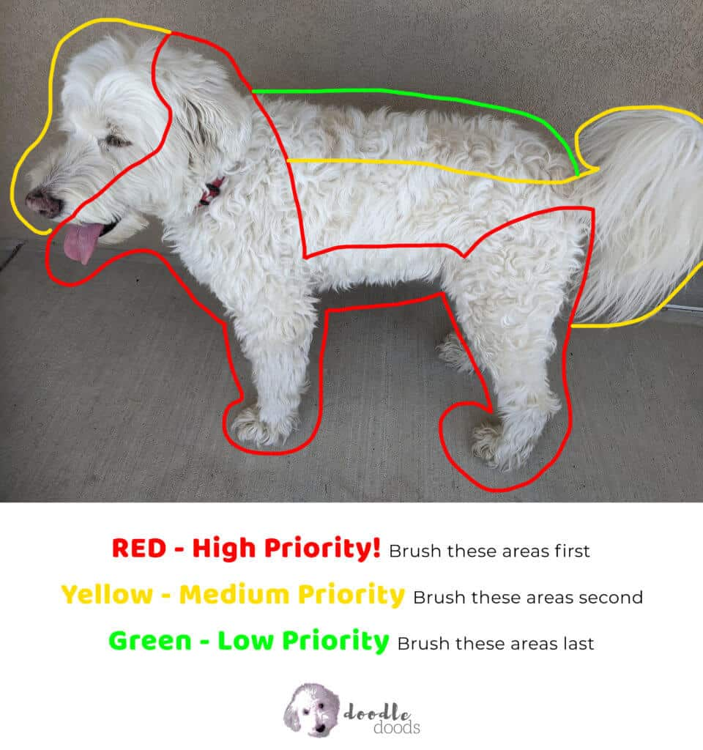

I like to go back over high priority areas with the small end of the comb to be sure I got all snaggles out. Corn starch is an amazing aid for any tangles. Shake a little onto the mat or tangle and repeat combing, starting with wide width and switching with small width to be sure. I also get lazy and will shave the mat out. They have so much hair that if the mat is on the small or medium size you won’t miss that patch of hair. Also I never want grooming to be stressful. It should be comfortable for them and can be great bonding time with owners. Treats are always helpful. The lick mats are an amazing tool to keep them busy. I like to have treats that are extra special just for grooming. I start my puppies at week 2 with nail trims and repeat every 2 weeks. At week 8 we spend time on a table (doesn’t have to be a fancy grooming table). We get treats, cut a few toenails, more treats, more cutting toenails. And then brushing also the same way. With my dogs we lay on the sofa and they actually fall asleep while I line brush. The sooner you start the better they become with it.

**Remember one small tangle or mat will be a big mat within a week.**

Picture of line brushing below.

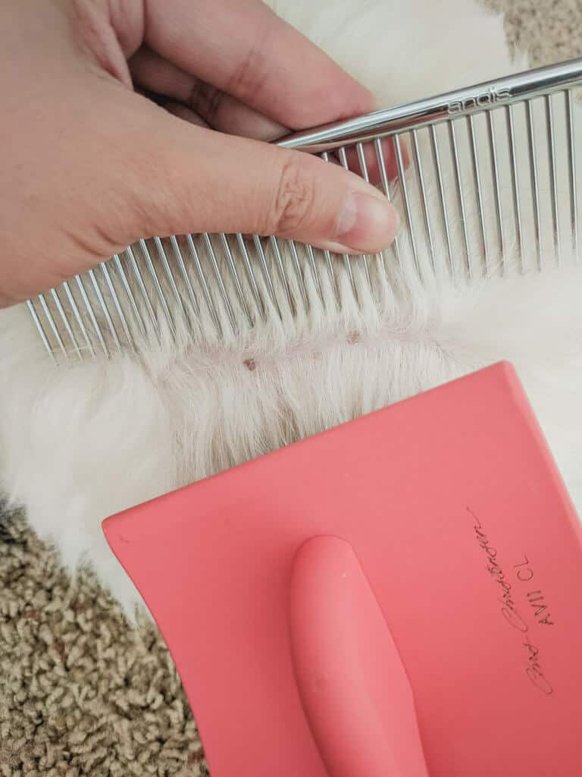

*****It’s not a terrible experience to shave them down and start fresh! Do not get upset. Their hair grows so fast! Grooming should never be stressful for you or your pup!*****