How to set up your DTA cable box from Coast Communications:
Step 1: Plug in, and screw to tighten the coax cable from the outlet, to the cable in spot on the back of the DTA.
Step 2: Connect the power cord, and plug into the electrical outlet.
Step 3: Connect the HDMI cord from the back of the DTA, to the back of your TV.
Step 4: Change the TV input to the HDMI spot you plugged into the back of the TV with the remote that originally came with your TV, not with the remote we gave you. If you do not have the remote that originally came with your TV, you may use the buttons located on your TV itself to change the input. (Hint: Most likely the input selection will be HDMI 1)
Step 5: Use the remote we gave you to change channels on your DTA, there is also added instructions on how to program the remote we gave you to the TV for volume control. The instructions are printed on the back of the remote, or can be located with a paper print out that came with the remote, or found on our website www.coastcommunications.com under Resources, Support, Support Documents for Television.

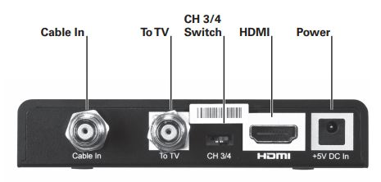
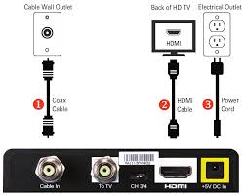
If you need any further assistance, please call us at 360-289-2252 and one of our customer service representatives would be more than happy to walk you through setup over the phone. Monday – Friday 8AM-5PM.

How to set up your HD DVR cable box from Coast Communications:
Step 1: Plug in, and screw to tighten the coax cable from the outlet, to the cable in spot on the back of the DVR.
Step 2: Connect the power cord, and plug into the electrical outlet.
Step 3: Connect the HDMI cord from the back of the DVR to the back of your TV.
Step 4: Change the TV input to the HDMI spot you plugged into the back of the TV with the remote that originally came with your TV, not with the remote we gave you. If you do not have the remote that originally came with your TV, you may use the buttons located on your TV itself to change the input. (Hint: Most likely the input selection will be HDMI 1)
Step 5: Use the remote we gave you to change channels on your HD DVR, there is also added instructions on how to program the remote we gave you to the TV for volume control. The instructions are printed on the back of the remote, or can be located with a paper print out that came with the remote, or found on our website www.coastcommunications.com under Resources, Support, Support Documents for Television.
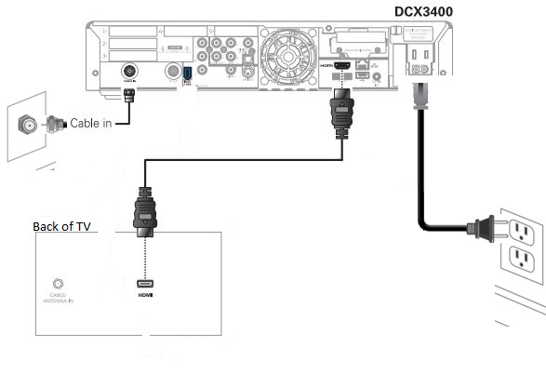

If you need any further assistance, please call us at 360-289-2252 and one of our customer service representatives would be more than happy to walk you through setup over the phone. Monday – Friday 8AM-5PM.

