How to set up your modem from Coast Communications:
Step 1: Plug in, and screw to tighten the coax cable from the outlet, to the back of the modem.
Step 2: Connect the modem with the power cord to the electrical outlet.
Step 3 (optional): If a hard lined connection to a computer or other device is needed, plug in an ethernet cord from the modem to the computer or other device.
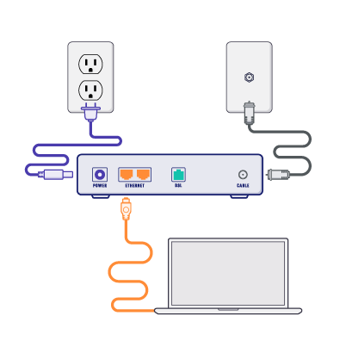
If you are using the same coax outlet for another connection with Coast Communications, such as a cable box, you will need to use a cable splitter.
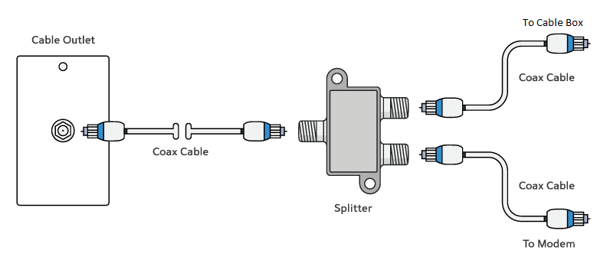
From the coax outlet, there is a coax cable that should go to the side of the splitter with 1 end. Then on the side of the splitter there should be 1 coax cable that goes to the back of the modem, and another coax cable that goes to the back of your cable box.

How to connect a router to your modem:
Step 1: Complete the modem setup on page 1.
Step 2: With an ethernet cord, plug into the back of the modem, and then with the other end of the ethernet cord, plug it into the router on the spot labeled internet. (Hint: On the back of the router, 1 spot is usually labeled another color from the rest of the spots. This is most likely the one you will need to plug the ethernet cord from the modem into)
Step 3: Plug the router in with the power cord.
Step 4: Most routers when new come with a preset network name and password, check the paperwork provided from the router manufacturer for the preset network name and password, and how to change them if needed.
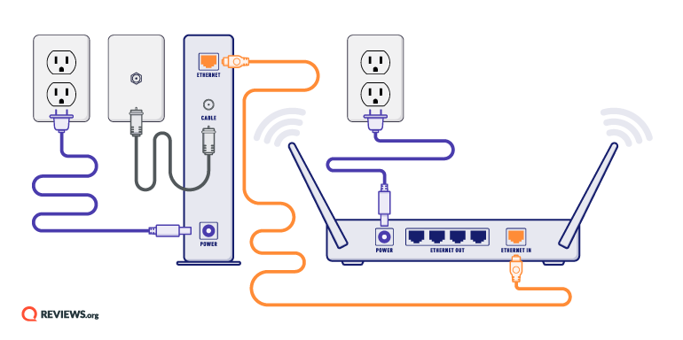

If you need any further assistance, please call us at 360-289-2252 and one of our customer service representatives would be more than happy to walk you through setup over the phone.

