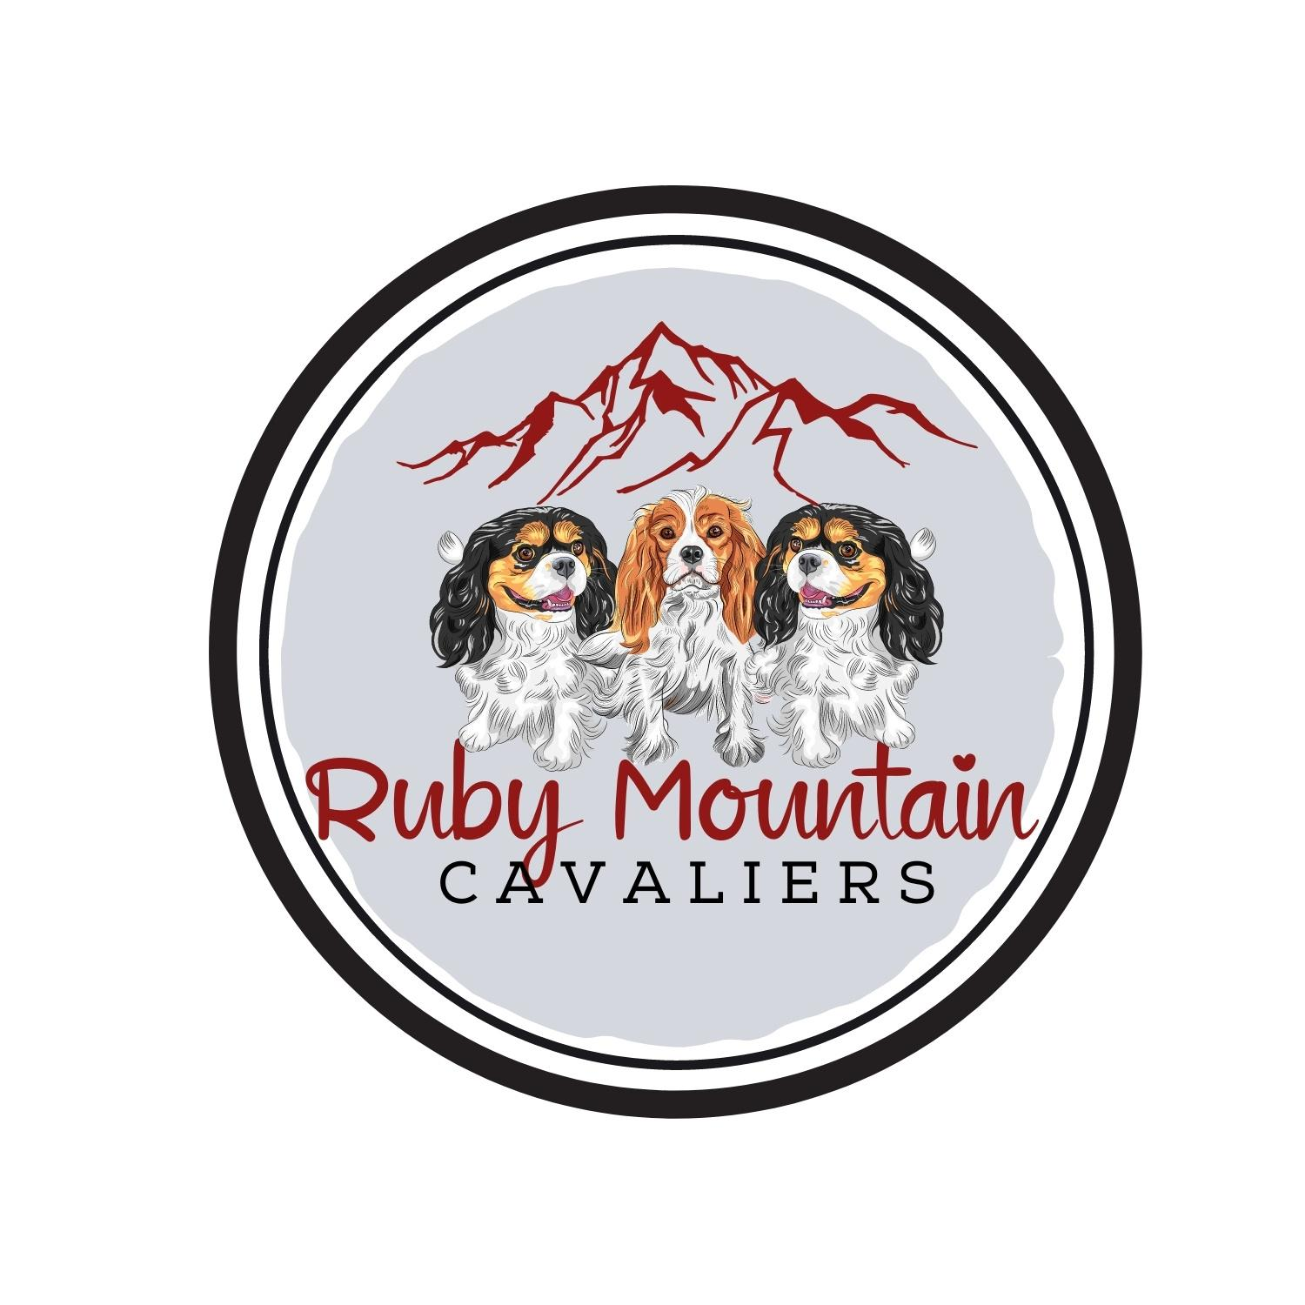 **PUPPY SALE CONTRACT**

**Ruby Mountain Cavaliers**

**4110 Stonybrook Dr. Winnemucca, NV 89445**

**(801) 787-1615 – sydney@rubymountaincavaliers.com**

This contract is between **Austen & Sydney Bills**, hereinafter referred to as **SELLER**

&_________________________________, hereinafter referred to as **BUYER(s)**

Address of Buyer:

Phone:

Email Address:

Seller agrees to sell the Buyer a CKCS Puppy whelped From AKC Litter Number:

Sex:

Registered Name of Sire:

Registration Number of Sire:

Registered Name of Dam:

Registration Number of Dam:

For the sum of $

This Puppy is being sold for:

1. **Pet/Companion**

2. **Breeding, as well as Pet, Companion**

**1)** The **BUYER agrees** to treat the dog with love and kindness and not abuse or neglect it; provide a life-long commitment, comfortable environment inside the home, prompt medical attention and responsible care. This includes keeping this puppy/dog parasite free and up to date with vaccinations, deworming, heartworm prevention, proper nutrition (which consists of good quality feed given at regular intervals), and fresh water available at all times. The **BUYER promises** to provide a safe environment for the puppy/dog, and never allow the puppy/dog to be chained up or roam freely without proper fencing or supervision.

**2)** The **SELLER guarantees** this puppy to be of sound health and temperament at the time of this sale. A health record of all to-date shots and deworming will be provided by the Seller. The puppy will also come with a health certificate from a certified vet from their 8 week checkup. At this time the vet will also implant the puppy with an AKC ReUnite Microchip. The Buyer agrees to take this puppy/dog to a **licensed veterinarian** of their choice, within seven (7) business days, for a physical examination. Should the puppy be determined to be in unacceptable health by the licensed veterinarian, the cause of which the Seller is clearly to blame, the puppy may, upon a signed written diagnosis from said licensed veterinarian, be returned for refund of the purchase price less deposit. The puppy must be returned to the Seller within two (2) business days of the written diagnosis. The Seller assumes absolutely no responsibility for fees associated with caring for the puppy.  **Seller** offers a **2**-**year** genetic **Health Guarantee** for life threatening congenital defects that can be tested for at time of breeding. This includes severe hip dysplasia grade 4, heart murmur grade 4, lung, liver, and kidney defects. Not included is: internal or external parasites, umbilical hernia (easily repaired and does not cause a life-threatening condition), undescended testicles, under or overbite, injuries, allergies, negligence/abuse, heat exhaustion or hyperglycemia. Because luxating patellas and collapsed tracheas can be caused by injury, they are not covered after Buyer’s veterinarian's initial exam. Kennel cough and other communicable diseases are not covered after your veterinarian’s initial exam. In case of death, a necropsy will be required to determine if death is due to a genetic disorder in order for a puppy replacement to be given. This 2-year Health Guarantee is for the Buyer only and is non-transferrable. If the puppy is found to have a life-threatening congenital defect in his or her first two years, then a report from two veterinarians is required in writing no later than 2 days after the diagnosis. It can be two veterinarians from the same clinic. Under no circumstances will there be a cash refund. If exchange is necessary due to circumstances outlined above, Seller will select a replacement puppy from the same litter, if available, or from another litter of equal quality. If living, the original puppy must be returned to Seller at Purchaser's expense. The purchaser is also responsible for any shipping fees for a replacement puppy. The original puppy must be returned before a replacement puppy will be delivered. The purchaser assumes all vet bills incurred up to that point on his or her puppy. If shipping has been approved by the Breeder, arrangements will be made between the Breeder and the Buyer. Puppy becomes the sole responsibility of the Buyer once the Breeder delivers the puppy to the Buyer or transport personnel and puppy is in their care.

**3)** If at any time the Buyer can no longer retain possession of this puppy/dog, the Seller is to be notified, and given first option of resuming full ownership of dog, or to assist the

Buyer to locate this dog a new home. Refunds, if any, will be at the discretion of the Seller. The dog will be returned with all AKC papers and medical records. Should any circumstances arise that affect the quality of life of the dog, the Seller is to be informed, so that they may participate in determining the future of the dog. The Seller reserves the right to approve/prohibit any transfer of this puppy/dog to a third party and breeding rights will not transfer. **Under no circumstances will this puppy/dog be sold, leased, traded or given away to any pet shop, research laboratory, animal shelter or similar facility.**

**4)** The Buyer agrees to contact the Seller immediately if any questions, or concerns, arise about the puppy, such as housing, diet, or health. The Buyer also agrees to keep the Seller

informed of any treatment as it occurs. This provides the Seller/Breeder with an opportunity

to follow up on the puppies and gives them important feedback and information on the health

of their dogs for future generations.

**5)** The Seller will provide the Buyer with an American Kennel Club Official Registration Form, properly filled out, with all registration numbers, color and marking codes, transfer and

signature. It is the responsibility of the Buyer to complete the application, name the puppy,

and send the application in, along with all fees, to the American Kennel Club. The Seller will also provide the Buyer with a copy of the AKC Litter Certificate and four generation pedigree.

**6)** If this puppy is being sold for a **Pet/Companion**, the Buyer agrees that **UNDER NO** **CIRCUMSTANCES,** will this dog be used for breeding and agrees to have it spayed/neutered at the age recommended by their veterinarian (usually 6 months to 1 year for males and at least a month after the first heat cycle for females). The box will be marked on the registration application for **LIMITED REGISTRATION**, which means that the dog cannot produce AKC Registrable litters. However, it may participate in most AKC events, including Agility, Obedience and Junior Showmanship. The preceding paragraphs contain conditions established by the Seller to ensure the wellbeing of the puppy/dog. The Buyer’s agreements will continue for the duration of the dog’s life and the Seller will have the right to enforce the agreements.

**This Agreement is the entire Agreement between the Seller and the Buyer. The Seller and Buyer have made no other Agreements or Promises expressed or implied outside of this Agreement. By signing this contract I, the Buyer of Dog from Ruby Mountain Cavaliers, agree to the terms of this contract and acknowledge that I have received a copy of this contract. This Document is a legally binding contract. Any court costs and attorney fees necessary to enforce this contract shall be paid by Buyer in the state of Nevada. The laws of the State of Nevada, County of Humboldt, United States of America will govern the interpretation of this contract.**

**Seller Signature:**

**Seller’s Name Printed:**

**Buyer Signature**

**Buyer’s Name Printed**