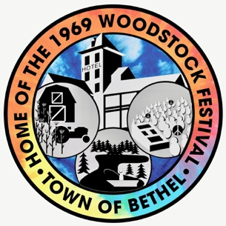
Sustainable Bethel 2026 Forum
Saturday, August 8, 2026
10AM to 2PM Doctor Duggan School Bethel, NY

Learn about actions and issues each of us can take to reduce our own greenhouse gas emissions and impact on the climate.

Special Presentations:

- Heather Brown, Sullivan County Commissioner Division of Planning, Community Development and Environmental Management. Ms Brown will be talking about the water studies the county has conducted.

- Buck Moorhead the architect and inspiration behind The Catskill Project. Located on 90 acres in Livingston Manor, NY, the project marries the principles of Passive House design with the efficiency & quality control of off-site panelized wall systems, carbon tracking, renewable energy, and master craftsmanship.

- Steve Bonds-Liptay, Energy Advisor for Cornell Cooperative Extension will present ways homeowners can reduce energy inefficiencies in our homes.

Information will be available about:
- Smallwood Water District
- Electric and hybrid vehicles
- Community Solar
- Home Heating and Cooling Systems
- Private Septic system maintenance
- Composting and Waste Management strategies
- Local Food Systems
- Transportation Infrastructure
- Landscaping tips
- Drinking Water Source Protection Plan for the Town of Bethel
- Sullivan County Assessment of Potable Water and Wastewater Infrastructure

