

SASC Visual Difficulties Screening Protocol

Visual difficulties that affect an individual’s performance will typically give rise to symptoms of discomfort and visual disturbance, which may result in changes in behaviour as an effect of the symptoms, or as a strategy to cope with the difficulty. These behavioural changes are often helpful signs that the individual is experiencing visual difficulty. Often, though not always, visual difficulties will be exacerbated by tasks involving sustained and intensive reading or studying of visual material.

The role of the SpLD practitioner is to undertake visual difficulties screening (if it is feasible to do so) and refer the individual for professional assessment, if necessary, on the basis of this screening.

The screening protocol described below provides two short questionnaires, which assessors should use to gather information on an individual’s visual history and any symptoms and signs of visual difficulty, and a template letter for referral to an optometrist if required on the basis of the questionnaire responses.

It must be emphasised that assessment of visual difficulties by an SpLD practitioner is to be limited to recording of reported symptoms and signs — there must be no attempt to suggest a diagnosis or propose a treatment, for the following reasons:
- In some cases there may be ocular or visual system pathology, so symptoms MUST be investigated by a qualified professional.
- Refractive problems are a very common cause of symptoms, but assessment and management of these can only legally be undertaken by suitably qualified, registered professionals.
- Similar symptoms may have very different causes, especially those involving headache and eyestrain, and so a variety of assessments and professional knowledge may be required to reach a correct diagnosis.

Note specifically that, in keeping with advice in the previous paragraph, SpLD practitioners, specialist teachers, and others involved in providing support to individuals with SpLD should not undertake assessment aimed at identification and treatment of ‘visual stress’.

Symptoms and Signs
An individual will generally present symptoms and signs of visual difficulty in one or more of three ways, according to i) what s/he FEELS (visual discomfort), ii) SEES (visual disturbance), and/or iii) DOES (behaviour — voluntary or involuntary reactions or coping strategies). Each of these will have its own degree of intricacy.
For example, visual discomfort may present as feelings of eyestrain with aching, painful or gritty eyes, or as feelings associated with or induced by the visual discomfort itself, such as headache and nausea. Feelings of visual discomfort may be brought on by either a single factor or a combination of factors such as the task, the environment and the individual’s threshold for reporting the problem. The degree of visual discomfort experienced and the point at which it becomes troublesome will vary on an individual basis. This introduces a level of complexity for the SpLD practitioner when trying to decide on an appropriate course of action to help the individual reporting visual difficulties.
An indication of types of experience commonly presented in each of these categories is:
- FEELS (symptoms) — Visual Discomfort: headache; eyestrain; tired eyes; gritty eyes; sore eyes; general fatigue.
- SEES (symptoms) — Visual Disturbance: blurred vision at distance and/or near; text/objects go in and out of focus; double vision at distance and/or near; text/objects alternate between single and double; words jump or move on the page; missing words or lines when reading; seeing patterns, shimmer, flicker colours, and/or illusions when reading.
- DOES (signs) — Behavioural Response / Coping Strategies: holding reading material closer or farther away than normal; screwing eyes up to see more clearly; frequently rubbing the eyes; pointing with a finger to keep place when reading; looking around or blinking to alleviate discomfort, avoiding reading; turning away or aversion to viewing some types of pattern.
FIGURE 1 shows how these examples of symptoms and signs may relate selectively to different types of visual difficulty. Note: this list is by no means exhaustive but indicates the most common signs and symptoms of visual difficulty that should alert SpLD practitioners to consider a referral.

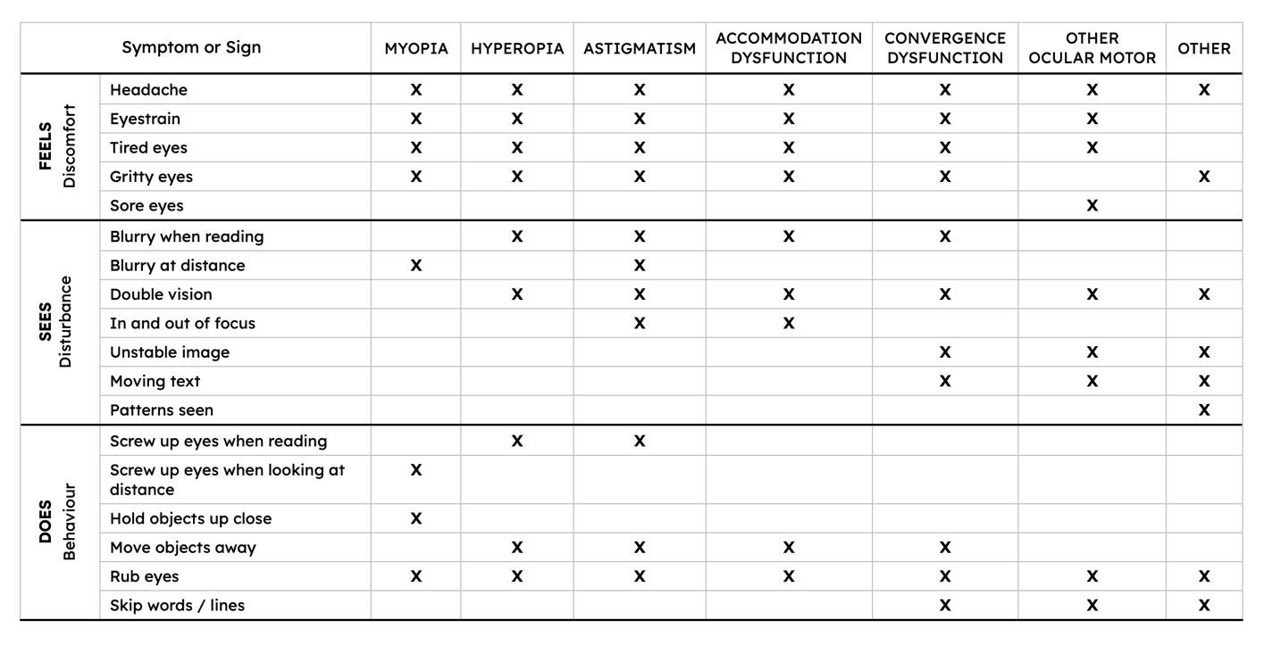
FIGURE 1. Frequently-reported symptoms & signs, related to some common conditions that cause them.

Screening Protocol

FIGURE 2 shows a flowchart of the visual difficulties screening protocol, with explanation in paragraphs below.

The flowchart in FIGURE 2 can be read from left to right. The panel on the left is a summary representation of a proposed model for dyslexia assessment, from the recent (SASC-led) Delphi Study on Assessment and Identification of Dyslexia. For simplicity and generality here we label this ‘SpLD Assessment’ with no distinction between whether assessment relates to a child or an adult — but we outline the three key stages of the assessment model to show that explicit consideration of the possibility of problems affecting vision should occur at the first stage of SpLD assessment. Thus, the arrowhead located here is routed to the start of the Visual Difficulties Screening Protocol (VDSP Start).

From VDSP Start we move to collection of information on visual difficulties and visual history using questionnaires. The + sign indicates that both questionnaires must be completed, but the order in which they are completed does not matter. The responses given on these questionnaires lead to one of 3 decisions on action to be taken, indicated here using a ‘traffic-light’ (red, amber, green) colour scheme:
- RED — If the individual answers YES to any question on the Visual Difficulties Questionnaire, then referral to an optometrist for further assessment is required, regardless of whether there is any recent history of a sight-test.

If all questions on visual difficulties symptoms & signs are answered NO, then action depends on sight-test history …
- AMBER — if the individual has NOT had a sight-test by an optometrist within the last 2 years, then a sight-test at this stage is advisable.
- GREEN — if the individual has had a sight-test within the last 2 years then no action is required now, but general advice may be given to consult an optometrist if they experience any persistent symptoms of the sort indicated.

For cases having no visual difficulties requiring referral (i.e. AMBER & GREEN outcomes) the SpLD assessment may of course proceed uninterrupted. However, for cases requiring referral (RED) the SpLD practitioner will need to consider whether the visual difficulties reported are likely to have such an adverse effect on other tests that there should be a pause in the assessment process until visual difficulties have been addressed. This may not be clear-cut but, as a general guide, symptoms of frequent and/or severe visual disturbance (e.g. words moving, print going double, or going in and out of focus, etc.) are likely to have an adverse effect on performance in measures of reading rate, orthographic skills and rapid automatised naming.

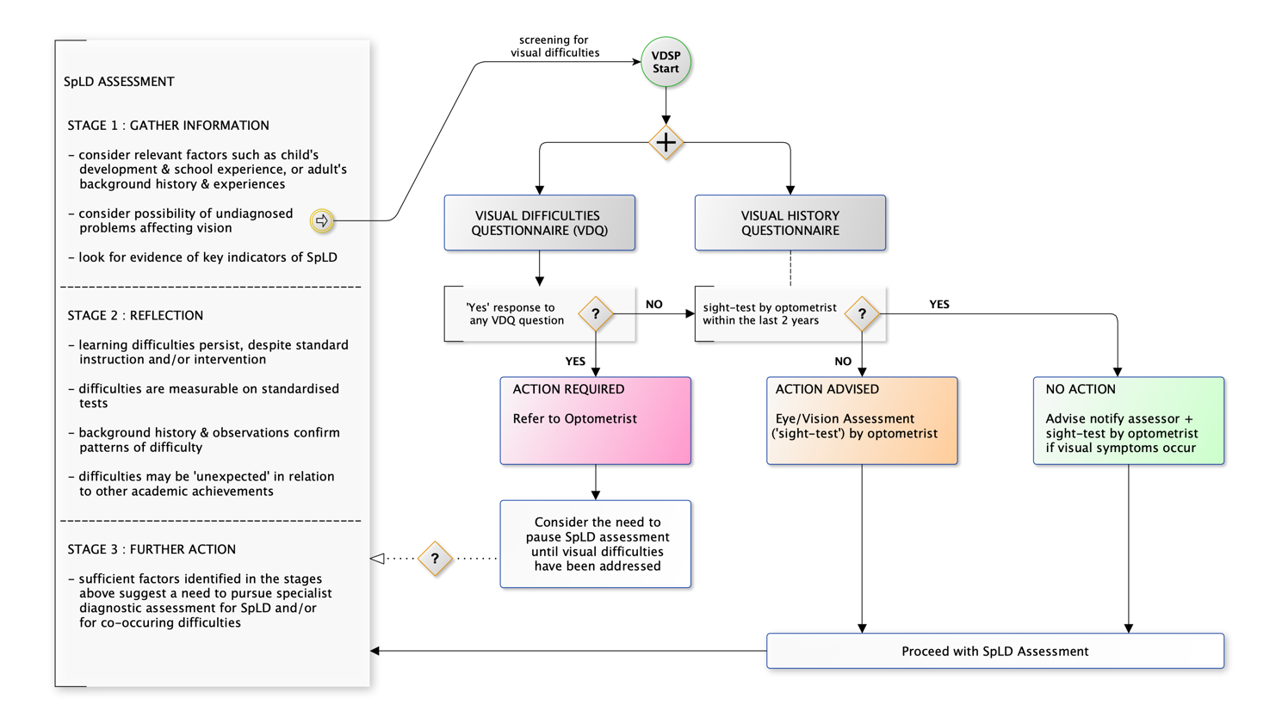
FIGURE 2. Visual Difficulties Screening Protocol (VDSP) as part of SpLD Assessment

Visual History Questionnaire
The following questions provide information on visual history, which helps in putting any reports of current visual difficulties into context.
QUESTIONS | RESPONSES | NOTES
1. Have you been prescribed and advised to wear any optical prescription lenses (i.e. glasses or contact lenses)?  if YES then :  1a. Are these required for distance vision (e.g. television), near vision (e.g. reading), or both?  1b. Do you wear your glasses / contact lenses as advised?  1c. Do you have your glasses / contact lenses with you today? | Yes / No  Dist / Near / Both  Yes / No  Yes / No | If correction prescribed and normally worn for near work, then it should be worn for SpLD assessment
2. How long ago was your last sight-test or eye test by an optometrist (”optician”) — less than two years ago, more than two years, NEVER)? | < 2 years  > 2 years  Never | see Screening Protocol above for use of the response to this question
3. Have you ever used coloured overlays or precision-tinted lenses?  if YES then :  3a. Who recommended and provided these?  3b. Why were they recommended?  3c. Did they help? — if YES, in what way?  3d. Do you still use them? — if NO, why not? | Yes / No
4. Have you ever had hospital treatment for a problem with your eyes or vision?  for example …  — wearing a patch for a ‘lazy eye’ (amblyopia)?  or  — wearing glasses or having exercises to help correct a ‘turn’ in your eye (squint)?  or  — any other condition? | Yes / No

Visual Difficulties Questionnaire (VDQ)
The VDQ requests simple yes/no answers to a few questions about symptoms and signs involving FEEL (visual discomfort, Q1-3), SEE (visual disturbance Q4-7), DO (behaviour Q8-9), and one general question (10) about any other experience.

QUESTIONS | NO | YES
often = persistent, occurring several times a week, though not necessarily every day
1. Do you often get headaches when you read or study?
2. Do your eyes often feel sore, or gritty, or watery?
3. Does reading from white paper or from a bright screen often feel uncomfortable?
4. Does print often appear blurred, or go in and out of focus, when you are reading?
5. Does the print, or book, or screen, often appear double when you are reading?
6. Do words often seem to move or merge together when you are reading?
7. Do objects in the distance often appear more blurred after you have been reading?
8. Do you often have to screw up your eyes to see more clearly when you are reading?
9. Do you often move your eyes around or blink to make things clearer or more comfortable when you are reading?
10. Do you experience any other problems with your vision that interfere with your ability to read or study?
If YES then describe:

Note the emphasis on the word often in questions 1-9, which is deliberately intended to identify when a symptom occurs frequently. Therefore, the individual should be advised to answer NO if reported symptoms would be considered infrequent (e.g. rarely, occasionally, sometimes, <2-3 times per month).

Referral Letter Template
The following is a suggested template for a referral letter to an optometrist. Copies of the completed Visual History and Visual Difficulties Questionnaires must be sent with this letter.

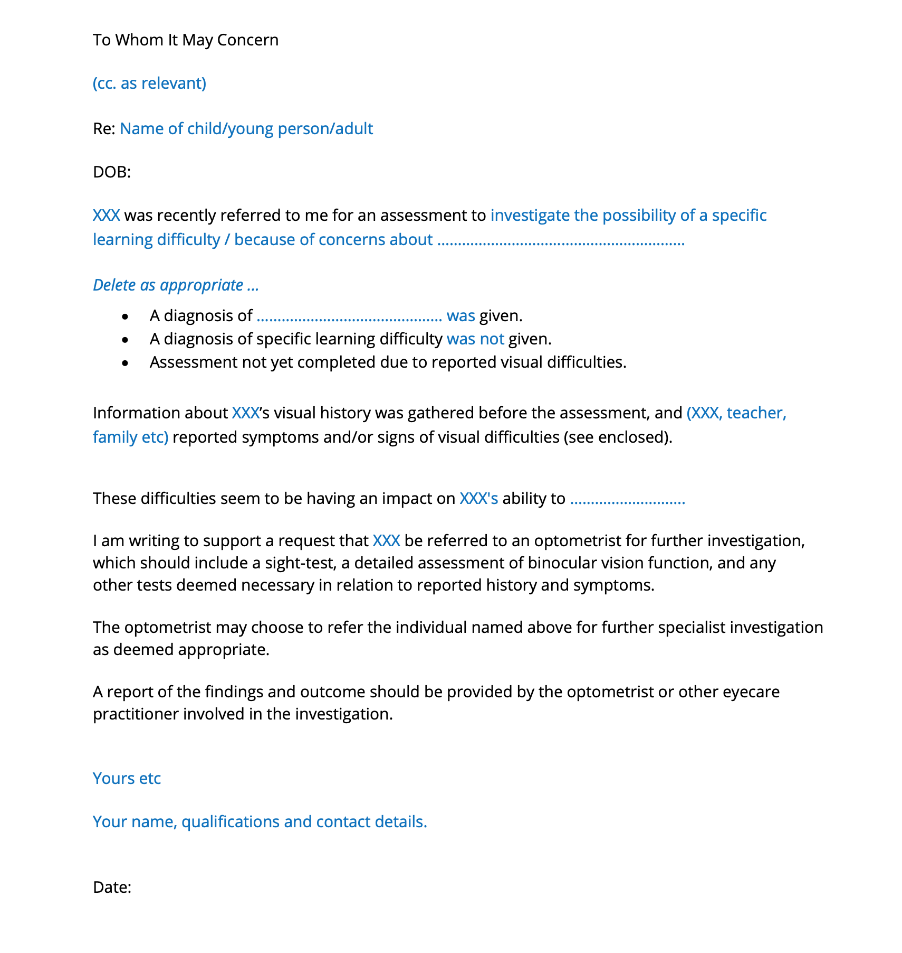
Note that the referral letter includes an option to indicate whether the SpLD Assessment has been paused due to the visual difficulties reported. An ideal scenario is generally that screening, referral, and subsequent management of any visual difficulties would be carried out before SpLD assessment, but in practice this may result in time delays and related difficulties for the individual concerned. The SpLD practitioner must consider whether resolution of the optometry assessment is required before the SpLD diagnosis can be reached, or whether the investigations may run concurrently, bearing in mind that other agencies / healthcare professions may also be involved in the assessment process.

