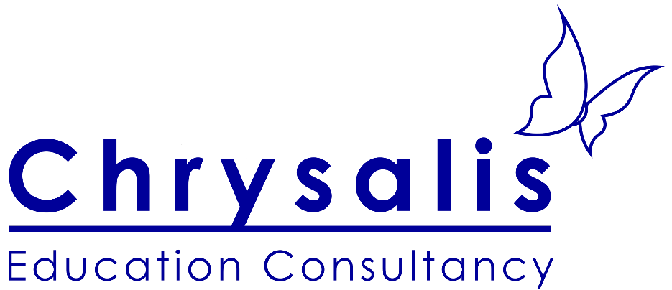

Chrysalis Education Consultancy Limited Privacy Notice



Chrysalis Education Consultancy

0750 710 5326

enquiries@chrysaliseduc.com

chrysaliseduc.com

**Table of Contents**

1Our Contact Details 3

2What Type Of Information We Have 3

3How We Get The Information And Why We Have It 3

4What We Do With The Information We Have 4

5How We Store Your Information 5

6 Your Data Protection Rights 6

7How To Complain 7

# Our Contact Details

Name: Dianne Allsup (main data protection contact), Joel Allsup

Address: 10 Chatsworth Avenue, WA3 4LE, Culcheth, Warrington

Phone Number: 07507105326

E-mail: [Admin@chrysaliseduc.com](mailto:Admin@chrysaliseduc.com), [dianneallsup@chrysaliseduc.com](mailto:dianneallsup@chrysaliseduc.com)

Website address: Chrysaliseduc.com

# What Type Of Information We Have

We currently collect and process the following information:

* The name, contact details and address of the Parent/carer’s
* The name, date of birth and school of the child
* Information regarding educational and medical histories and the social context that is pertinent to the services being provided.
* Relevant file information associated with the services provided to each individual (e.g. Completed diagnostic assessment reports, notes and record sheets from the assessment and information provided to inform the assessments.)
* Information given by organisations regarding their persons of contact, Postal addresses, email address.
* Information of organisations associated with services purchased e.g. SLA, invoices and dates of Payment.
* Functional information regarding employees e.g. contact details, Payroll.
* Information provided by employees regarding professional qualifications and training.
* Information gathered regarding employees according to the safeguarding and safer recruitment policy.
* Website user statistics

# How We Get The Information And Why We Have It

Most of the personal information we process/store is provided to us directly by you or the referring body (e.g. School) for one of the following reasons:

* Points of contact for provision of services e.g. Email addresses, home addresses for in-person visits or postal communication.
* Evidence of permission to provide services e.g. permission to undertake diagnostic assessment.
* Relevant information for the contracted services to be provided effectively e.g. Referral forms
* Employee information is gathered directly from employees or contacts they provide to us. This is to ensure safe recruitment and the legal functioning of the company regarding payroll and human resource obligations.
* All parties have the right to withdraw permission for us to hold or use information they have previously provided to us. In the case of employees, this only applies where it does not conflict with the legal obligations of Chrysalis education consultancy regarding tax, employment laws or safeguarding policy.

Under the General Data Protection Regulation (GDPR), the lawful bases we rely on for processing this information are:

**(a) Your consent. You are able to remove your consent at any time. You can do this by contacting the company director or administrator on** [*admin@chrysaliseduc.com*](mailto:admin@chrysaliseduc.com)

**(b) We have a legal obligation regarding employee data**

# What We Do With The Information We Have

We use the information that you have given us in order;

* To communicate with you and provide our services to you.
* We use the information you give us to assist in the decisions we make, the advice and diagnoses we give as part of the services you contract us to provide to you.
* All emails sent and received within the chrysalis email system are encrypted. Emails sent to addresses outside of the chrysalis system that contain sensitive documentation such as diagnostic reports are specifically encrypted. Only Initials or the first names of clients are used in non-encrypted emails that are sent outside of the chrysalis email system
* Information is shared purely on a need-to-know basis within the Chrysalis team for the effective provision of services.
* All information is fully shared with parents/carers for children under 16yrs old. When the client is 16yrs or over, all information is shared directly with the client.
* Information is never shared with 3rd party agencies such as a speech and language service unless specific permission has been given by Parent/carer or client over 16yrs.
* With the knowledge of parent/carer/client, information is shared with the initial referrer e.g. school.
* If safeguarding concerns arise, information is shared on a need to know basis with a relevant 3rd party in line with the Chrysalis Safeguarding policy.
* Information regarding employees is shared with government agencies solely for the purpose of fulfilling the company’s legal obligations to HMRC.
* Information regarding employees is shared with Thirtyone:eight for the purposes of obtaining a DBS and with the company accountants (Bright Partnership) for the purposes of payroll. In these instances, the information is held securely according to the GDPR policies of these companies.
* When employees require personal or professional references from Chrysalis Education, any appropriate information is shared for this purpose.

# How We Store Your Information

* Electronic information is kept in passworded systems e.g. Notion, Xero, Outlook
* Hard copy information is stored in a Locked filing cabinet.
* All Chrysalis employees work on passworded laptops.
* All Chrysalis employees share information via our encrypted chrysaliseduc.com email system.
* Individual employees are given specific access to stored information depending on their role in the company. This applies to electronic or hard copy information.
* We keep information relating to the financial and business aspects of the company for 7 years after they are no longer required for the day to day running of the company.
* We keep client information of children under 18yrs old until the individual is 25yrs of age.
* We keep client information of adults for 20 years after the final contact.
* We keep information relevant to any safeguarding concerns for 75 yrs.
* We keep company personnel files for 7 years after the employer has left the company.
* When these timescales are satisfied electronic information is thoroughly deleted. Hard copy information is shredded.

# Your Data Protection Rights

Under data protection law, you have rights including:

**Your right of access** - You have the right to ask us for copies of your personal information.

**Your right to rectification** - You have the right to ask us to rectify information you think is inaccurate. You also have the right to ask us to complete information you think is incomplete.

**Your right to erasure** - You have the right to ask us to erase your personal information in certain circumstances.

**Your right to restriction of processing** - You have the right to ask us to restrict the processing of your information in certain circumstances.

**Your right to object to processing** - You have the the right to object to the processing of your personal data in certain circumstances.

**Your right to data portability** - You have the right to ask that we transfer the information you gave us to another organisation, or to you, in certain circumstances.

You are not required to pay any charge for exercising your rights. If you make a request, we have one month to respond to you.

Please contact us at [admin@chrysaliseduc.com, 07507105326 and 10 Chatsworth avenue, Culcheth, Warrington, WA 4LE] if you wish to make a request.

# How To Complain

You can also complain to the ICO if you are unhappy with how we have used your data.

The ICO’s address:

Information Commissioner’s Office

Wycliffe House

Water Lane

Wilmslow

Cheshire

SK9 5AF

Helpline number: 0303 123 1113